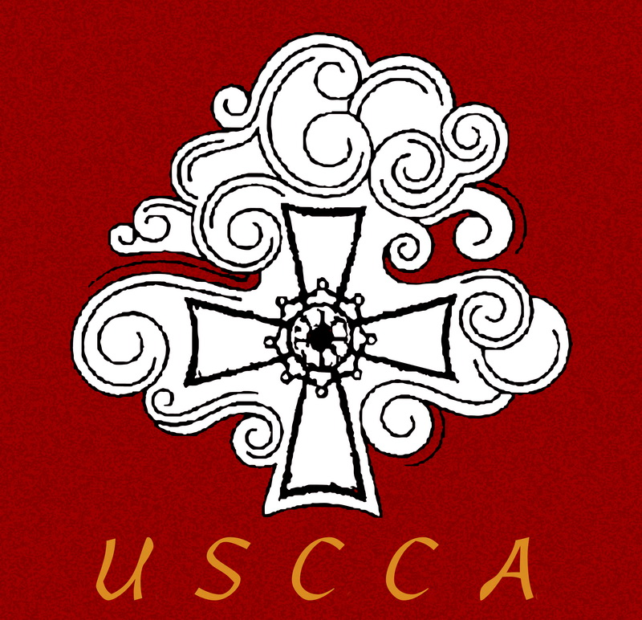US-China Catholic Association

Mission Appeal at St. Therese, March 30-31

The weekend of March 30-31representatives of the US-China Catholic Association (USCCA) will speak at all the Masses at St. Therese Chinese Catholic Mission.

The USCCA was founded 1989, during the post-Maoist era, after China had reopened to the world. It was a collaborative effort of the US bishops, Maryknoll, the Jesuits, and other religious orders who sought to build fraternal ties between the Churches in the U.S. and in China, to aid the Church in China to get back on its feet, and to provide Americans with an informed understanding of circumstances facing the Church in China.

* Mary Sluka, a native Chicagoan and long-time member of the China Association Board, will speak at the Saturday 5:00 PM Mass.
* Fr. Hugh O'Donnell, CM, who has served as Superior of the Vincentians’ Midwest Province and their China Province, as well, will speak at the Sunday 8:00 AM Mass.
* Fr. Michael Agliardo, SJ, executive director of the China Association, will speak at the 10:30 AM Mass.

Over the years the USCCA has run national conferences to bring together people concerned about the Church in China, operated study tours to bring American Catholics to China to understand the realities of the Church there first-hand, and maintained various other forums (a website, a newsletter, and a speaker series) to keep U.S. Catholics informed of the inspiring story of the witness to the faith of our brothers and sisters in China.

Fr. Francis Li serves on the Board of Directors of the USCCA and has been a guiding voice as the China Association expands its work to meet the challenges of a new era. This includes greater outreach to Chinese here in the United States and providing the resources that the Church in China requires in this new era.

Find out more about the vital mission of the USCCA by visiting its website: [**www.uscatholicchina.org**](http://www.uscatholicchina.org)

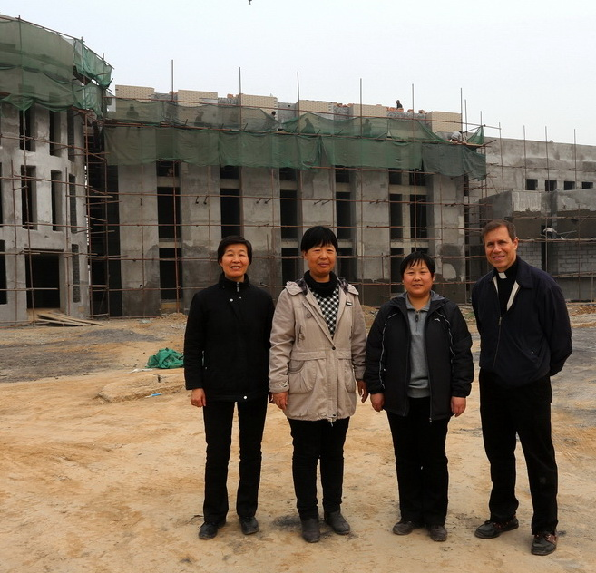

Sino-Vatican Talks and the Church in China Today

On Sunday, March 31 at 11:45 AM Fr. Michael Agliardo, executive director of the US-China Catholic Association, will speak in the parish hall of St. Therese Catholic Church about the recent accord between the Vatican and Beijing on the naming of bishops. He also will offer remarks on the wider circumstances of the Church in China today.

Fr. Michael and sisters of the Congregation of Holy Hope in front of the retreat center they built.

The Sino-Vatican accord has raised deep concern among Catholics overseas because it comes at a time when the Beijing authorities have launched a drive requiring all religions to limit outside influence and conform to the Chinese norms. Many have criticized the accord as naïve, as a betrayal of the “underground Church” (Catholics who do not cooperate with government officials), or as a capitulation to Beijing. What are the issues at stake?

Fr. Michael is a sociologist who has taught at Boston College and Loyola University Chicago. He has also taught at the Chinese Catholic National Seminary and met with faithful Catholics throughout China.