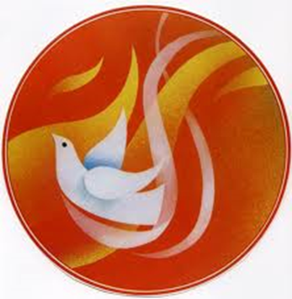

***Presider Bishop Andrew P. Wypych***

**Congratulations to our Confirmandi:**

 Austin **Vincent** Cabello

Gaby **Gabriel** Del Raso

Hannah **Elizabeth** Dykehouse

Bianco **Agnes** Gallardo

**Matthew** Lee

Maureen **Madeleine** McDonald

Jason **Maximilian Kolbe** McGrath

Matthew **Nicholas** Wong

Lauren **Hermione** Yee

***Oh Holy Spirit of God; take me as Thy disciple.***

***Guide me, illuminate me, sanctify me.***

***Bind my hands that they may do no evil.***

***Cover my eyes that they may see it no more.***

***Sanctify my heart that evil may not dwell within me.***

***Be Thou my God***

***Be Thou my guide.***

***Whatsoever Thou forbiddest me I will renounce.***

***And whatsoever Thou commandest me, in Thy strength I will do.***

***Lead me then unto the fullness of Thy truth. Amen.***

**Mass Intentions**

***May 26, 2013 The Most Holy Trinity***

**8:00A.M.**

**9:30A.M.** + Eric Yun by Lushia and Tim  
 + Henry Lee by wife Agnes Lee

**11:00A.M. Mandarin Mass**

***MON. May 27th Saint Augustine of Canterbury, Bishop***

**8:00A.M.** + Barry Yong by Mom June Moy

+ Rocky Iacullo– 10th Anniversary by Marion

***TUE. May 28th Weekday***

**8:00A.M.** + S. Chow Woo by Bo Kam Woo & Family

***WED. May 29th Weekday***

**8:00A.M. +** Jennie Bertucci by Zito Family

***THU. May 30th Weekday***

**8:00A.M.**+ Frank Roti, Sr. by Marion

+ Catherine Barbaro by Family

+ Bruno Bertucci by Zito Family

***FRI. May 31st The Visitation of the Blessed Virgin Mary***

**8:00A.M. +** Special Intentions by Zito Family

***SAT. June 1st Saint Justin, Martyr***

**8:00A.M.** Immaculate Heart of Mary

**5:00P.M.** Friends and Parishioners of St. Therese

***From the Desk of Fr. Francis***

**Greetings of Christ’s Peace and Joy! Hope you all had a blessed week.**

**Congratulations**

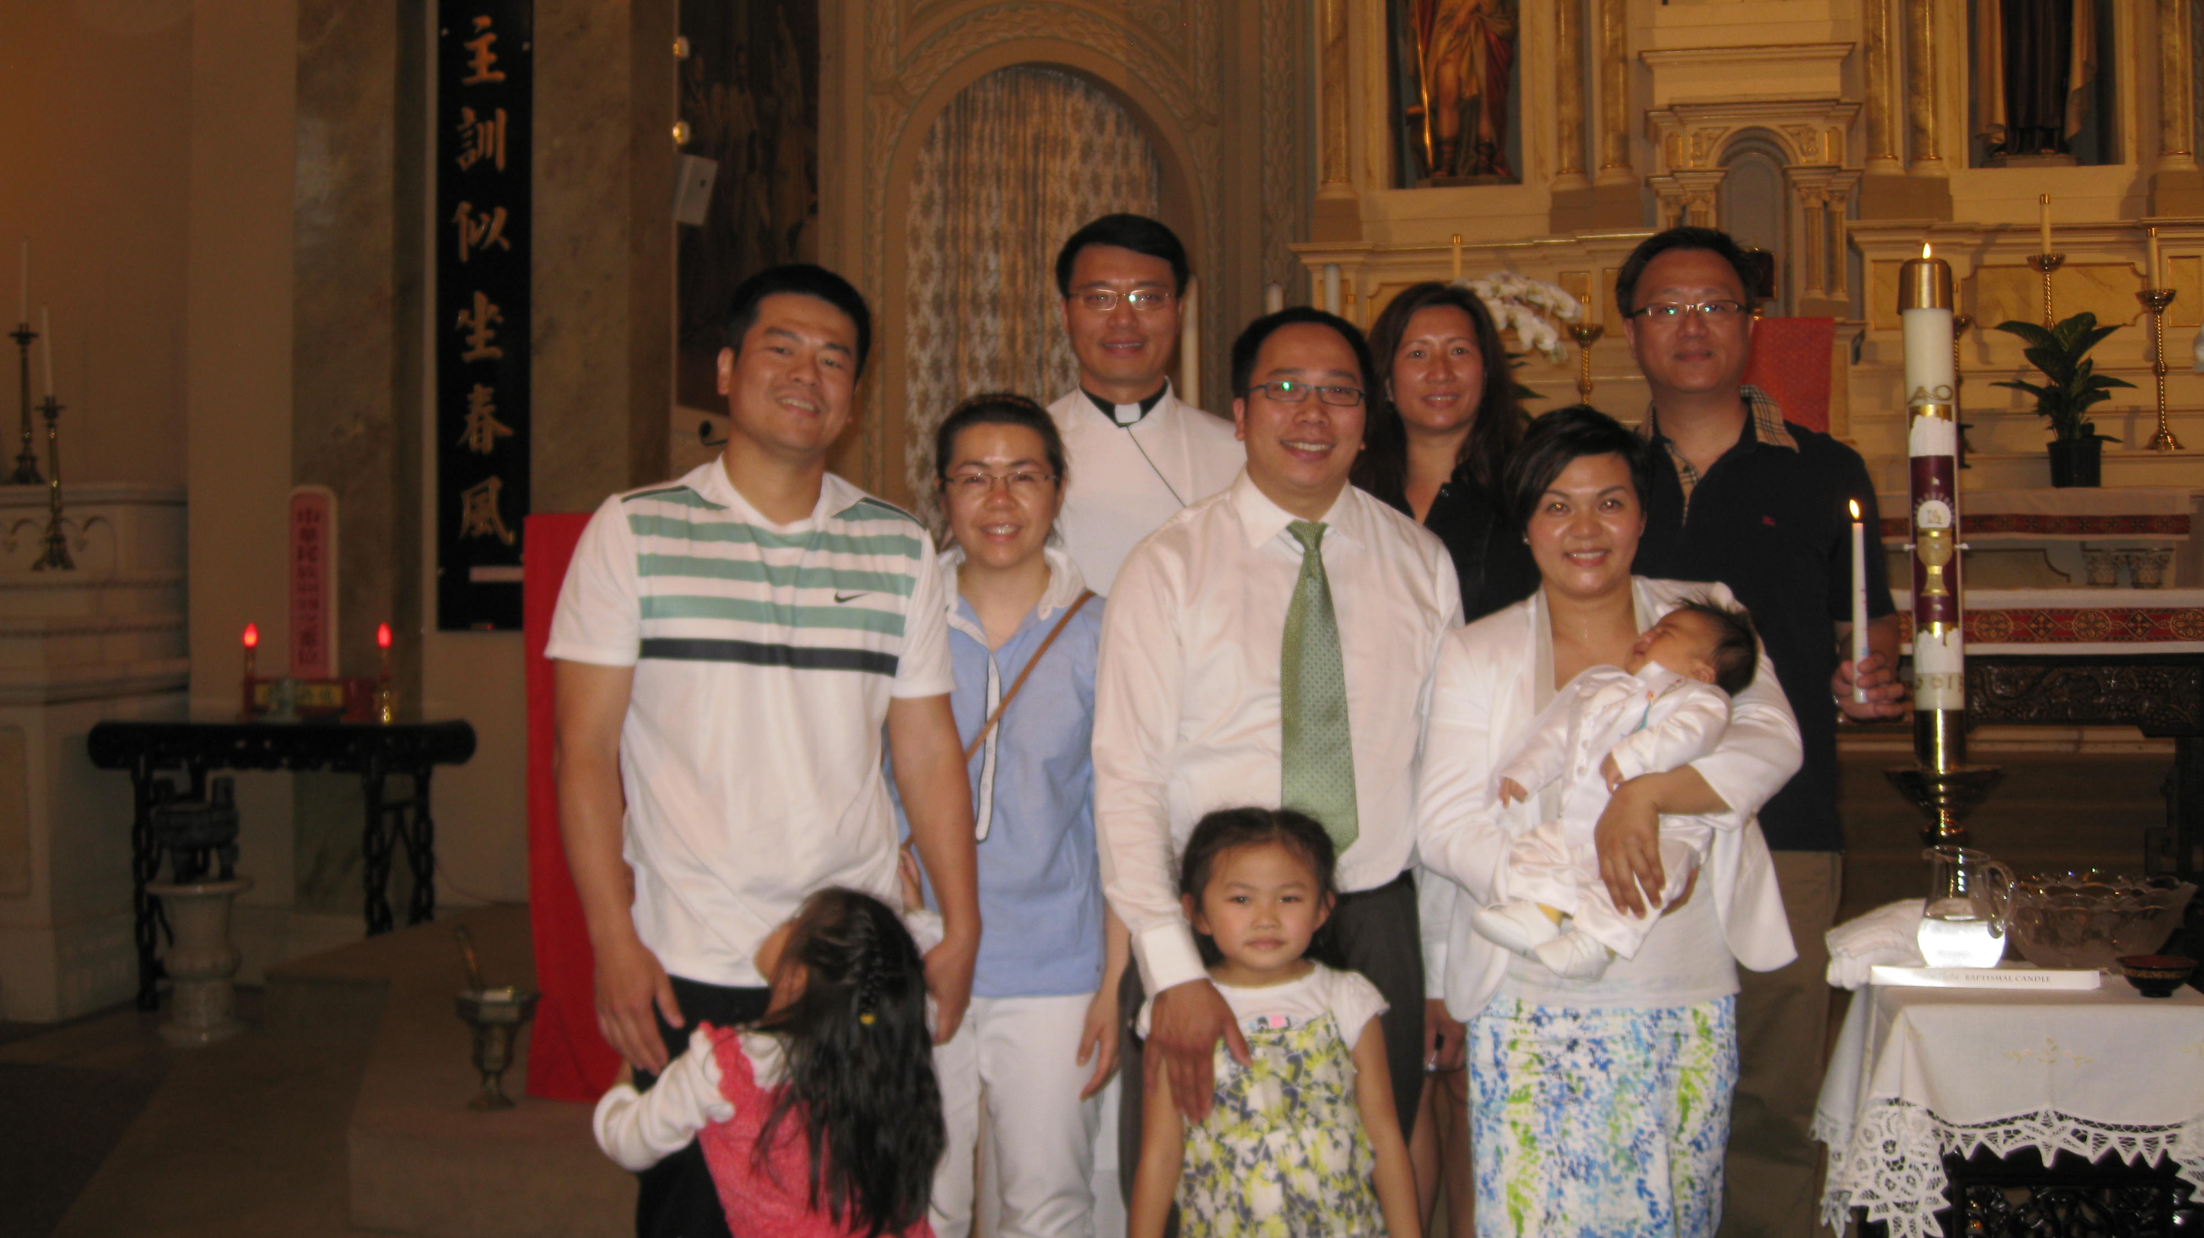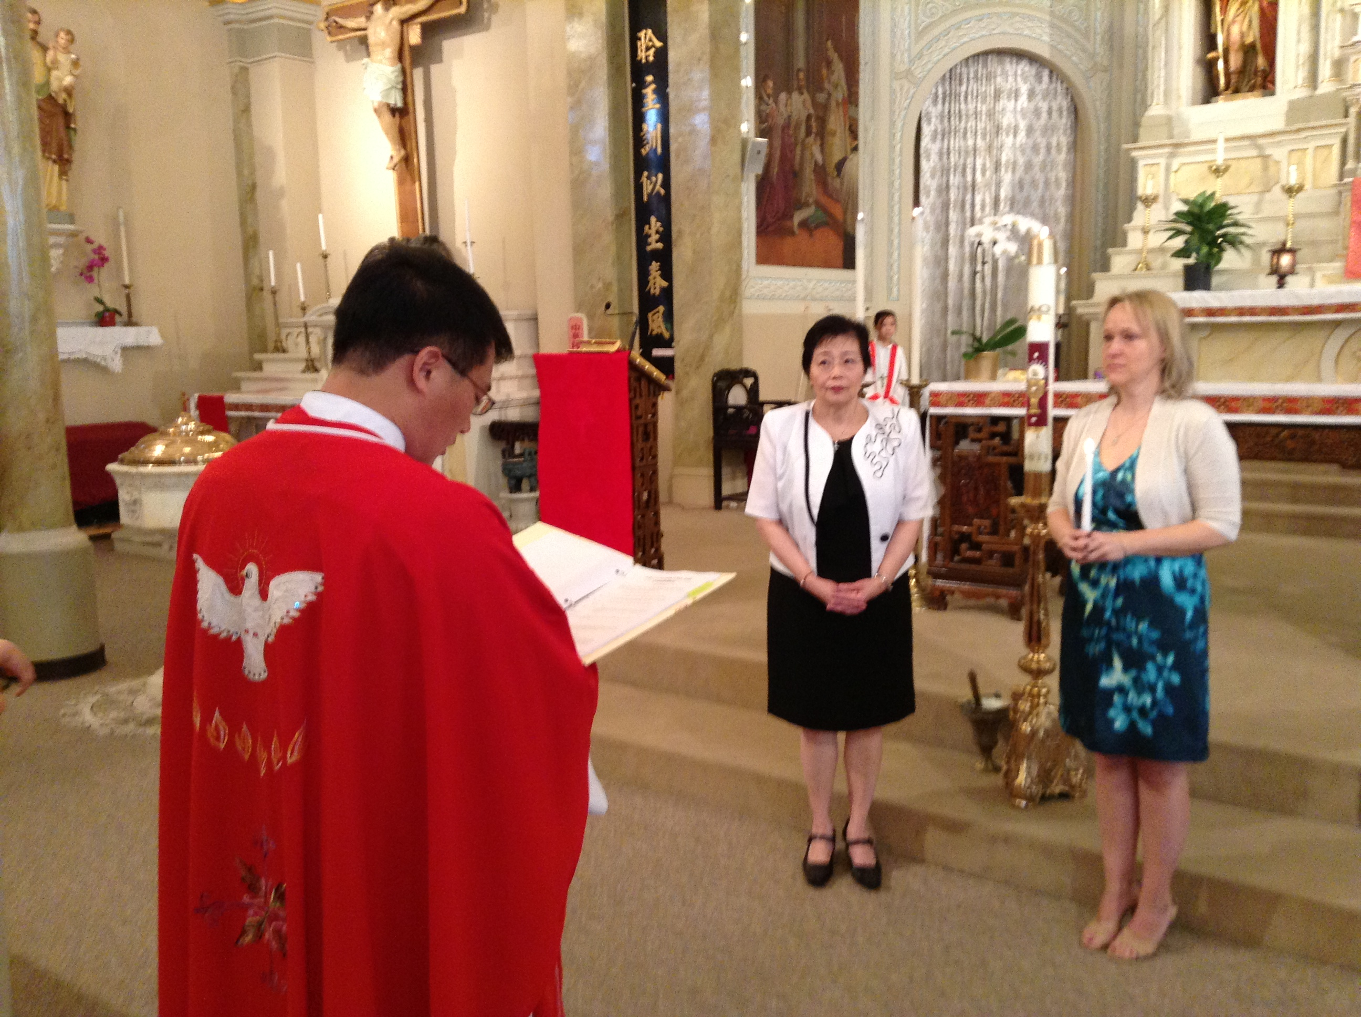

Congratulations to Maureen McDonald (*left photo*) who was received into Full Communion with the Catholic Church as well as celebrated her First Communion last Sunday, and to Marcus Zexi Lin, son of Tony Lin and Sharon Wong, who was baptized last Sunday. We welcome both Maureen and Marcus and assure them of our prayers.

 Congratulations to our Confirmandis! As their faith is strengthened by the outpouring of the gifts of the Holy Spirit, we rejoice with them and renew our faith in the Lord.

We welcome Bishop Andrew Wypych as he visits our parish for the first time as an axillary Bishop of the Archdiocese of Chicago. We thank him for celebrating the Sacrament of Confirmation for our children today.

***The Solemnity of the Most Holy Trinity***

Today we celebrate the mystery of the Godhead as three persons in one nature- the ***Most Holy Trinity***. As humans, we know that we can’t fully understand our God, yet we desire to know more about our God. The old saying of St. Augustine is very true: *our hearts are restless until we rest in God.*

One of the most common ways for us to know more about our God is through prayers. The expression, ***Lex orandi, lex credendi*** - "the law of prayer is the law of belief," refers to the interrelatedness of worship and belief. When we make the sign of the cross, we profess our faith in the Trinity. When we pray the Creed, we affirm our beliefs in God.

Our prayers can help us to know better about our God. This is one of the reasons why it is very important for us to participate actively, fully and consciously at Mass. Last Saturday, many of you attended the workshop titled ***Basics On Catholic Worship.*** Todd Williamson, Director of the Office for Divine Worship, spoke passionately at the workshop on the necessity of participation at mass. He referred to *The Constitution on the Sacred Liturgy*, which I quote in its length for your reflection.

“**The Church, therefore, earnestly desires that Christ’s faithful when present at this mystery of faith, should not be there as strangers or silent spectators. On the contrary, through a good understanding of the rites and prayers they should take part in the sacred action, conscious of what they are doing, with devotion and full collaboration. They should be instructed by God’s word, and be nourished at the table of the Lord’s body. They should give thanks to God. Offering the immaculate victim, not only through the hands of the priest but also together with him, they should learn to offer themselves**.” (#48)

***~Peace, Fr. Francis***

***Hospitality Schedule for June 2, 2013***

**GREETERS: Carl DiFranco, Janet Fecteau, Gemma Wong**

**RECEPTION VOLUNTEERS: Jean Wong, Raymond**

**♪♫ Choir Corner ♪♫**

**May 26, 2013– The Most Holy Trinity - *Confirmation* - Guitar Mass**

**PROCESSIONAL: #475 – COME, NOW ALMIGHTY KING**

***Anointing Song:* # 676 – You Have Anointed Me**

**OFFERTORY: #700 – THE SUMMONS**

**COMMUNION: # 828 – I AM THE BREAD OF LIFE**

**RECESSIONAL: #474 – HOLY, HOLY, HOLY! LORD GOD ALMIGHTY**

***Year of Sunday Mass***

***Marriage and the Supreme Court***

***Good News! / dear Padre***

***News and Events***

**Confirmation** We are happy to welcome The Most Reverend Bishop Andrew P. Wypych, presiding today at the 9:30am Mass. Congratulations to all of our Confirmandi! Please continue to pray for them.

**Baccalaureate Mass** for St. Therese graduates will be on Friday, May 31st at 1pm.

**Graduation** Next Sunday, June 2nd at 1pm St. Therese School’s graduation ceremony takes place in the church. Congratulations and best wishes to the Class of 2013!

**The Most Holy Body and Blood of Christ**

**On June 2nd** In celebration of the Most Holy Body and Blood of Christ, if weather permits, a short procession with the Blessed Host will take place from our Church to our Prayer Garden immediately after the 9:30am Mass and then we will end the procession with benediction in the garden.

**Planning Masses**—If you would like your family to participate in the **July** planning Mass, please contact Sr. Caritas.

**St. Therese College Scholarship Fund Application**

Through the generosity of an Alumnus of St. Therese School, we have been able to award scholarship grants since year 2001 to help young people advance their studies. The donor of this scholarship fund, who wants to remain anonymous, grew up in Chinatown during the 1950s and was helped by the Catholic Church. After achieving professional and financial success in his life, in year 2000, he made a significant donation to set up this scholarship fund to help others at St. Therese, especially those who have demonstrated a spirit of sharing and service.

The Scholarship Application Form with criteria is available at the church entrance table. Service at St. Therese Church is a requirement. ***Deadline for submission of the application and supporting documents: June 10, 2013.***

**The Twenty-Eighth Annual Interfaith**

**Memorial Observance for Indigent Persons– Wednesday, May 29, 2013—Noon**

The Office for Ecumenical and Interreligious Affairs, Archdiocese of Chicago, invite you to join a celebration of life - commemorating the lives of people buried by the Office of Cook County Medical Examiner. This is an opportunity for our community to act as a “surrogate family” to people who were buried without family or friends to mark their passing. In some instances, their identity was known only to God. Service held at **First United Methodist Church—Chicago Temple**, 77 W. Washington Street, Chicago. Reception following service. For more info: httw://www.archchicago.org/departments/ecumenical/

**Walk and Pray in Solidarity** For Compassionate, Comprehensive and Just Immigration Reform with Cardinal George. **Prayer Vigil Thursday, May 30, 2013 from 7:30-9:00pm,** at Holy Family Church, 1080 W. Roosevelt, Chicago. **\***Enjoy a diversity of worship music. **\***Process with ethnic images of Mary. **\***Present commitments from all over the Archdiocese.

**St. James Food Pantry** We will once again support St. James Food Pantry. Please consider volunteering. We need about 10 adult helpers. Date to be determined and you may sign up next week at the church entrance table. Your help is appreciated!

**Free Bible** We thank the CityOf.com for donating 100 copies of Bibles to our parish. If you need a Catholic version of the Bible, please pick up a copy after mass today.

**Summer Fair 2013 Volunteers Needed!**

This year’s Summer Fair will be held on Sunday, July 21st. **REMINDER: Please sign up at the church entrance table if you have not already done so. We need YOUR help! Thank YOU!**

**\*\*\*\*\*\*\* Faith and Charity \*\*\*\*\*\*\***

In his Holiness, Benedict XVI’s Lenten message: “The celebration of Lent, in the context of the Year of Faith, offers us a valuable opportunity to meditate on the relationship between faith and charity … The Christian life consists in continuously scaling the mountain to meet God and then coming back down, bearing the love and strength drawn from him, so as to serve our brothers and sisters with God’s own love … In the Church, contemplation and action, symbolized in some way by the Gospel figures of Mary and Martha, have to coexist and complement each other.”

**Please join us, as a faith community, to set aside an hour once a month to offer it in silent meditation before the Blessed Sacrament & to pray together the Chaplet of Divine Mercy.**

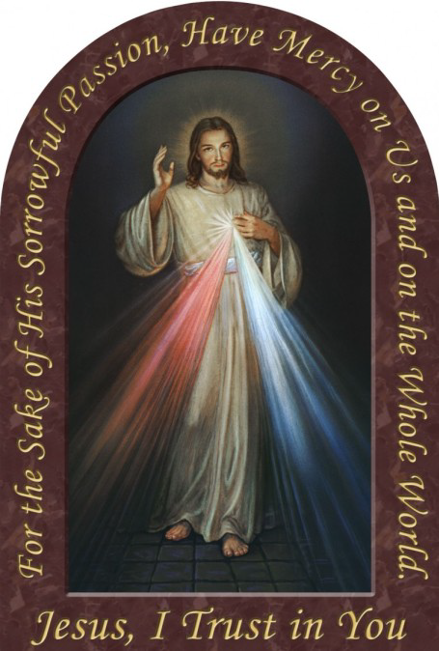

**First Friday of Each Month**

(Starts June 7, 2013)

7:00pm— 8:00pm

**Eucharistic Adoration**

**The Chaplet of Divine Mercy**

**Silent Meditation**

**Benediction**

**The fruit of Silence is prayer. The fruit of Prayer is faith. The fruit of Faith is love. The fruit of Love is service. The fruit of Service is peace.**

**~*Mother Teresa***

***Landings* ~ ST. THERESE CHURCH WANTS TO HELP!**

St. Therese Chinese Catholic Church is a Landings parish. Landings was started by Paulist Fathers to help non-practicing Catholics explore their faith and return to the Church in a nonthreatening way. It is a way to share, to be heard and to listen to faith journeys of a group of inactive & active Catholics. All this is conducted with compassionate listening and utmost confidentiality. If you are ready to consider returning to the Church, we are here to give you a helping hand and ensure your safe landing!

We offer sessions in English, Cantonese and Mandarin. For more information please contact either Sr. Anji Fan or Cita Orendain at our parish office: 312-842-6777 or email us at:

[landingsatsttherese@gmail.com](mailto:landingsatsttherese@gmail.com)

**Weekly Offering:**

Collection for May 19, 2013

Sunday Envelopes $1,512

Sunday Loose $ 512 July 1-To-Present (Actual): $92,605 Total Collection $2,024 July1-To -Present (Budget): $92,000

Weekly Budget: $2,000 % of Budget Attained: 100%

Please consider giving one hour of your weekly salary as your contribution.

***May God bless your generosity! Thank YOU!***

**Please remember in your prayers those who are**

**ill, hospitalized, and homebound...**

Sarah Phillips Marie Balestri Carmella Scanlon

Natasha Chang Lucille Iasillo Carmen (Rails) Balestri

Dominic Barbaro Winnie So Vincent Thome

Barbara McElroy Ken Barber Rose Perez

Ramona Zavala Lauren Mandel Nicholas Tobar

Michael Howley YoYo Damico Ruth Barone

Bernie Presto Baby Jessa Piotrowski Dolly Roti

Lina Andriacchi Fr. Walter Johnson, MM Sister Noel Devine

Su Zhen Liao John Galvin Wu Wai Hing

Sister Elizabeth Lee Barbara Maung Lan Ying Yee

Shirley A. Bills Roseann Gurgone Frank Nardi

John Palenik Alice Young Leonard Louie

David Leung John Piegari James Longo III

Bai Xue *Sister Agnes Christina* Jane Lee

*Richard Tobar* Mary Balestri Joyce Eng

Betsy Young

If you wish to add a name or remove your name from this list, please call the parish office.

**‘The Gift of the Spirit ~ CONFIRMATION ’**

We pray and celebrate the **Sacrament of Confirmation** today. It is the last of the sacraments of initiation. It completes our Baptism and activates and fills us more completely with *the Gifts of the Holy Spirit*. We received these gifts at Baptism. With the reception of this sacrament, the actions of the Holy Spirit, through these seven gifts, are more alive in us.

In the Trinitarian Mystery, whose feast we celebrate today, God the Holy Spirit is more difficult to grasp and understand. The sequence from the Mass of Pentecost gives us some insight The Spirit is addressed as Father of the poor. Perhaps this is because the inspiration to care for the poor, modeled after Jesus, is one of the calls and encouragements of the Spirit. The Spirit helps people to use what they have to help the poor and needy among us. The Spirit is called the Comforter and “sweet refreshment”. The Spirit’s support and presence with us, helps renew and strengthen us. He gives us solace in our times of trouble. The Spirit enlightens us as we search, melts our stubborn “heart and will.” He helps us stay on the correct road morally, and helps us grow in holiness. If we have peace and joy in an action or situation, we know the Holy Spirit is acting.

As we celebrate the sacrament of Confirmation we remember we are given the fullness of the Holy Spirit just as the Apostles were on the first Pentecost as described in the Acts of the Apostles in Scripture. We know God the Father sent the Holy Spirit and we believe the promise of the Son, that the Holy Spirit would/does come. We know the **Holy Spirit is the LOVE of God the Father and the Son**, poured out and given to us. **We celebrate and GIVE THANKS**.

**~Sr. Caritas**

Church Stained Glass Window Repair Update

The entire exterior work for our church window repair and broken stained glasses have completed. Unfortunately, this is not the end of the project. We need to replace a few of the moon-shaped top window frames on the inside. The additional work on the inside window frames, brings the estimated total cost of this project to $55,000. The next phase of this work will begin in May 2013. **We need your support for this project.  If you would like to make any donations, please mark your contributions with “*Window Repairs*.” *Thank you to all who have already made a donation:***

***Paul &Cindy Lau: $2000* Francine Caruso: $100**

***James &Akina Moy: $1000* Bonnie Tse: $100**

***Dan & Pam Spano: $250* Kevin Wu (Sweet Station): $100**

***Shu Man & Florence Yu: $300* Frank S. Scuito: $100**

***Chris & Darlene Lowe: $500* Peter Blais: $50**

***N. N.: $200* Teresa Au: $50**

***N. N.: $100* Phyllis & Rose Marie Centofanti: $100**

***Sacred Heart Ladies Club: $1000* Wendy Fluder: $100**

***The May Family: $2105* Frank & Sophie Nardi: $500**

***Betsy Young & Woodie Lee: $50* Dominic Barbaro: $200**

***Wanda Stearns: $50* Richard & Rita Young: $200**

***Lucille Salerno: $100* Edy & Lisa Gunawan: $100**

***Santa Maria Incoronata : $ 1000* Annie Lowe: $100**

***Albert & Bernie Wong: $200* Menacita Chan: $100**

***Rose Cho: $2000* Gemma Wong: $200**

***Dominic Lai: $380* Jennifer Chan & Jorge Morales: $50**

***Robert Lee: $10* Tony Lin & Sharon Wong: $355**

***Larry A. Pusateri : $500* Wendy Sin: $500**

***Eugene & Geraldine Kwan: $100* The Tse Family : $53**

***Gene & Teresa Lee: $200* Renee & George Fong: $53**

***Gary & Linda Leong: $200* The Urso Family: $500**

***Wesley & Sharon Wong: $100* Gertrude Chan: $50**

***Sandra Moy: $100* Leonard & Elaine Louie: $1900**

***Sharon Yu: $1000* Joseph and Natia DiFazio: $100**

***Ray Lin (The Lin Family): $500* Lucille Salerno: $500**

**Mr. & Mrs. William Moy: $50 Joseph & Bernadette Zito: $100**

**Andrew & Eva Feng: $1900 Michael & Sevila Schiml: $150**

**Fr. Francis Li: $100 Mr. & Mrs. Francis Degnan: $75**

**Amy C. Floyd: $200 Mr. & Mrs. Vincent Briglio: $100**

**Karen L. Zewe: $50 Mr. & Mrs. John Lusak: $1000**

**Peter Tse: $100 Agustin & Donna Gonzalez: $200**

**Joe & Margaret Cabello: $100 Josie Lia Kawazoye: $50**

**Tony & Mary Ann Nudo: $100 Sonny Spalla: $200**

**Janet & Albert Moy: $300 Dorothy Albanese: $100**

**Janet Fecteau & Al DiFranco: $50 Mr. & Mrs. Chuck Oi: $1000**

**Marion B. Roti: $100 Theresa Scopacasa and Jane Pivac: $100**

**Monica Lam: $100 Antoinette Choate & John Tangren: $1000**

**Caecilia Payton: $60 Felicia Kristanto: $200**

**Teresa Au: $50 The Family of Michele Morelli: $1000**

**Nick & Ellen Andriacchi: $200 (Fred M. Morelli, Mary Morelli Lusak,**

**Jennifer M. DiFazio: $50 Madeleine Morelli Donnelly, Fred M. Morelli,**

**N.N.: $30 Jr., Marilyn Morelli, Katherine Morelli,**

**Agnes Lee: $50 Michael D. Morelli)**

**Joseph V. DiFazio: $100 Nancy Longmire: $250**

**Teresa Moy: $100 Harry W. & Mary L. Tong: $2092**

**Lucy Setlack: $100 Stephen Delia & Melissa Perez: $100**

**Frank & Sheila Bertucci: $500 Lucy Wong (in Memory of Mother Yuke Sang**

**N.N.: $300 Chan-Cheng): $100**

**Linda & Michele Young: $224 N.N.: $1000**

**Marie Panozzo, Catherine Gurgone, Mary Capecci: $50 James & Maryann Distasio: $200**

**Ana Juan: $20**

**Kien & Agnes Chai: $100**

**BULLETIN TOTAL AS OF 05/22/13: $34,207**

**A plaque of remembrance will be placed in the church in gratitude to all the donors at the end of the project. *If you would like to have your name listed differently as shown from above, please contact the parish office at 312-842-6777.**