**Fifth Sunday of Easter**

**April 28, 2013**

**St. Therese Chinese Catholic Church and School**

**Archdiocesan Center for Chinese Apostolate**

**聖德力華人天主教堂**

218 W. Alexander, Chicago, Illinois 60616 ∙ (312) 842-6777 Fax (312) 567-1389

StTherese@ArchChicago.org ∙ www.sttheresechinatown.org

**Like Us on Facebook:** [**facebook.com/sttherese**](http://facebook.com/sttherese) **Twitter @StThereseChi**

StTherese@ArchChicago.org ∙ www.StThereseChinatown.org

**\*\*\*\*\*\*\* Faith and Charity \*\*\*\*\*\*\***

In his Holiness, Benedict XVI’s Lenten message: “The celebration of Lent, in the context of the Year of Faith, offers us a valuable opportunity to meditate on the relationship between faith and charity … The Christian life consists in continuously scaling the mountain to meet God and then coming back down, bearing the love and strength drawn from him, so as to serve our brothers and sisters with God’s own love … In the Church, contemplation and action, symbolized in some way by the Gospel figures of Mary and Martha, have to coexist and complement each other.”

**Please join us, as a faith community, to set aside an hour once a month, to offer it in silent meditation before the Blessed Sacrament, and to pray together— the Chaplet of Divine Mercy.**

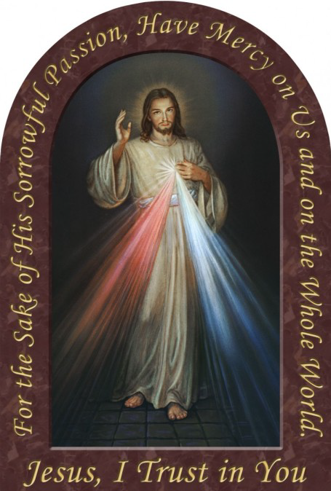

**First Friday of Each Month**



(Starts June 7, 2013)

7:00pm— 8:00pm

**Eucharistic Adoration**

**The Chaplet of Divine Mercy**

**Silent Meditation**

**Benediction**

**The fruit of Silence is prayer. The fruit of Prayer is faith. The fruit**

**of Faith is love. The fruit of Love is service. The fruit of Service is peace.**

**~*Mother Teresa***

***Landings* ~ ST. THERESE CHURCH WANTS TO HELP!**

St. Therese Chinese Catholic Church is a Landings parish. Landings was started by Paulist Fathers to help non-practicing Catholics explore their faith and return to the Church in a nonthreatening way. It is a way to share, to be heard and to listen to faith journeys of a group of inactive and active Catholics. All this is conducted with compassionate listening and utmost confidentiality. If you are ready to consider returning to the Church, we are here to give you a helping hand and ensure your safe landing!

Our spring sessions of 1½ hours a week for 8 to 10 weeks will start on Thursday, May 16th at 6:30pm in the St. Francis Assisi room at our church, located at 218 W. Alexander St., Chicago IL 60616. We offer sessions in English, Cantonese and Mandarin. For more information please contact either Sr. Anji Fan or Cita Orendain at our parish office: 312-842-6777 or email us at: [landingsatsttherese@gmail.com](mailto:landingsatsttherese@gmail.com)

**Mass Intentions**

***April 28, 2013 Fifth Sunday of Easter***

**8:00A.M.**

**9:30A.M.** + Eric Yun by Lushia and Tim

+ Jorge Lau by daughter Agnes Lee

**11:00A.M. Mandarin Mass**

+ Wang Yue Feng by Yu Jian

***MON. April 29th Saint Catherine of Siena, Virgin and Doctor of the Church***

**8:00A.M.**

***TUE. April 30th Saint Pius V, Pope***

**8:00A.M.** Birthday Blessings for Nicole by Mom Cita

+ Pasquale Salerno by Family

***WED. May 1st Saint Joseph the Worker***

**8:00A.M.** + Gene Pontillo

***THU. May 2nd Saint Athanasius, Bishop and Doctor of the Church***

**8:00A.M.**

***FRI. May 3rd Saints Philip and James, Apostles***

**8:00A.M.** In Honor of the Sacred Heart of Jesus

+ Catherine Gurgone by daughter

+ Josephine Parrilli by Lucille Salerno

***SAT. May 4th Easter Weekday***

**8:00A.M.**  In Honor of the Immaculate Heart of Mary

**5:00P.M.** Friends and Parishioners of St. Therese

+ Jennie Bertucci by Briglio Family

***From the Desk of Fr. Francis***

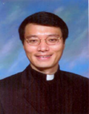

**Greetings of Christ’s Peace and Joy! Hope you all had a blessed week.**

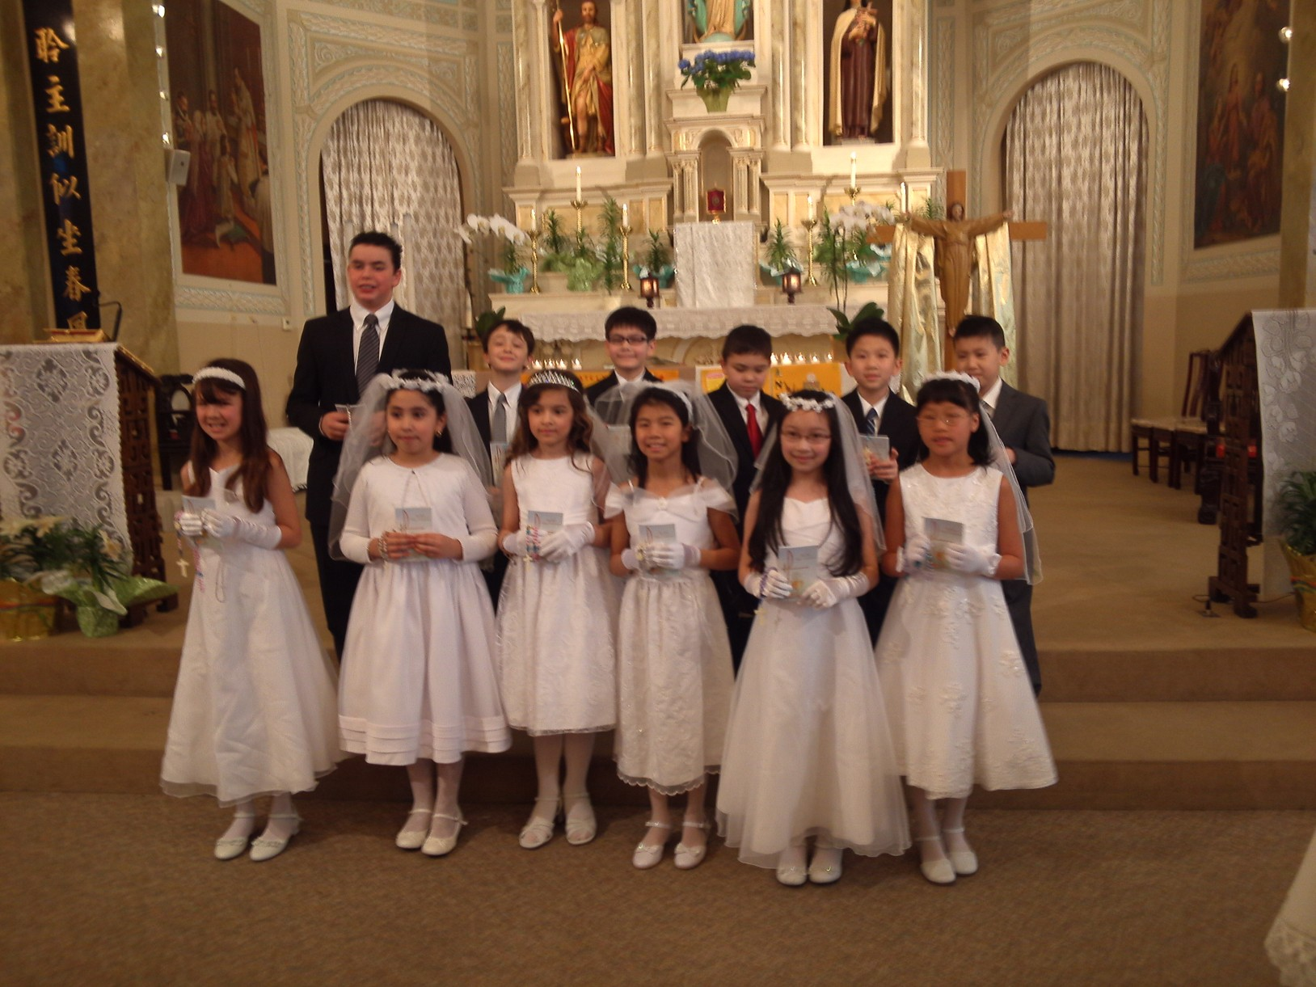

**Congratulations and Thank You**

Congratulations to all of our First Communicants! Twelve of our CCD and school children received their First Communion last Sunday. This was one of the largest groups for our parish and school. It was wonderful to see so many families and friends of the First Communicants who joined us for this special celebration.

Thanks to their teachers and catechists for well-preparing our children for the Sacrament of Eucharist. Thanks to all families who donated either food or funds toward the reception. Very special thanks to our cooks who spent hours and hours to prepare food for us, and to those

(Photo courtesy of Darlene Chan-Lowe) who helped to decorate and clean-up. Your hard-work made our

celebration so prayerful and enjoyable.

**Love One Another!**

How many times have we heard these words? Yet every time we hear them, we are refreshed and challenged. These three words are at the heart of Jesus’ mission and of our discipleship. These three words are the focal point of today’s Gospel reading. These three words remind me of a short article I read recently by Jean Vanier, a Canadian Catholic and the founder of L’Ache and Faith & Light, two international community-based organizations that embrace and support people with intellectual disabilities, titled: “*Seek out the weak and the excluded*.”

When asked about his expectations for the new Pope, Jean Vanier shared two hopes. First, he thinks “we need to be together to face the drama of our world and build bridges between the haves and have-nots***.” It is through community where we learn to love one another and live the commandment of Jesus***. When we talk about love, we shouldn’t forget the poor. Second, we, the people of God, must learn to be with people with intellectual disabilities. Donating money to help their causes is not enough. We must learn from them and help them to discover their fundamental value. The article ended by saying: “My dream is that we will all become the face of Jesus, weak and humble of heart. My hope for Pope Francis is that he may join us all to make these dreams a reality.”

I believe what Mr. Vanier expressed above is an indispensable element of the new commandment that Jesus gives us in the Gospel. ***Love one another*** demands us to have a heart of love for all people, especially the poor and those who are considered outcast. As disciples, we learn how to love one another from our Master-Jesus Christ. His life, death, resurrection show us the way that we need walk on, the truth that we should seek after, and the life that we must live. The question each one of us has to answer is: ***How do I/we strive to show my/our love toward our brothers and sisters in our daily lives?***

May the Risen Lord deepen our Faith! ***~Peace, Fr. Francis***

***Hospitality Schedule for May 5, 2013***

**♪♫ Choir Corner ♪♫**

**April 28, 2013—5th Sunday of Easter—Guitar Mass**

**PROCESSIONAL: #537—SING A NEW SONG**

**OFFERTORY: #504– I HAVE LOVED YOU**

**COMMUNION: #828– I AM THE BREAD OF LIFE**

**RECESSIONAL: #799– ALIVE IN JESUS CHRIST**

***Year of Sunday Mass***

***News and Events***

**Baptism**

Please pray for Anthony Maggiore, IV, who will be baptized today at 2pm. Anthony is the son of Matthew Maggiore and Martina Spalla,

**Prayer Garden Spring Planting Meeting**

Meeting for all prayer garden members today after the 9:30am Mass in the garden.

**MAY CROWNING**

On Wednesday, May 1st, Mass at 1pm by our school children.

On Sunday, May 5th, Mass at 11:30am by Santa Maria Incoronata Club.

**Mother’s Day Breakfast**

Breakfast for the Moms of our parish will be hosted by the men of St. Therese on Sunday, May 12th after the 9:30am Mass. If you can help out with the prep work, cooking and serving, or would like to make a donation, please see George Lee.

**Summer Fair 2013 Planning Committee Members & Volunteers Needed!**

This year’s Summer Fair will be held on Sunday, July 21st. Our first planning meeting will be held next **Sunday, May 5th at 11am** in the Santa Maria Room, and we’d love to include anyone interested with helping to organize this year’s upcoming event. Sign up sheets for the planning committee and event day volunteers are on the ‘events’ table at the entrance of the church, so please sign up today! **We need YOUR help! Thanks!**

**MINISTRY OF CARE***—We need Ministers of Care to bring the Eucharist to hospitalized and homebound parishioners. If you are trained or would like to be trained in this Ministry, please contact Fr. Li or Sr. Caritas.*

**Planning Masses**—If you would like your family to participate in the June planning Mass, please contact Sr. Caritas.

**Safety Service Systems, Inc.—Part time job opportunities.** **S3, Inc.,** Chicago’s premier event security and event staffing provider is seeking energetic and outgoing individuals to work as Event Security, Event Staff and Ushers. Our employees work concerts, festivals and sporting events. Some of the 2013 events are Chicago Bears games, Bon Jovi, Illini Football, Jason Aldean/Kelly Clarkson, Justin Timberlake/JayZ, Pearl Jam, Taylor Swift, North Coast Music Festival, Pitchfork Music Festival, Lollapalooza Music Festival, Riot Fest and many more!

EVENT SECURITY: Minimum 18 years of age, Active PERC and 20 hour training. Flexible scheduling, primarily weekends and nights.

EVENT STAFFER/USHER: Minimum 16 years of age. Flexible scheduling, primarily weekends and nights. Work is part time seasonal, ideal as a 2nd job and for students, senior citizens.

Apply in person at **S3, Inc**., 4036 N. Nashville Avenue, Chicago. Mon-Fri: 9am-4pm or Sat: 10am-2pm, or call 773-494-8616 for more info. www.safetyservicesystems.com

**St. Therese College Scholarship Fund Application**

Through the generosity of an Alumnus of St. Therese School, we have been able to award scholarship grants since year 2001 to help young people advance their studies. The donor of this scholarship fund, who wants to remain anonymous, grew up in Chinatown during the 1950s and was helped by the Catholic Church. After achieving professional and financial success in his life, in year 2000, he made a significant donation to set up this scholarship fund to help others at St. Therese, especially those who have demonstrated a spirit of sharing and service.

The Scholarship Application Form with further criteria is available at the church entrance table. Service at St. Therese Church is a requirement. ***Deadline for submission of the application and supporting documents: June 10, 2013.***

**Easter Donations Update**

Judy Moy: $20 Mei Fung Yong: $30

**Total as of 4/24/13: $15,436 THANK YOU!**

BASICS ON CATHOLIC WORSHIP



**BASICS ON CATHOLIC WORSHIP** is a 4-hour seminar designed for Asian leaders and members of liturgy committees involved in planning liturgical celebrations for their parishes or their Asian communities. Those who are interested in learning or having a refresher on the Basics on Catholic Worship are also invited to attend. The mix of Asian representatives from the diverse Asian communities will create an opportunity for a rich dialogue on the different Asian perspectives and practices.

Liturgy, we say, is the source and the summit of our Christian lives. This means that nothing we do as a parish community is as important as gathering for the Sunday Mass. All other ministries and services which the parish provides flows out of and back to the parish’s Sunday celebration of the Eucharist.

The first session of this workshop will explore the four main parts of the Mass (Introductory Rites, Liturgy of the Word, Liturgy of the Eucharist and the Concluding Rite). We will examine what the Liturgy calls for in each part and what we believe God does in each of the 4 parts.

The second session will then look at the issues and concerns that surround preparing and planning for the celebration of the Liturgy.

The afternoon will conclude with the celebration of Mass, joining the communities of St. Therese and St. Henry.

**Faculty:** Todd Williamson, Director, Office for Divine Worship

**1st Series:**

**Date:** Saturday, May 18, 2013; **Time:** 12-4pm; **Vigil Mass:** 5:00pm

**Venue:** St. Therese Chinese Catholic Church, 218 W. Alexander Street, Chicago, IL 60616

**(Repeat): 2nd Series:**

**Date:** Saturday, June 1, 2013; **Time:** 11:30-3:30pm; **Vigil Mass:** 4:00pm

**Venue:** St. Henry Parish, 6335 N. Hoyne, Chicago, IL 60659, Phone: 773-764-7413

**Registration Fee** is $5:00 (will cover expenses for handouts). ***Fee will be waived for the first 20 people who register*** ***from our parish.*** If you are interested, please fill out a Registration Form which can be found on the table at the church entrance. Please return your registration form to St. Therese parish office as soon as possible. Thank You!

**\*Co-sponsored by the Office for Asian Catholics and the Office for Divine Worship in collaboration with the parishes of St. Therese Chinese Catholic Church and St. Henry’s Parish.**

***Good News! / dear Padre***

*First Holy Communion Reception*

*April 21, 2013*

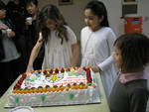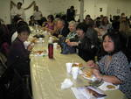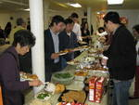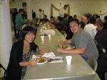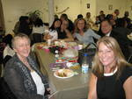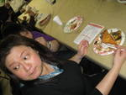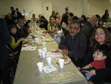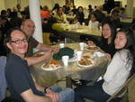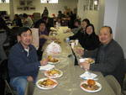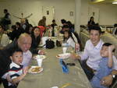

**Weekly Offering:**

Collection for April 21, 2013

Sunday Envelopes $1,514

Sunday Loose $ 512 July 1-To-Present (Actual): $84,477 Total Collection $2,026 July1-To -Present (Budget): $84,000

Weekly Budget: $2,000 % of Budget Attained: 100%

Please consider giving one hour of your weekly salary as your contribution.

***May God bless your generosity! Thank YOU!***

**Indonesian Mass of April 14, 2013: $75.00 Thank YOU!**

**Please remember in your prayers those who are**

**ill, hospitalized, and homebound...**

Sarah Phillips Marie Balestri Carmella Scanlon

Natasha Chang Lucille Iasillo Carmen (Rails) Balestri

Dominic Barbaro Winnie So Vincent Thome

Barbara McElroy Ken Barber Rose Perez

Ramona Zavala Lauren Mandel Nicholas Tobar

Michael Howley YoYo Damico Ruth Barone

Bernie Presto Baby Jessa Piotrowski Dolly Roti

Lina Andriacchi Fr. Walter Johnson, MM Sister Noel Devine

Su Zhen Liao John Galvin Wu Wai Hing

Sister Elizabeth Lee Barbara Maung Lan Ying Yee

Shirley A. Bills Roseann Gurgone Frank Nardi

John Palenik Alice Young Leonard Louie

David Leung John Piegari James Longo III

Bai Xue *Sister Agnes Christina* Jane Lee

*Richard Tobar* Joseph LeungPam Ecklund

Betsy Young Mary Balestri

If you wish to add a name or remove your name from this list, please call the parish office.

**Something ALIVE and NEW!**

When I first came to St. Therese about two years ago, I discovered that Chinatown had expanded beyond 26th street. When I attend another church in the area that is west of St. Therese, I was surprised to see residents of the area were Chinese. I was also aware of the housing and development of stores and other businesses in Chinatown Square. Many of those things were not developed when I had been teaching at Santa Lucia, a number of years ago. It was all new.

As a Catholic faith community, we are called and challenged to continue to respond to the Holy Spirit’s urging to renew our parish community. **WE** know we are a vibrant faith community. The challenge is to reach out, to go beyond our Church doors, to help others in the area to experience our welcome, friendliness, and care. We are called to invite others and make them welcome when they come to share worship and food with us. We need to reach out to *St. James’ Food Pantry* which is servicing many Chinese families. They need our help to translate, to help package and distribute the food. Inviting family members or friends or others to participate in the *Landings* program is an important way to renew our parish. Perhaps some people will continue to participate with us. Do you know people who might want to become Catholic? Invite them now. Our parish family will grow. We will respond to the urging of the Spirit TO BE NEW.

The last sentence of the second reading tells us, “BEHOLD, I MAKE ALL THINGS NEW.” Jesus tells us His special commandment, “***Love one another as I have loved you***.” This is a call to personal renewal. It is also a call to parish renewal. ***He tells us others will know we are His disciples if we* LOVE**. The witness of this love needs to go out to the community as well. People will come to know **we are here**! (Some people do not know there is a Catholic Church in Chinatown.) By our caring and compassionate love for each other and others, we will let people know that St. Therese is an ALIVE place, not an old Church building or museum. They will more fully come to know that God, through Jesus, in the Holy Spirit is doing “SOMETHING NEW” at St. Therese. Each of us is invited and called to be part of this process. What are you going to do? What can we do? ***It’s “NEWNESS TIME”!*  ~Sr. Caritas**

Church Stained Glass Window Repair Update

The entire exterior work for our church window repair and broken stained glasses have completed. Unfortunately, this is not the end of the project. As with fixing up any old windows, there is a higher chance of surprise. It’s now been confirmed that we need to replace a few of the moon-shaped top window frames on the inside. With the additional work on the inside window frames, our estimated total cost of this project is now $55,000. We expect to begin the next phase of this work in April 2013. **We need your support for this project.  If you would like to make any donations, please mark your contributions with “*Window Repairs*.” *Thank you to all who have already made a donation:***

***Paul &Cindy Lau: $2000* Francine Caruso: $100**

***James &Akina Moy: $1000* Bonnie Tse: $100**

***Dan & Pam Spano: $220* Kevin Wu (Sweet Station): $100**

***Shu Man & Florence Yu: $300* Frank S. Scuito: $100**

***Chris & Darlene Lowe: $500* Peter Blais: $50**

***N. N.: $200* Teresa Au: $50**

***N. N.: $100* Phyllis & Rose Marie Centofanti: $100**

***Sacred Heart Ladies Club: $1000* Wendy Fluder: $100**

***The May Family: $2105* Frank & Sophie Nardi: $500**

***Betsy Young & Woodie Lee: $50* Dominic Barbaro: $200**

***Wanda Stearns: $50* Richard & Rita Young: $200**

***Lucille Salerno: $100* Edy & Lisa Gunawan: $100**

***Santa Maria Incoronata : $ 1000* Annie Lowe: $100**

***Albert & Bernie Wong: $200* Menacita Chan: $100**

***Rose Cho: $2000* Gemma Wong: $200**

***Dominic Lai: $380* Jennifer Chan & Jorge Morales: $50**

***Robert Lee: $10* Tony Lin & Sharon Wong: $355**

***Larry A. Pusateri : $500* Wendy Sin: $500**

***Eugene & Geraldine Kwan: $100* The Tse Family : $53**

***Gene & Teresa Lee: $200* Renee & George Fong: $53**

***Gary & Linda Leong: $200* The Urso Family: $500**

***Wesley & Sharon Wong: $100* Gertrude Chan: $50**

***Sandra Moy: $100* Leonard & Elaine Louie: $1900**

***Sharon Yu: $1000* Joseph and Natia DiFazio: $100**

***Ray Lin (The Lin Family): $500* Lucille Salerno: $500**

**Mr. & Mrs. William Moy: $50 Joseph & Bernadette Zito: $100**

**Andrew & Eva Feng: $1900 Michael & Sevila Schiml: $150**

**Fr. Francis Li: $100 Mr. & Mrs. Francis Degnan: $75**

**Amy C. Floyd: $200 Mr. & Mrs. Vincent Briglio: $100**

**Karen L. Zewe: $50 Mr. & Mrs. John Lusak: $1000**

**Peter Tse: $100 Agustin & Donna Gonzalez: $200**

**Joe & Margaret Cabello: $100 Josie Lia Kawazoye: $50**

**Tony & Mary Ann Nudo: $100 Sonny Spalla: $200**

**Janet & Albert Moy: $300 Dorothy Albanese: $100**

**Janet Fecteau & Al DiFranco: $50 Mr. & Mrs. Chuck Oi: $1000**

**Marion B. Roti: $100 Theresa Scopacasa and Jane Pivac: $100**

**Monica Lam: $100 Antoinette Choate & John Tangren: $1000**

**Caecilia Payton: $60 Felicia Kristanto: $200**

**Teresa Au: $50 The Family of Michele Morelli: $1000**

**Nick & Ellen Andriacchi: $200 (Fred M. Morelli, Mary Morelli Lusak,**

**Jennifer M. DiFazio: $50 Madeleine Morelli Donnelly, Fred M. Morelli, N.N.: $30 Jr., Marilyn Morelli, Katherine Morelli, Agnes Lee: $50 Michael D. Morelli)**

**Joseph V. DiFazio: $100 Nancy Longmire: $250**

**Teresa Moy: $100 Harry W. & Mary L. Tong: $2092**

**BULLETIN TOTAL AS OF 04/24/13: $31,483**

**A plaque of remembrance will be placed in the church in gratitude to all the donors at the end of the project. *If you would like to have your name listed differently as shown from above, please contact the parish office at 312-842-6777.**