**Mass Intentions**

***April 21, 2013 Fourth Sunday of Easter***

**8:00A.M.**  + David Jarzyna by wife Cookie

+ Genevieve Vittori, Birthday Remembrance by Bart, James,

Louis & Family

+ Deceased Friends & Relatives of Dominic Barbaro

**9:30A.M.** + Wai Sun Lau by Gemma Wong

+ Eric Yun by Lushia and Tim

***MON. April 22nd Easter Weekday***

**8:00A.M.** + Jeanette Moy by Family

***TUE. April 23rd Saint George, Martyr; Saint Adalbert, Bishop and Martyr***

**8:00A.M.**

***WED. April 24th Saint Fidelis of Sigmaringen, Priest and Martyr***

**8:00A.M.**

***THU. April 25th Saint Mark, Evangelist***

**8:00A.M.**

***FRI. April 26th Easter Weekday***

**8:00A.M.**

***SAT. April 27th Easter Weekday***

**8:00A.M.** + Josephine Nudo by son Tony

**5:00P.M.** Friends and Parishioners of St. Therese

***From the Desk of Fr. Francis***

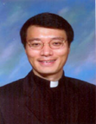

**Greetings of Christ’s Peace and Joy! Hope you all had a blessed week**

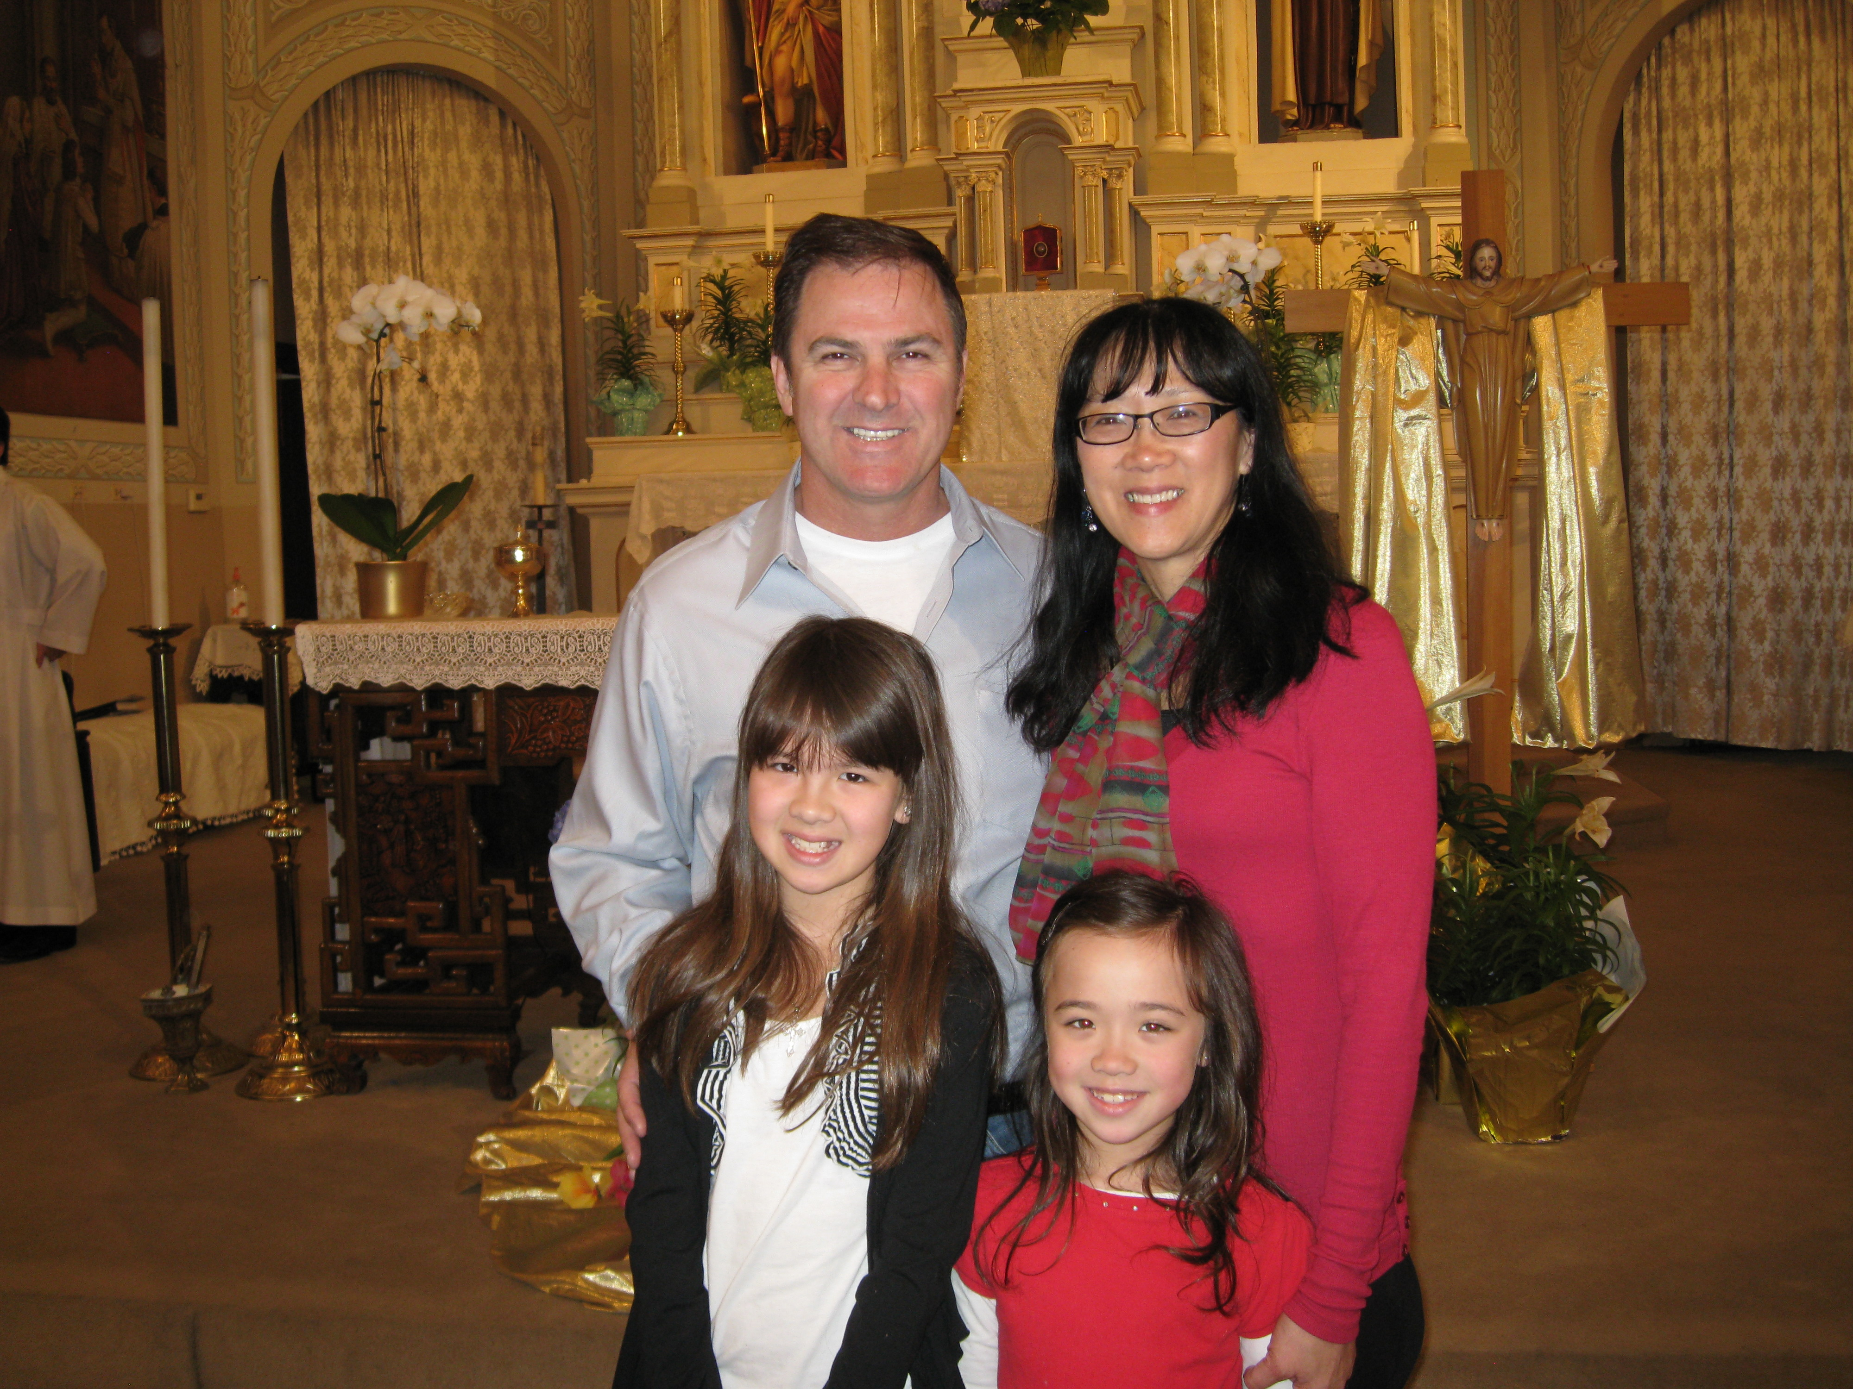

**Congratulations**

Congratulations to Katelyn Schumacher, who celebrated her First Reconciliation last Sunday. Due to a cold, Katelyn wasn’t able to have the Sacrament of Reconciliation on March 16th with her group. We are happy that she is well and received her First Reconciliation.

Today we celebrate the ***First Communion*** with our School and CCD children. We pray for them and share their excitement and enthusiasm for receiving the Eucharist for the first time in their faith journey. This truly is a very special day for them and for our faith community. Their reception of First Communion reminds us of our need and love for the Eucharist, especially during this year of Sunday Mass in the Archdiocese of Chicago. Let’s keep our First Communicants in our prayers

*(The Schumacher Family)* and renew our personal devotion and passion for Sunday Mass.

**World Day of Prayer for Vocations**

On this “Good Shepherd Sunday,” we also observe the World Day of Prayer for Vocations. While we do pray for vocations throughout the year, this is a special day we all pray for our young men and women to respond generously to the Lord’s call to priesthood, diaconate, religious life, societies of apostolic life or secular institutes. We know that there is a shortage of ordained ministers and decrease in numbers for those committed in consecrated life. One of the questions I often hear is, “Who will preside at the Sacraments, if we don’t have enough priests?” This need and the command of our Lord to "Pray the Lord of the harvest to send laborers into his harvest" (Mt 9:38; Lk 10:2), compels us to promote, encourage, and pray for vocations.

Speaking of vocations, our parish has been blessed to have Derek Ho and Christian Shiu, who are pursuing priesthood at Mundelein Seminary. Please keep them and all Seminarians in your prayers.   Below is a prayer for vocations taken from: http://www.usccb.org/prayer-and-worship/prayers/prayers-for-vocations.cfm

***Gracious and loving God, help the  
men and women of our parish to hear the  
call to serve in the Archdiocese of Chicago.  
Our needs are great and our people  
thirst for your presence***

***Open the hearts of many, raise up  
faithful servants of the Gospel, dedicated,  
holy priests, sisters, brothers and deacons,  
who will spend themselves for your people and their needs.***

***Bless those who are serving now  
with courage and perseverance.  
Grant that many will be inspired by their  
example and faith.***

***We ask this through Christ our Lord.  
Amen.***

May the Risen Lord deepen our Faith! ***~Peace, Fr. Francis***

**♪♫ Choir Corner ♪♫**

**April 21, 2013—4th Sunday of Easter– First Communion (Family Mass)**

**PROCESSIONAL: #537—SING A NEW SONG**

**OFFERTORY: #430– I KNOW THAT MY REDEEMER LIVES**

**COMMUNION: #852– AT THAT FIRST EUCHARIST**

***Meditation Song:* THIS LITTLE LIGHT OF MINE (First Communicants)**

**RECESSIONAL: #443-ALLELUIA, ALLELUIA, GIVE THANKS**

***Year of Sunday Mass***

***News and Events***

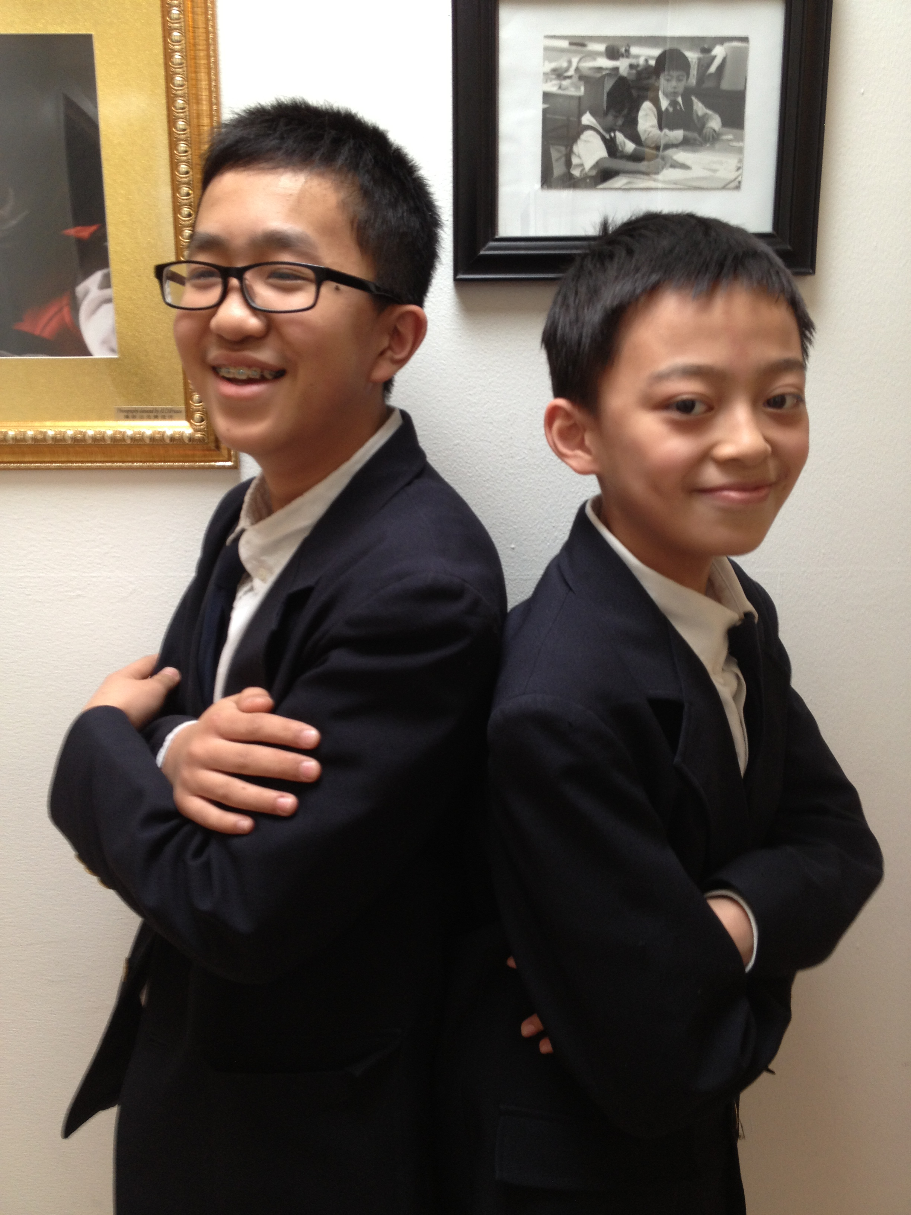

**ST. THERESE SENDS TWO STUDENTS TO NATIONAL HISTORY BEE (Press Release)**

**April 11, 2013 (Chicago, IL)** Two St. Therese School students, **Michael Chen** (grade 7) and **Lambert Hu** (grade 6) have just qualified for the NATIONAL HISTORY BEE to be held in Atlanta, Georgia on June 1st. This is the first time in St. Therese history that more than one student advanced to the regional level competition and has also qualified for the nationals. The 120 highest scorers in each of the 35 regions attend and compete at the Regional Finals, events which are organized and staffed by the National History Bee.

The Regional Finals consist of three preliminary rounds of head-to-head buzzer competition, followed by a final championship round. The top students from each of the Regional Finals advances to the National Championships. Of the thousands of students at schools across the country who participate in the National History Bee, only a select few are invited to advance to the nationals.

St. Therese School’s excellent reputation has been solidified by recent accomplishments, such as Principal Phyllis Cavallone-Jurek being named one **of Tech & Learning Magazine’s *Leader of the Year 2012,***being named a **2012 National Intel School of Distinction Finalist – *Middle School Mathematics*** and a **2011 U. S. Department of Education National Blue Ribbon School of Excellence.**

**MINISTRY OF CARE***—We need Ministers of Care to bring the Eucharist to hospitalized and homebound parishioners. If you are trained or would like to be trained in this Ministry, please contact Fr. Li or Sr. Caritas.*

**Planning Masses**—If you would like your family to participate in the June planning Mass, please contact Sr. Caritas.

**First Holy Communion**

**Please pray for the following children who are receiving the *Sacrament of Holy Eucharist today*:**

**Zachary Chen Jason McGrath**

**Campbell Culen Cameran Moy**

**Jacob Fong Robert Novak**

**Wyatt Harley John Plebanski**

**Anya Haynes Soleil Reyes**

**Olivia McDonald Katelyn Schumacher**

**St. Therese College Scholarship Fund Application**

Through the generosity of an Alumnus of St. Therese School, we have been able to award scholarship grants since year 2001 to help young people advance their studies. The donor of this scholarship fund, who wants to remain anonymous, grew up in Chinatown during the 1950s and was helped by the Catholic Church. After achieving professional and financial success in his life, in year 2000, he made a significant donation to set up this scholarship fund to help others at St. Therese, especially those who have demonstrated a spirit of sharing and service.

The Scholarship Application Form with further criteria is available at the church entrance table. Service at St. Therese Church is a requirement. ***Deadline for submission of the application and supporting documents: June 10, 2013.***

**Easter Donations Update**

Annie G. Lowe: $50 Loretta Yu: $20

Ruth Ann Koesun: $25 Bernie Wong: $20

Nancy Longmire: $100 Lucy Setlak: $50

Jane & Jack Pivac: $30

Geraldine (Lonnie) Lee: $50

St. Rocco Society: $250

Paul & Cindy Lau: $500

**Total as of 4/17/13: $15,386 THANK YOU!**

**ST. THERESE CHURCH WANTS TO HELP!**

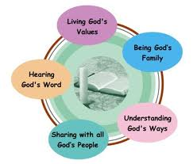

Do you come to church only on Easter and Christmas? Or not at all? Are you facing a life altering event: getting married, having a baby, having lost or in the process of losing a loved one, or dealing with a health diagnosis that is frightening? These are situations that need to be faced, either enjoyed and cherished or met with strength and action. Maybe it is time to go back to your roots as a Catholic to help you deal with these life altering situations.

St. Therese Chinese Catholic Church is a Landings parish. Landings was started by Paulist Fathers to help non-practicing Catholics explore their faith and return to the Church in a nonthreatening way. It is a way to share, to be heard and to listen to faith journeys of a group of inactive and active Catholics. All this is conducted with compassionate listening and utmost confidentiality. If you are ready to consider returning to the Church, we are here to give you a helping hand and ensure your safe landing!

Our spring sessions of 1½ hours a week for 8 to 10 weeks will start on Thursday, May 16th at 6:30pm in the St. Francis Assisi room at our church, located at 218 W. Alexander St., Chicago IL 60616. We offer sessions in English, Cantonese and Mandarin. For more information please contact either Sr. Anji Fan or Cita Orendain at our parish office: 312-842-6777 or email us at: [landingsatsttherese@gmail.com](mailto:landingsatsttherese@gmail.com).

*If you know of inactive Catholics, please pass this on to them.*

***St. Therese wants to help them!***



**Landings** was created more than 20 years ago by the late Fr. Jac Campbell, a Paulist priest. He designed it for lay active Catholics to welcome, or “love back” inactive Catholics to the church. It was founded on the belief that we do not have to be trained theologians to share what we believe and to speak honestly about our faith, trusting in the Holy Spirit (from Landings International website). Since it started, over 1.5 million Catholics have returned to the Church through **Landings**.

**Landings** is the time for someone who has been away from the Church to explore his/her faith and future within the Church. It is a gentle way to connect with lay people who are steadfast in their faith and who practice it. Questions from the inactive Catholic are welcome and will be answered in light of an active Catholic’s faith experience with the guidance of the Holy Spirit. Questions that require deeper theological knowledge will be referred to the pastor.

Meetings are about an hour and a half long, once a week over a period of 8 to 10 weeks. There are 7 to 10 inactive and active Catholics combined in each group. Every active Catholic participant has been trained to be a “welcomer” in **Landings**.

There is a facilitator, a time keeper, a prayer leader and someone to bring the refreshments. A Participant’s Journal is given to each participant in the first **Landings** session. Each participant is asked to read it carefully, a few days before each session. The Journal gives the full schedule of a Landings meeting. It also has 8 to 10 Catholic themes, 1 for each meeting, with references, to help participants understand and reflect on Church teachings and on how the faith is practiced.

Please bear in mind that Landings is not a counseling session or group therapy. It is simply a way for inactive Catholics to discern if coming back to the church is for him/her by listening, sharing and asking questions of active Catholics who are committed to loving them back to the Church.

**Weekly Offering:**

Collection for April 14, 2013

Sunday Envelopes $1,154

Sunday Loose $ 355 July 1-To-Present (Actual): $82,451 Total Collection $1,509 July1-To -Present (Budget): $82,000

Weekly Budget: $2,000 % of Budget Attained: 100%

Please consider giving one hour of your weekly salary as your contribution.

***May God bless your generosity! Thank YOU!***

***Good News! / dear Padre***

**Please remember in your prayers those who are**

**ill, hospitalized, and homebound...**

Sarah Phillips Marie Balestri Carmella Scanlon

Natasha Chang Lucille Iasillo Carmen (Rails) Balestri

Dominic Barbaro Winnie So Vincent Thome

Barbara McElroy Ken Barber Rose Perez

Ramona Zavala Lauren Mandel Nicholas Tobar

Michael Howley YoYo Damico Ruth Barone

Bernie Presto Baby Jessa Piotrowski Dolly Roti

Lina Andriacchi Fr. Walter Johnson, MM Sister Noel Devine

Su Zhen Liao John Galvin Wu Wai Hing

Sister Elizabeth Lee Barbara Maung Lan Ying Yee

Shirley A. Bills Roseann Gurgone Frank Nardi

John Palenik Alice Young Leonard Louie

David Leung John Piegari James Longo III

Bai Xue *Sister Agnes Christina* Jane Lee

*Richard Tobar* Joseph LeungPam Ecklund

Betsy Young Mary Balestri

If you wish to add a name or remove your name from this list, please call the parish office.

**Good Cooks!**

**During Lent, St. Therese parishioners again went to Sister House. Sister House is a residence for women who are continuing their programs after drug and alcohol treatment. Our wonderful women teach the women there to cook a healthy Chinese meal. Their graciousness and friendliness as well as their ability to share their skills with the women have proven to be quite helpful. The women at Sister House have been able to again cook the same meal without the assistance of our women. It is a sign of good teaching!**

**If you would like to help the next time we plan to go in early summer. Please contact George Lee if you would like to share your talents. Special thanks to Sanda Costa, Florence Gin-Yu and Linda Leong - shown in the 1st picture standing to the left of Sr. Caritas.**

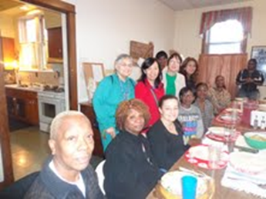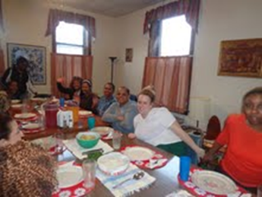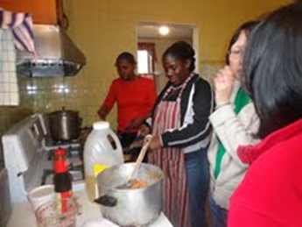

**God Bless the women! ~Sr. Caritas**

Church Stained Glass Window Repair Update

The entire exterior work for our church window repair and broken stained glasses have completed. Unfortunately, this is not the end of the project. As with fixing up any old windows, there is a higher chance of surprise. It’s now been confirmed that we need to replace a few of the moon-shaped top window frames on the inside. With the additional work on the inside window frames, our estimated total cost of this project is now $55,000. We expect to begin the next phase of this work in April 2013. **We need your support for this project.  If you would like to make any donations, please mark your contributions with “*Window Repairs*.”** *T****hank you to all who have already made a donation:***

***Paul &Cindy Lau: $2000* Francine Caruso: $100**

***James &Akina Moy: $1000* Bonnie Tse: $100**

***Dan & Pam Spano: $210* Kevin Wu (Sweet Station): $100**

***Shu Man & Florence Yu: $300* Frank S. Scuito: $100**

***Chris & Darlene Lowe: $500* Peter Blais: $50**

***N. N.: $200* Teresa Au: $50**

***N. N.: $100* Phyllis & Rose Marie Centofanti: $100**

***Sacred Heart Ladies Club: $1000* Wendy Fluder: $100**

***The May Family: $2105* Frank & Sophie Nardi: $500**

***Betsy Young & Woodie Lee: $50* Dominic Barbaro: $200**

***Wanda Stearns: $50* Richard & Rita Young: $200**

***Lucille Salerno: $100* Edy & Lisa Gunawan: $100**

***Santa Maria Incoronata : $ 1000* Annie Lowe: $100**

***Albert & Bernie Wong: $200* Menacita Chan: $100**

***Rose Cho: $2000* Gemma Wong: $200**

***Dominic Lai: $380* Jennifer Chan & Jorge Morales: $50**

***Robert Lee: $10* Tony Lin & Sharon Wong: $355**

***Larry A. Pusateri : $500* Wendy Sin: $500**

***Eugene & Geraldine Kwan: $100* The Tse Family : $53**

***Gene & Teresa Lee: $200* Renee & George Fong: $53**

***Gary & Linda Leong: $200* The Urso Family: $500**

***Wesley & Sharon Wong: $100* Gertrude Chan: $50**

***Sandra Moy: $100* Leonard & Elaine Louie: $1900**

***Sharon Yu: $1000* Joseph and Natia DiFazio: $100**

***Ray Lin (The Lin Family): $500* Lucille Salerno: $500**

**Mr. & Mrs. William Moy: $50 Joseph & Bernadette Zito: $100**

**Andrew & Eva Feng: $1900 Michael & Sevila Schiml: $150**

**Fr. Francis Li: $100 Mr. & Mrs. Francis Degnan: $75**

**Amy C. Floyd: $200 Mr. & Mrs. Vincent Briglio: $100**

**Karen L. Zewe: $50 Mr. & Mrs. John Lusak: $1000**

**Peter Tse: $100 Agustin & Donna Gonzalez: $200**

**Joe & Margaret Cabello: $100 Josie Lia Kawazoye: $50**

**Tony & Mary Ann Nudo: $100 Sonny Spalla: $200**

**Janet & Albert Moy: $300 Dorothy Albanese: $100**

**Janet Fecteau & Al DiFranco: $50 Mr. & Mrs. Chuck Oi: $1000**

**Marion B. Roti: $100 Theresa Scopacasa and Jane Pivac: $100**

**Monica Lam: $100 Antoinette Choate & John Tangren: $1000**

**Caecilia Payton: $60 Felicia Kristanto: $200**

**Teresa Au: $50 The Family of Michele Morelli: $1000**

**Nick & Ellen Andriacchi: $200 (Fred M. Morelli, Mary Morelli Lusak,**

**Jennifer M. DiFazio: $50 Madeleine Morelli Donnelly, Fred M. Morelli, N.N.: $30 Jr., Marilyn Morelli, Katherine Morelli, Agnes Lee: $50 Michael D. Morelli)**

**Joseph V. DiFazio: $100 Teresa Moy: $100**

**BULLETIN TOTAL AS OF 04/17/13: $29,131**

**A plaque of remembrance will be placed in the church in gratitude to all the donors at the end of the project.**

**\*If you would like to have your name listed differently as shown from above, please contact the parish office at 312-842-6777.**