**Mass Intentions**

***March 31, 2013 - Easter Sunday of the Resurrection of the Lord***

**8:00A.M.**  + David Jarzyna by wife Cookie

+ Deceased Family Members of Marion Roti

**9:30A.M.** Parishioners and Friends of St. Therese

Special intentions by Mandarin Group

+ Barry Yong by Mom, June Moy

+ Wei-Tung Ting by daughter Lily

+ Kong-Won & Yet-Moy Gong May by Richard & Lily May

+ Eric Yun by Lushia and Tim

***MON. April 1st Monday within the Octave of Easter***

**8:00A.M. +** Yue Feng Wang by Yu Jian

***TUE. April 2nd Tuesday within the Octave of Easter***

**8:00A.M.** + Yue Feng Wang by Yu Jian

***WED. April 3rd Wednesday within the Octave of Easter***

**8:00A.M. +** Chi-Kung Tseng by Lily May

***THU. April 4th Thursday within the Octave of Easter***

**8:00A.M.**+ Chong Wei Lee Helen Lee by Agnes and Grandchildren

***FRI. April 5th Friday within the Octave of Easter***

**8:00A.M.** In Honor of the Sacred Heart of Jesus

+ Catherine Gurgone by daughter

+ Barry Yong by Mom, June Moy

+ Josephine Parrilli by Lucille Salerno

***SAT. April 6th Saturday within the Octave of Easter***

**8:00A.M.** In Honor of the Immaculate Heart of Mary

**5:00P.M.** Parishioners and Friends of St. Therese

+ Josephine Parrilli by Rose Ann Gurgone

***From the Desk of Fr. Francis***

**Greetings of Christ’s Peace and Joy! Hope you all had a blessed week.**

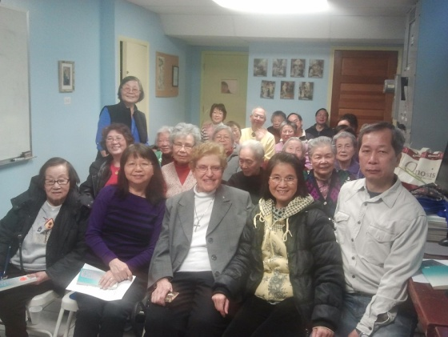

**Thank You**

Thanks to all who participated in our Cantonese and Mandarin Retreats last Sunday and to Sr. Mary Lou for leading the Cantonese recollection and to Sr. Anji for guiding the Mandarin one. I am also very grateful to Fr. John Li and Fr. Xu for helping me with the Sacrament of Reconciliation at the end of the Mandarin retreat. It took three of us almost two hours to hear confessions. What a fruitful day for all who were involved!

Thanks to all who helped with the decoration of our Church on this past Wednesday, Friday and Saturday. Your generosity with time and talent beautifully transformed our church into a very prayerful and festival environment.

(Courtesy of John Lin: Sr. Mary with Retreaters)

**The Resurrection of the Lord and Us**

Today’s Gospel tells us that Mary arose “early in the morning” and went to the tomb. She was looking for Jesus after they had buried him. The timing of her searching for Jesus-early in the morning-speaks to us of the freshness of new life. It symbolizes that something new is going to happen. This new thing is the risen Lord. After six weeks of penance and preparation, we come to church this Sunday knowing something wonderful has happened, namely the Lord is risen and alive in us and among us. This good news should fill us with joy and hope.

With the resignation of Pope Benedict XVI and the installation of Pope Francis 1st, our Church has been on the spot light since February. There have been a lot of speculations for the reasons why Pope Benedict XVI stepped down, the needs for changes in our Church, and the simpler and humbler lifestyles of our new Pope. Many Catholics and even non Catholics alike have new expectations for Pope Francis 1st. We hope and pray that Pope Francis 1st will bring “the freshness of new life” into our Church. His election, humility and simplicity should bring us joy and hope

Reading a short article, a quotation from Mother Teresa caught my attention. She wrote, "*I can do something you cannot do; you can do something I cannot do. Together let us do something beautiful for God.*" This is what Easter reminds of us too. Jesus has conquered sin and death and offered us salvation, which we can’t obtain as humans. Yet in order for each one of us to be saved, we each have to cooperate with God’s grace and show our willingness to accept Christ’s salvation for us. Christ cannot overpower our human freedom and does that part for us. Together with the Risen Lord, we make salvation our own. This theory implies to our family, community and world relations too. We need each other to “*do something beautiful for God*.” Our willingness to work with others in the Lord should increase our joy and hope.

***May the Risen Lord deepen our faith! Happy Easter!***   ***~Peace, Fr. Francis***

***Hospitality Schedule for April 7, 2013***

**GREETERS: Regina Cheong, Teresa Moy, Florence Yu**

**RECEPTION VOLUNTEERS: Anne, Earl Hokens**

**♪♫ Choir Corner ♫♪ March 31, 2013 – Easter Sunday**

**PROCESSIONAL: #435—SING TO THE MOUNTAINS**

***Sequence for Easter:* #438 (After the 2nd Reading, before the Gospel)**

**OFFERTORY: #434-THIS JOYFUL EASTERTIDE**

**COMMUNION: 1) #430-I KNOW THAT MY REDEEMER LIVES**

**2) Choir—Alleluia Canon**

**RECESSIONAL: #422-JESUS CHRIST IS RISEN TODAY**

***Year of Sunday Mass***

***News and Events***

**Finance Committee***—will meet on Monday, April 1st at 7:00pm.*

**Special Intentions***—Please pray for the eternal repose of the soul of Jean Toy, whose funeral mass will be held at 11:00am on Monday, April 1st here at St. Therese.*

**Conversational English***—We are still offering conversational English classes four times a week and are now accepting new students for the Spring sessions. If interested, please sign up at the church entrance table. Schedules can be worked out with the instructors.*

**Computer Teachers—***we need people who can teach basic computer skills in our parish. Requirements are:* ***a****) knows Microsoft Office, Google Docs;* ***b****) knows how to surf the internet, use and create Email* ***c****) can operate a printer,* ***d****) can commit to 1.5 to 3 hours a week* ***e****) knowledge of Cantonese or Mandarin preferred. If interested please contact Edy Gunawan at:*

*egunawan@sttheresechinatown.org or call the church office at 312-842-6777.*

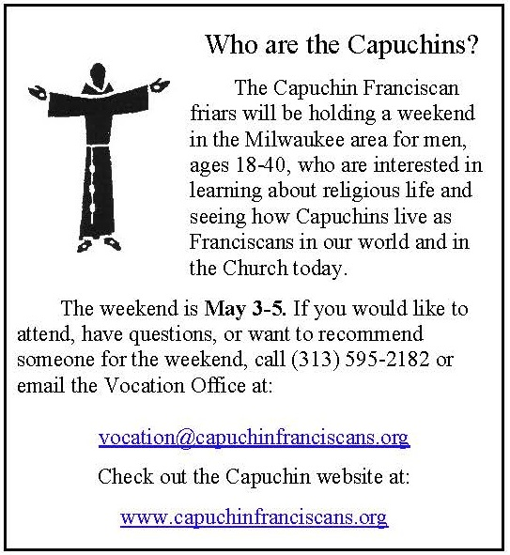

***Good News!***

**ST. THERESE CHURCH WANTS TO HELP!**

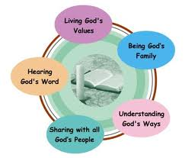

Do you come to church only on Easter and Christmas? Or not at all? Are you facing a life altering event: getting married, having a baby, having lost or in the process of losing a loved one, or dealing with a health diagnosis that is frightening? These are situations that need to be faced, either enjoyed and cherished or met with strength and action. Maybe it is time to go back to your roots as a Catholic to help you deal with these life altering situations.

St. Therese Chinese Catholic Church is a Landings parish. Landings was started by Paulist Fathers to help non-practicing Catholics explore their faith and return to the Church in a nonthreatening way. It is a way to share, to be heard and to listen to faith journeys of a group of inactive and active Catholics. All this is conducted with compassionate listening and utmost confidentiality. If you are ready to consider returning to the Church, we are here to give you a helping hand and ensure your safe landing!

Our spring sessions of 1½ hours a week for 8 to 10 weeks will start on Thursday, May 17th at 6:30pm in the St. Francis Assisi room at our church, located at 218 W. Alexander St., Chicago IL 60616. We offer sessions in English, Cantonese and Mandarin. For more information please contact either Sr. Anji Fan or Cita Orendain at our parish office: 312-842-6777 or email us at: [landingsatsttherese@gmail.com](mailto:landingsatsttherese@gmail.com).

*If you know of inactive Catholics, please pass this on to them.*

***St. Therese wants to help them!***



**Landings** was created more than 20 years ago by the late Fr. Jac Campbell, a Paulist priest. He designed it for lay active Catholics to welcome, or “love back” inactive Catholics to the church. It was founded on the belief that we do not have to be trained theologians to share what we believe and to speak honestly about our faith, trusting in the Holy Spirit (from Landings International website). Since it started, over 1.5 million Catholics have returned to the Church through **Landings**.

**Landings** is the time for someone who has been away from the Church to explore his/her faith and future within the Church. It is a gentle way to connect with lay people who are steadfast in their faith and who practice it. Questions from the inactive Catholic are welcome and will be answered in light of an active Catholic’s faith experience with the guidance of the Holy Spirit. Questions that require deeper theological knowledge will be referred to the pastor.

Meetings are about an hour and a half long, once a week over a period of 8 to 10 weeks. There are 7 to 10 inactive and active Catholics combined in each group. Every active Catholic participant has been trained to be a “welcomer” in **Landings**.

There is a facilitator, a time keeper, a prayer leader and someone to bring the refreshments. A Participant’s Journal is given to each participant in the first **Landings** session. Each participant is asked to read it carefully, a few days before each session. The Journal gives the full schedule of a Landings meeting. It also has 8 to 10 Catholic themes, 1 for each meeting, with references, to help participants understand and reflect on Church teachings and on how the faith is practiced.

Please bear in mind that Landings is not a counseling session or group therapy. It is simply a way for inactive Catholics to discern if coming back to the church is for him/her by listening, sharing and asking questions of active Catholics who are committed to loving them back to the Church.

**If you know of any inactive catholics, please pass this on to them. St. Therese wants to help them!**

**Weekly Offering:**

Collection for March 24, 2013

Sunday Envelopes $1,601

Sunday Loose $ 268 July 1-To-Present (Actual): $78,687

Total Collection $1,869 July1-To -Present (Budget): $78,000

Weekly Budget: $2,000 % of Budget Attained: 100%

Please consider giving one hour of your weekly salary as your contribution.

***May God bless your generosity! Thank YOU!***

***Mandarin Mass of March 24, 2013: $686.00 Thank YOU!***

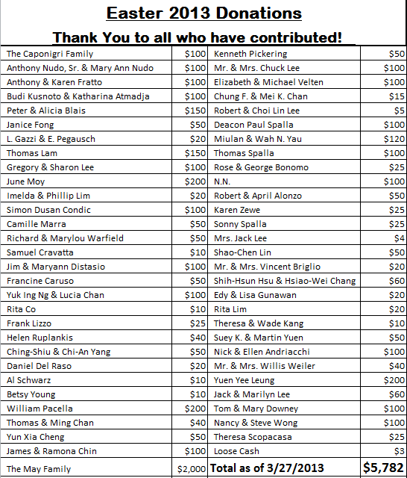

**Please remember in your prayers those who are**

**ill, hospitalized, and homebound...**

Sarah Phillips Marie Balestri Carmella Scanlon

Natasha Chang Lucille Iasillo Carmen (Rails) Balestri

Dominic Barbaro Winnie So Vincent Thome

Barbara McElroy Ken Barber Rose Perez

Ramona Zavala Lauren Mandel Nicholas Tobar

Michael Howley YoYo Damico Ruth Barone

Bernie Presto Baby Jessa Piotrowski Dolly Roti

Lina Andriacchi Fr. Walter Johnson, MM Sister Noel Devine

Su Zhen Liao John Galvin Michele Young

Sister Elizabeth Lee Barbara Maung Wu Wai Hing

Shirley A. Bills Roseann Gurgone Lan Ying Yee

John Palenik Alice Young Frank Nardi

David Leung John Piegari Leonard Louie

Bai Xue *Sister Agnes Christina* James Longo III

*Richard Tobar* Joseph LeungJane Lee

Betsy Young Mary Balestri Pam Ecklund

If you wish to add a name or remove your name from this list, please call the parish office

**ALIVE? YES, ALIVE!**

Have you ever been almost knocked down by someone racing down the sidewalk? Certainly you wonder what is so important or perhaps you look to see if the person is being chased? I think of those things when it happens to me.

Our Easter gospel tells of an early morning kind of race. Peter and the Disciple Jesus loved, rushed, running to the tomb where Jesus was buried. Mary Magdala had told them the stone was moved and Jesus’ body gone. They were surely not anywhere near being over the sadness of Jesus’ Death. Now this! What more could happen?

The disciple, who reached the tomb first, being younger and faster, waited for Peter to reach the tomb. To their amazement , they found the tomb as Mary had said. Questions rushed to their minds, who, what, how, why? Looking more carefully, they noticed the head covering separate from the other burial cloths. Scripture says “the one who arrived first, saw and believed ,for they did not yet understand that He must rise from the dead.”

We who live now have heard of this Jesus who ROSE from the dead. We believe, trust, and love Him. But for those there at the time, such a thought was beyond ALL experience and expectation. Who could think such a thing? Later that day they SAW Jesus when He came to the upper room.

When we are baptized, we are baptized into Jesus’ death and resurrection. He shares His life with us. He lives in us, lives our life if we ask Him to do so . The good we do, the kindnesses we show, the joy we share are His gifts, His actions, His way of touching our world and time through us. Jesus who Rose from the dead IS ALIVE today and ALWAYS. Do you BELIEVE? CELEBRATE with EASTER JOY!

**~Sr. Caritas**

Church Stained Glass Window Repair Update

(The entire exterior work for our church window repair and broken stained glasses have completed. Unfortunately, this is not the end of the project. As with fixing up any old windows, there is a higher chance of surprise. It’s now been confirmed that we need to replace a few of the moon-shaped top window frames on the inside. With the additional work on the inside window frames, our estimated total cost of this project is now $55,000. We expect to begin the next phase of this work in April, 2013.**We need your support for this project.  If you would like to make any donations, please mark your contributions with “*Window Repairs*.”** *T****hank you to all who have already made a donation:***

***Paul &Cindy Lau: $2000* Francine Caruso: $100**

***James &Akina Moy: $1000* Bonnie Tse: $100**

***Dan & Pam Spano: $180* Kevin Wu (Sweet Station): $100**

***Shu Man & Florence Yu: $300* Frank S. Scuito: $100**

***Chris & Darlene Lowe: $500* Peter Blais: $50**

***N. N.: $200* Teresa Au: $50**

***N. N.: $100* Phyllis & Rose Marie Centofanti: $100**

***Sacred Heart Ladies Club: $1000* Wendy Fluder: $100**

***The May Family: $2105* Frank & Sophie Nardi: $500**

***Betsy Young & Woodie Lee: $50* Dominic Barbaro: $200**

***Wanda Stearns: $50* Richard & Rita Young: $200**

***Lucille Salerno: $100* Edy & Lisa Gunawan: $100**

***Santa Maria Incoronata : $ 1000* Annie Lowe: $100**

***Albert & Bernie Wong: $200* Menacita Chan: $100**

***Rose Cho: $2000* Gemma Wong: $200**

***Dominic Lai: $380* Jennifer Chan & Jorge Morales: $50**

***Robert Lee: $10* Tony Lin & Sharon Wong: $355**

***Larry A. Pusateri : $500* Wendy Sin: $500**

***Eugene & Geraldine Kwan: $100* The Tse Family : $53**

***Gene & Teresa Lee: $200* Renee & George Fong: $53**

***Gary & Linda Leong: $200* The Urso Family: $500**

***Wesley & Sharon Wong: $100* Gertrude Chan: $50**

***Sandra Moy: $100* Leonard & Elaine Louie: $1900**

***Sharon Yu: $1000* Joseph and Natia DiFazio: $100**

***Ray Lin (The Lin Family): $500* Lucille Salerno: $500**

**Mr. & Mrs. William Moy: $50 Joseph & Bernadette Zito: $100**

**Andrew & Eva Feng: $1900 Michael & Sevila Schiml: $150**

**Fr. Francis Li: $100 Mr. & Mrs. Francis Degnan: $75**

**Amy C. Floyd: $200 Mr. & Mrs. Vincent Briglio: $100**

**Karen L. Zewe: $50 Mr. & Mrs. John Lusak: $1000**

**Peter Tse: $100 Agustin & Donna Gonzalez: $200**

**Joe & Margaret Cabello: $100 Josie Lia Kawazoye: $50**

**Tony & Mary Ann Nudo: $100 Sonny Spalla: $200**

**Janet & Albert Moy: $300 Dorothy Albanese: $100**

**Janet Fecteau & Al DiFranco: $50 Mr. & Mrs. Chuck Oi: $1000**

**Marion B. Roti: $100 Theresa Scopacasa and Jane Pivac: $100**

**Teresa Au: $50 Monica Lam: $100**

**Nick & Ellen Andriacchi: $200 Caecilia Payton: $60**

**BULLETIN TOTAL AS OF 03/27/13: $26,571**

**A plaque of remembrance will be placed in the church in gratitude to all the donors at the end of the project.**

**\*If you would like to have your name listed differently as shown from above, please contact the parish office at 312-842-6777.**