Mass Intentions

March 3, 2013 - Third Sunday of Lent

8:00A.M. + Pete Pivac by Theresa & Jane

9:30A.M. + Carolyn Fields by Brian, Ed, Mary Ann, Marty, Sam & Wendy

MON. March 4th Saint Casimir

8:00A.M. + Michael Ng by Mae Toy & Jenping Chan
+ Carolyn Fields by Brian, Ed, Mary Ann, Marty, Sam & Wendy

TUE. March 5th Lenten Weekday

8:00A.M. + Carolyn Fields by Brian, Ed, Mary Ann, Marty, Sam & Wendy

WED. March 6th Lenten Weekday

8:00A.M. + Wei-Tung Ting by daughter Lily May
+ Carolyn Fields by Brian, Ed, Mary Ann, Marty, Sam & Wendy

THU. March 7th Saints Perpetua and Felicity, Martyrs

8:00A.M. + Carolyn Fields by Brian, Ed, Mary Ann, Marty, Sam & Wendy

FRI. March 8th Saint John of God, Religious

8:00A.M. + Joseph Spina by Zito’s
+ Birthday Remembrance for Joseph Spina by Briglio Family
+ Darlene Ray by her Children
+ Art Greco by Dominic Barbaro
+ Carolyn Fields by Brian, Ed, Mary Ann, Marty, Sam & Wendy

SAT. March 9th Saint Frances of Rome, Religious

8:00A.M. + Birthday Remembrance for Rose Marie & Howard Thome by Briglio Family
+ Catherine Barbaro by Family
+ Carolyn Fields by Brian, Ed, Mary Ann, Marty, Sam & Wendy
5:00P.M. Friends and Parishioners of St. Therese
+ Josephine Parrilli by Mr. & Mrs. Nudo
+ Howard and Rose Marie Thome by Zito’s

From the Desk of Fr. Francis
Greetings of Christ’s Peace and Joy! Hope you all had a blessed week.

Thank You
Thanks to all who helped with putting away our Lunar New Year decorations and getting our Church ready for this Lenten season last Sunday. Your involvement made the project much faster and easier and is very much appreciated.
Journeying with Our Catechumens and Candidates (2)

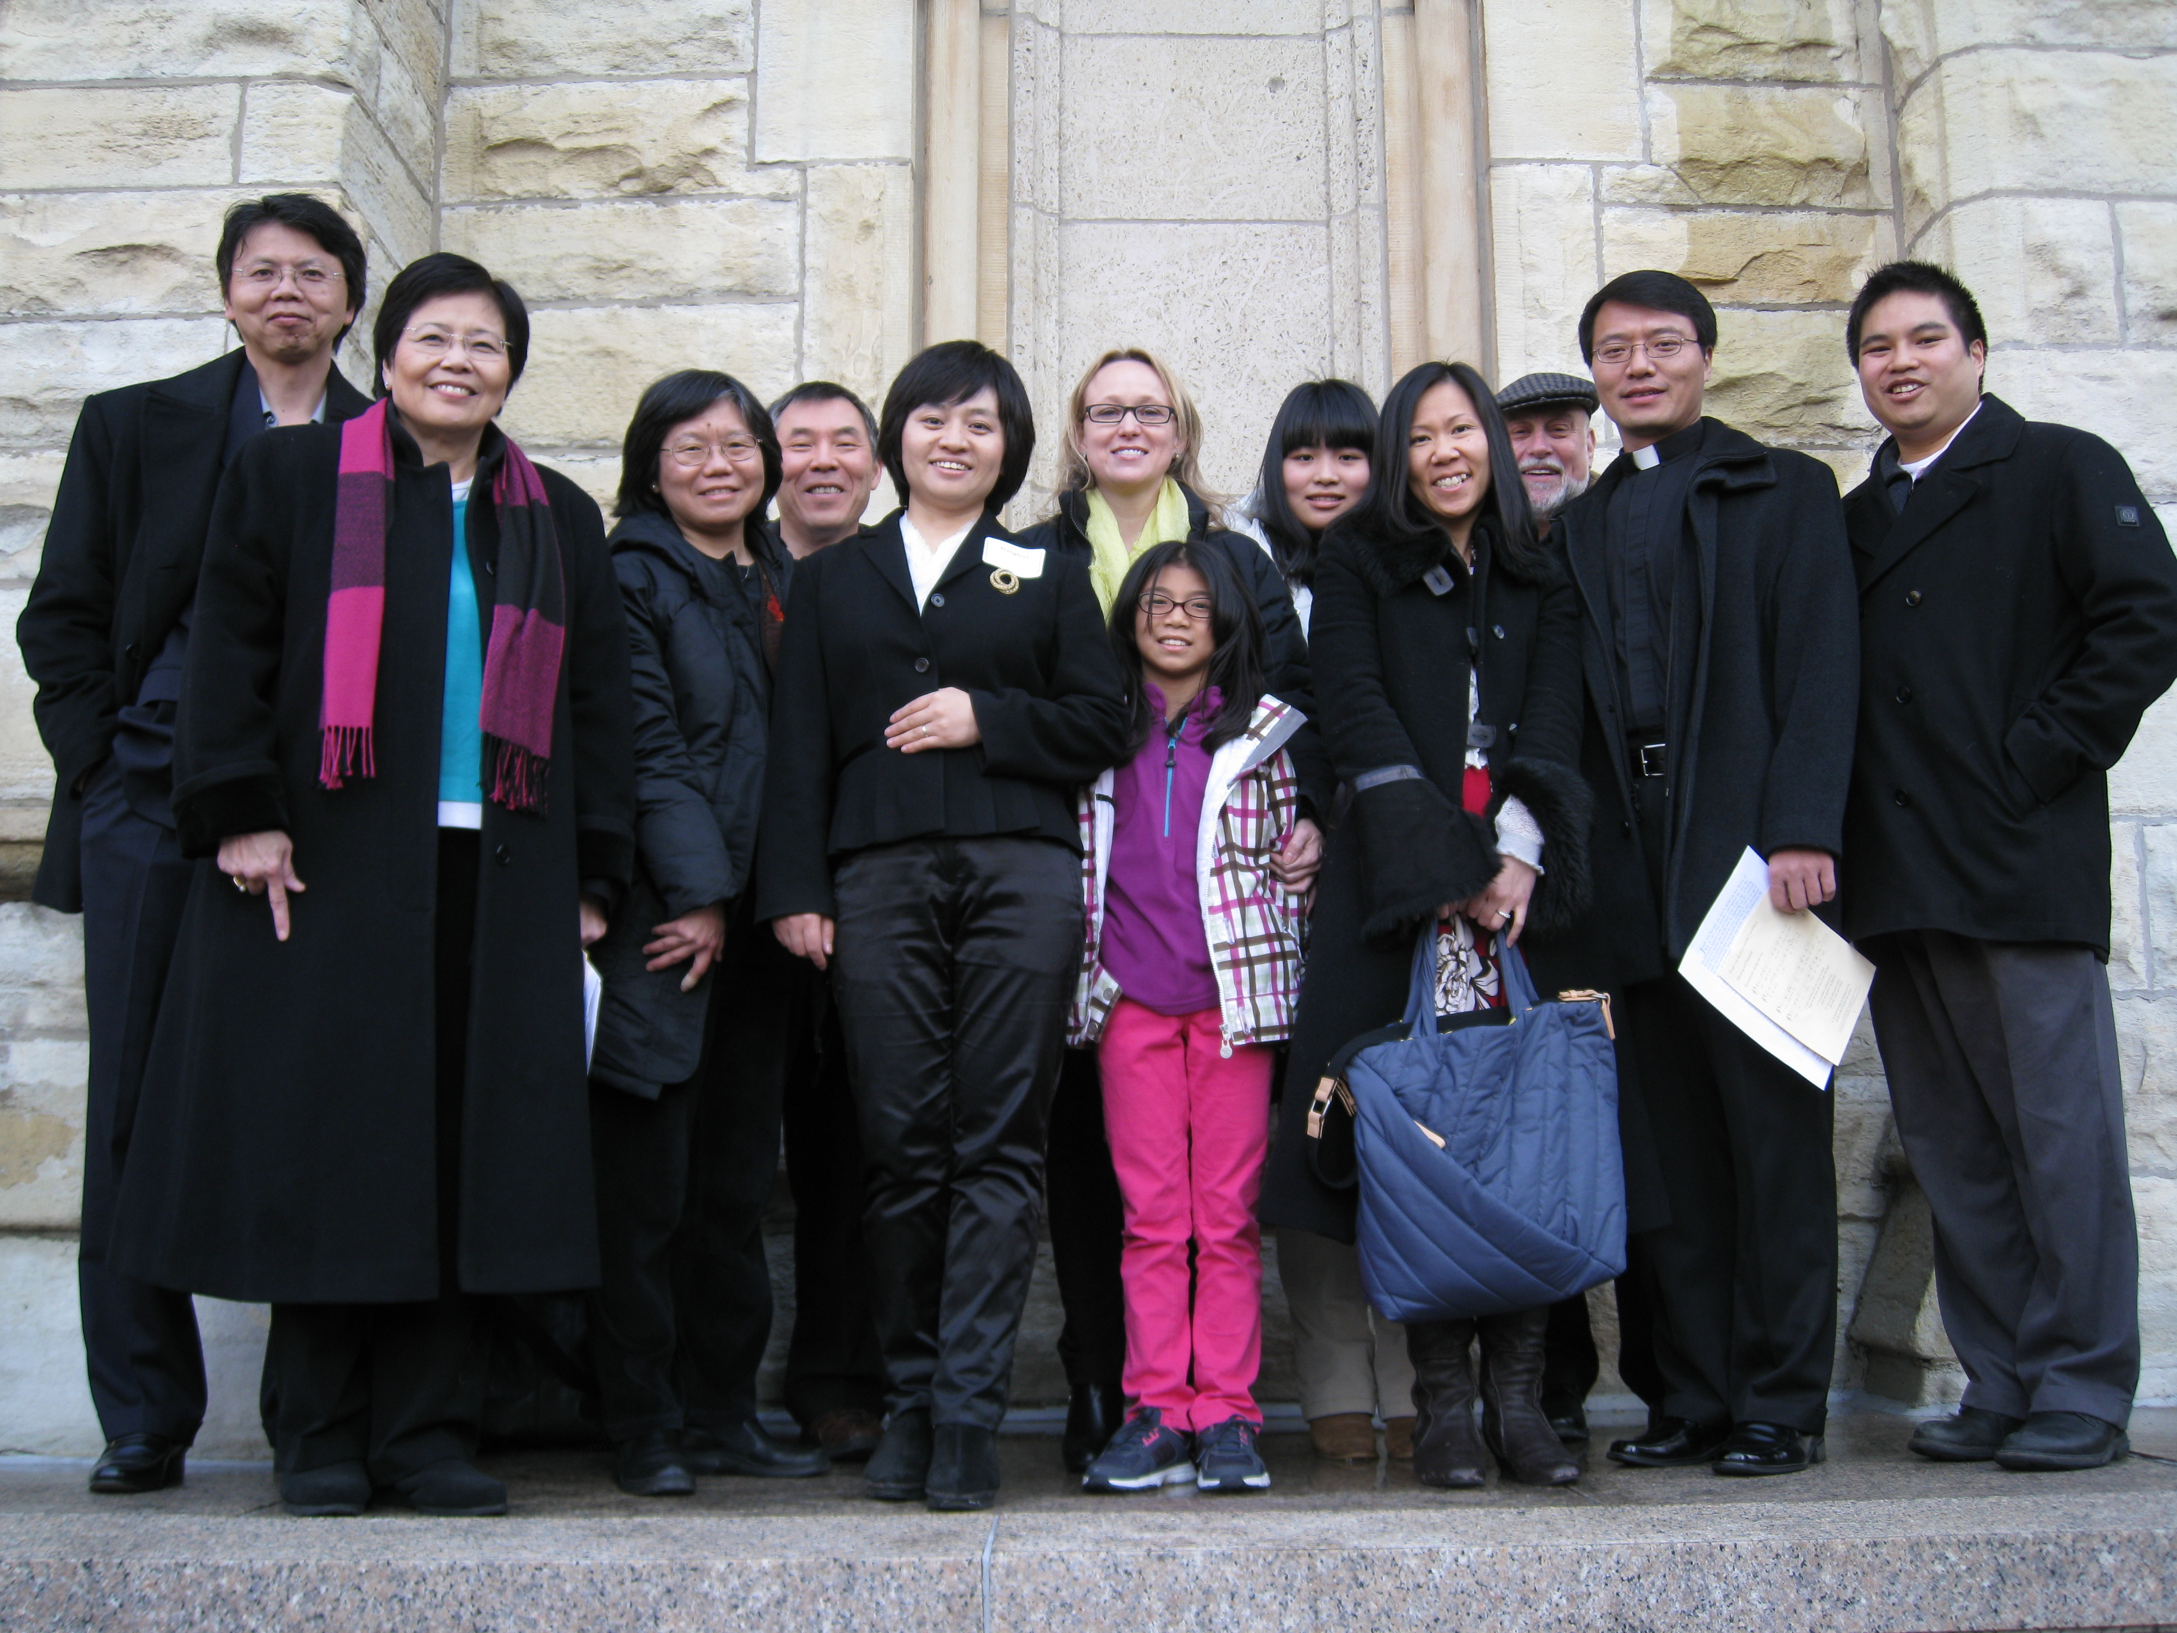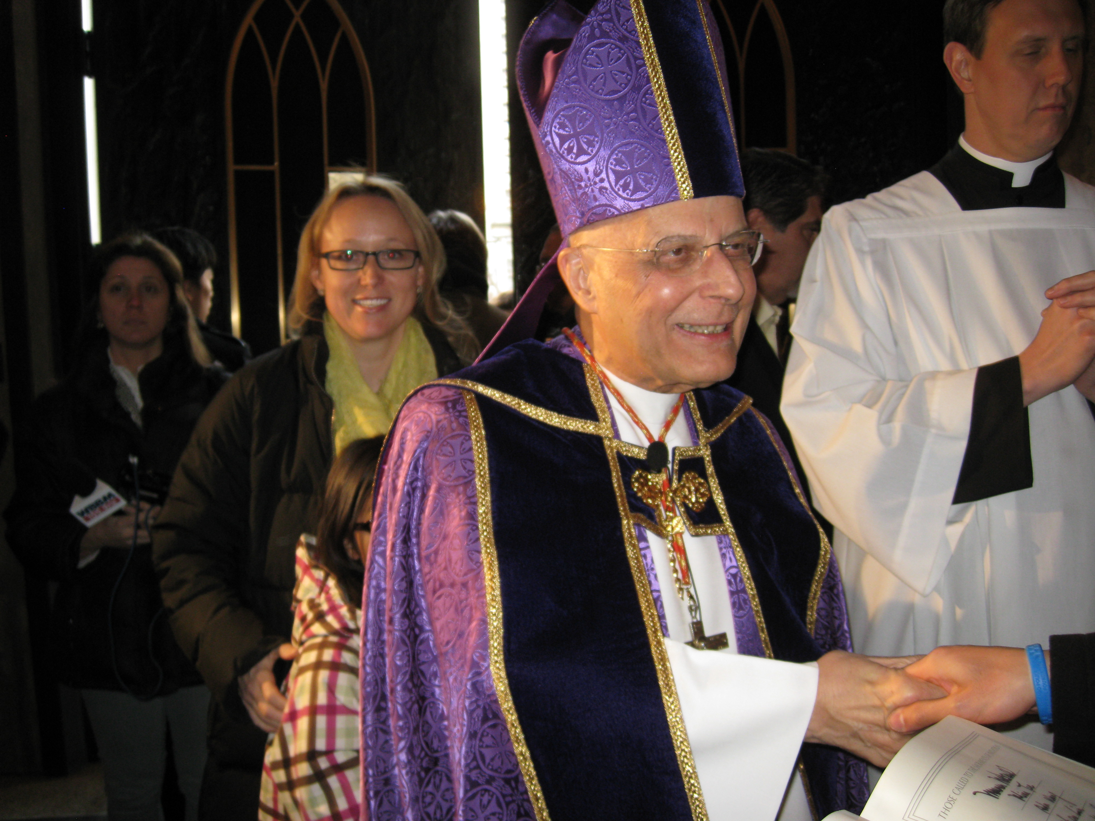

(After Maureen greeted the Cardinal ) (Group picture outside of Holy Name Cathedral)
Six of our Catechumens and Candidates along with their godparents, sponsors, and catechists celebrated the Rite of Election last Sunday at Holy Name Cathedral. Cardinal George presided over the Rite. The Cathedral was packed. One of our Catechumens told me that the experience was powerful and it was encouraging and inspiring to see so many Catechumens and Candidates from different parishes gathered in the Cathedral.

This and the next two Sundays, we will celebrate the rites of scrutiny for them. After their Godparents and sponsors offered favorable testimonies about their readiness at the Rite of Election, the Church continues to help them to access their spiritual lives through three Scrutiny rites on the 3rd, 4th, and 5th Sundays of Lent. “The scrutinies are celebrated in order to deliver the elect from the power of sin and Satan, to protect them against temptation, and to give them strength in Christ (RCIA 141).” This rite is not meant to make them feel guilty about themselves, but to help them to see our human conditions more clearly and to remind them of the overwhelming grace of God in Christ. The purpose of each of the scrutinies is “to uncover, then heal all that is weak, defective, or sinful in the hearts of the elect” and “to bring out, then strengthen all that is upright, strong and good (RCIA 141).”

Realizing one’s weakness and strengthening one’s goodness, isn’t this what we all are called to do especially during this season of Lent? Through our Lenten disciplines, the Church hopes all Christians would know better about our human conditions and come to experience God’s healing power and life in Christ. This is precisely why we are companions with our elect and candidates. We are not speculators. We are on the same journey, a journey that leads us closer to God. Our prayers for them assure them of our support and care. Their presence reminds us that we too are in need of uncovering our sinfulness and increasing our faith.

Please continue to pray for: Maureen McDonald, Mina Tse, Eda Wang, Yupo J. Lin, Megumi Hayashi, and Shell Han. Please continue to take advantage of the many Lenten prayer and service opportunities we offer. And may we find time and space to “Deepen Our Faith in Christ” this week and in the Year of Faith ~Peace, Fr. Francis

Hospitality Schedule for March 10, 2013
GREETERS: Regina Cheong, Jean Ng, Gemma Wong
RECEPTION VOLUNTEERS: Eva & Kalina

♪♫ Choir Corner ♫♪
March 3, 2013 – Cantonese Mass—Third Sunday of Lent
Chinese Service Music—Accompanist: Angel Hau
PROCESSIONAL: P. 131, #204—Glory to God
Lent Acclamation: #59– Praise to You Lord Jesus Christ
OFFERTORY: P. 33, #83– Lord, the Almighty
COMMUNION: P. 125, #196—By the Blood that Flowed from Thee
RECESSIONAL: P. 133, #207—The Endless Love of Jesus

Year of Sunday Mass

“Year of Sunday Mass” -Evaluation meeting at 12:30pm today.
Sacramental Pictures—at St. Therese School from 11:30 am to 12:30 pm today.

St. James Food Pantry St. James is in need of your helping hands on Saturday, March 9th from 8:30 A.M.. To 11:30A.M. We need 10 volunteers to help with the distribution of food. Be a witness to St. Therese’s spirit of love and care for our friends and neighbors in need. They are counting on us! Please sign up at the church entrance table.

Catechists Certification Class “Liturgy Part II” will take place on Saturday, March 9th from 9:00am to 3:00pm in the Community Room. All are welcome to attend. Please sign up at the church entrance table if you are planning to attend.

Ministry of Care What is “Ministry of Care?” Ministers of Care are those people who visit the sick and homebound. They pray with them and bring them the Holy Eucharist when they cannot come to Church by sharing the Eucharist with them and by visiting them in their time of need. The Minsters of Care touch people deeply. Are you interested in this ministry? Please contact Father Li if you are interested.

ST. THERESE SCHOOL NEEDS OUR VOTES!!!
Please help our school for a chance to win $60,000 from the Follett Grant. Please vote each day and encourage others to vote as well. It’s easy to do! How to vote:
1. Go to www.follettchallenge.com
2. In the search type, "St. Therese School". You should see "St. Therese School: Little School Big Dreams" video. CLICK on this.
3. On the right, you need to enter your email address. Click to submit.
4. Then you need to confirm your vote through an email sent to your email address.
VOTE ONCE A DAY through MARCH 18th.
Please ask family & friends to vote for St. Therese as well! Thanks for your support!

Computer Teachers
We need people who can teach basic computer skills in our parish. Requirements are: a) knows Microsoft Office, Google Docs; b) knows how to surf the internet, use and create Email c) can operate a printer, d) can commit to 1.5 to 3 hours a week e) knowledge of Cantonese or Mandarin preferred. If interested please contact Edy at eguwan@sttheresechinatown.org or call the church office at 312-842-6777.

Preparing for Holy Week Retreat March 22-24 at Saint Mary-of-the-Woods—Ready your soul for the Easter Triduum with the Sisters of Providence “Preparing for Holy Week Retreat” from 7 p.m. Friday, March 22 through noon Sunday, March 24 in Owens Hall at Saint Mary-of-the-Woods. Spend your Palm Sunday weekend preparing for Holy Week and the great Sacred Triduum of Holy Thursday, Good Friday and Easter. Participants will have opportunity for quiet, rest and reflective prayer while gaining a better understanding of Holy Week. Suggested donation per person is $150 for single room and $120 for double room. Four meals are included. Register by March 12 to ensure a spot. For more information contact Sister Paula Damiano at 812-535-2926 or pdamiano@spsmw.org or visit ProvCenter.org

Experience The Stations of the Cross online! There are two ways to check it out:
Visit the Official site: http:experiencethestations.com
View directly on YouTube:
http://youtu.be/_eFdXHi6tWE
Hope this video serves as a source of reflection and strength for you in the Lenten season.

Tax Letter—if you would like to receive a tax letter for your 2012 donations to St. Therese, please contact the office at 312-842-6777.

2012 Christmas Donations Update:

Al H. Schwarz: $25
Total as of March 3, 2013: $22,038 THANKS!

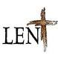2013 Updated

“Deepen Our Faith in Christ”

Stations of the Cross
Fridays at 7:00P.M. in Church preceded by dinner in the Community Room at 6:00 P.M.

Sharing on The Eucharist
Fridays at 7:45P.M. following the Stations of the Cross in the Community Room

Service
We will help out at St. James Food Pantry on Saturday March 9th, and Sisterhouse (date TBA). Volunteers are needed.

RCIA
*Scrutiny Rites will be celebrated on the 3rd, 4th and 5th Sundays of Lent.
CCD
*Reconciliation will take place on Sunday, March 10th after the 9:30A.M. Mass.
*CCD students Lenten project on Sunday March 17th
*Catechists will take their third class on Liturgy toward certification on Saturdays March 2nd and 9th from 9:00A.M. to 3:00P.M. in the Community Room.
All are welcome.

First Reconciliation
For CCD and School students will take place on March 16th at 10:00am.

Parish Retreat and Communal Reconciliation
Date: Saturday, March 16th from 10:00AM to 3:00PM at the Catholic Theological Un ion, 5416 S. Cornell. Communal Reconciliation will follow. Suggested donation: $10.

March Mandarin Mass
Will be on March 24th followed by an afternoon of reflection and prayer.

Cantonese Lent Recollection

When: Sunday, March 24th from 11am to 12 noon
Topic: The Seven Last Words of Jesus Christ
Where: Santa Maria Room
Speaker: Sr. Mary Lou Rajdl
All are invited! Please sign up at church entrance table if you plan to attend.

REPENT, AND BELIEVE IN THE GOOD NEWS!

The women Center Letter

Weekly Offering:

Collection for February 24, 2013

Sunday Envelopes $1,339
Sunday Loose $ 332 July 1-To-Present (Actual): $70,480
Total Collection $1,671 July1-To -Present (Budget): $70,000
Weekly Budget: $2,000 % of Budget Attained: 100%
Please consider giving one hour of your weekly salary as your contribution.
May God bless your generosity! Thank YOU!
Mandarin Mass of February 24, 2013: $410 Thank YOU!

Good News! / dear Padre

Ads

Please remember in your prayers those who are
ill, hospitalized, and homebound...
Sarah Phillips Marie Balestri Carmella Scanlon
Natasha Chang Lucille Iasillo Carmen (Rails) Balestri
Dominic Barbaro Winnie So Vincent Thome
Barbara McElroy Barb Davis Rose Perez
Ramona Zavala Ken Barber Nicholas Tobar
Michael Howley Lauren Mandel Ruth Barone
Bernie Presto YoYo Damico Dolly Roti
Lina Andriacchi Baby Jessa Piotrowski Sister Noel Devine
Su Zhen Liao Fr. Walter Johnson, MM Michele Young
Sister Elizabeth Lee John Galvin Wu Wai Hing
Shirley A. Bills Barbara Maung Lan Ying Yee
John Palenik Roseann Gurgone Frank Nardi
David Leung Alice Young John Piegari
Bai Xue Ching Siu Yau Leonard Louie
Richard Tobar Sister Agnes Christina Pam Ecklund
Betsy Young Joseph Leung
Jane Lee Mary Balestri

If you wish to add a name or remove your name from this list, please call the parish office.

———————————————————————————————————————————”LENTEN CALL”
Many times in a family as we are teaching our children, we have to correct their behavior. We try to teach them the correct way to act. We try to impart the good reasons why they should change their behavior. We give them examples of what should be done. We may even punish them if they do not correct their behavior. This is part of being a parent.

This is the season to look at our own behaviors and motivations We cannot be like the people in today’s gospel who are looking at others to justify their behavior. It is easy to look at others and judge them. Jesus calls us to be different.

Jesus says, ”if you do not repent, you will all perish as they did.” When we received ashes on Ash Wednesday we were called to repent. Repentance is not merely “feeling badly” about some way of acting or judging or thinking. At the center of the idea of repentance is change. We must think and act differently. We must be better. We are called to bear good fruit. Like the gardener in the parable of the fig tree, we must dig up what is not good in our lives. We must nourish and build up those thoughts and actions as well as good motivations that we already have. Just as the fig tree or any other plant, reaches to the sunlight as it grows, so are we called to reach out and be open to the light of God’s grace and mercy. The words of Jesus call us……REPENT or PERISH! ~Sr. Caritas

Church Stained Glass Window Repair Appeal
Due to old age, our church window frames and parts of the damaged stained glass are in great need of care and repairs. These stained glass windows add much beauty to our church and are part of the precious history of this parish, as donated by parishioners of decades ago.
To prevent further deterioration, we have engaged a firm to repair all 20 of these stained glass windows to bring them back to good form. The average repair cost is around $1,900 per window. ***UPDATE:
The entire exterior work for our church window repair and broken stained glasses have completed. Unfortunately, this is not the end of the project. As with fixing up any old windows, there is a higher chance of surprise. It’s now been confirmed that we need to replace a few of the moon-shaped top window frames on the inside. With the additional work on the inside window frames, our estimated total cost of this project is now $55,000. We hope to complete the next phase of this work as soon as possible.
We need your support for this project. If you would like to make any donations toward the window project, please mark your contributions with “Window Repairs.” Thank you to all who have already made a donation:

Paul &Cindy Lau: $2000 Francine Caruso: $100
James &Akina Moy: $1000 Bonnie Tse: $100
Dan &Pam Spano: $140 Kevin Wu (Sweet Station): $100
Shu Man & Florence Yu: $300 Frank S. Scuito: $100
Chris & Darlene Lowe: $500 Peter Blais: $50
N. N.: $200 Teresa Au: $50
N. N.: $100 Phyllis & Rose Marie Centofanti: $100
Sacred Heart Ladies Club: $1000 Wendy Fluder: $100
The May Family: $2105 Frank & Sophie Nardi: $500
Betsy Young & Woodie Lee: $50 Dominic Barbaro: $200
Wanda Stearns: $50 Richard & Rita Young: $200
Lucille Salerno: $100 Edy & Lisa Gunawan: $100
Santa Maria Incoronata : $ 1000 Annie Lowe: $100
Albert & Bernie Wong: $200 Menacita Chan: $100
Rose Cho: $2000 Gemma Wong: $200
Dominic Lai: $380 Jennifer Chan & Jorge Morales: $50
Robert Lee: $10 Tony Lin & Sharon Wong: $355
Larry A. Pusateri : $500 Wendy Sin: $500
Eugene & Geraldine Kwan: $100 The Tse Family : $53
Gene & Teresa Lee: $200 Renee & George Fong: $53
Gary & Linda Leong: $200 The Urso Family: $500
Wesley & Sharon Wong: $100 Gertrude Chan: $50
Sandra Moy: $100 Leonard & Elaine Louie: $1900
Sharon Yu: $1000 Joseph DiFazio: $100
Ray Lin (The Lin Family): $500 Lucille Salerno: $500
Mr. & Mrs. William Moy: $50 Joseph & Bernadette Zito: $100
Andrew & Eva Feng: $1900 Michael & Sevila Schiml: $150
Fr. Francis Li: $100 Mr. & Mrs. Francis Degnan: $75
Amy C. Floyd: $200 Mr. & Mrs. Vincent Briglio: $100
Karen L. Zewe: $50 Mr. & Mrs. John Lusak: $1000
Peter Tse: $100 Augustine & Donna Gonzalez: $200
Joe & Margaret Cabello: $100

BULLETIN TOTAL AS OF 03/03/13: $24,121
A plaque of remembrance will be placed in the church in gratitude to all the donors at the end of the project.

