***Lunar New Year Celebration- Sunday, February 17, 2013***

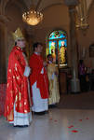

*(Photos courtesy of Martino Tangkar & Fr. Francis Li)*

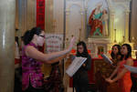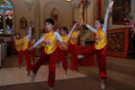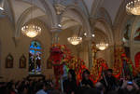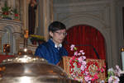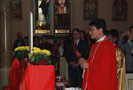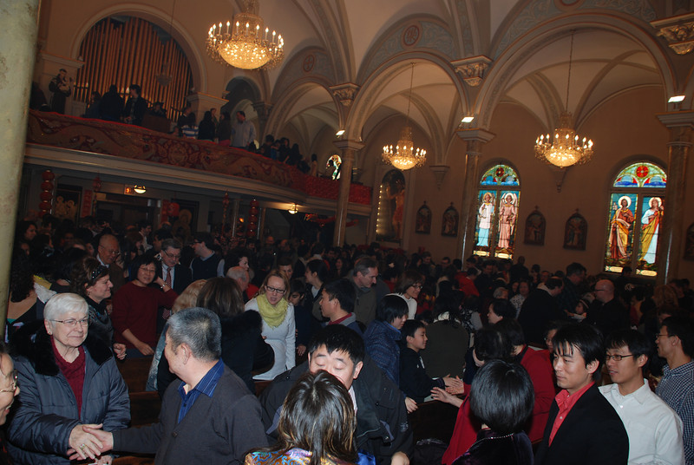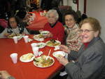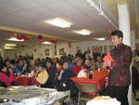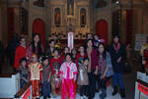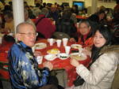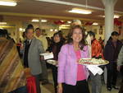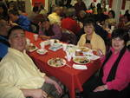

**Mass Intentions**

***Feb. 24, 2013 - Second Sunday of Lent***

**8:00A.M.** + Rocco Roti—8th Anniversary by Marion

**9:30A.M.** + Barry Yong by Mom June Moy

+ Carolyn Fields by Brenda McDevitt

**11:00A.M. Mandarin Mass**

+ Jung-Tsu Tien & Hui-Chu Ko by Family

***MON. Feb. 25th Lenten Weekday***

**8:00A.M.**  Birthday Blessings for Bernadette Zito by Briglio Family

Birthday Blessings for Bernadette Zito by Maria Vinci

+ Carolyn Fields by Brenda McDevitt

***TUE. Feb. 26th Lenten Weekday***

**8:00A.M.** + Michael Ng by Jonathan & Cheryl Chan

+ Carolyn Fields by Brenda McDevitt

***WED. Feb. 27th Lenten Weekday***

**8:00A.M.** + Neglected & Forsaken Souls in Purgatory by Dominic Barbaro

+ Catherine Spina by Zito’s

+ Carolyn Fields by Brenda McDevitt

***THU. Feb. 28th Lenten Weekday***

**8:00A.M.** + Michael Ng by Hubert & Kathleen Moy & Family

+ Birthday Remembrance for Catherine Spina by Briglio Family

+ Carolyn Fields by Brenda McDevitt

***FRI. March 1st Lenten Weekday***

**8:00A.M*.*** In honor of the Sacred Heart of Jesus

+ Catherine Gurgone by Daughter

+ Josephine Parrilli by Lucille Salerno

*+* Wai Chun Tse by Lucy Moy

***SAT. March 2nd Lenten Weekday***

**8:00A.M.** In honor of the Immaculate Heart of Mary

+ Carolyn Fields by Brian, Ed, MaryAnn, Marty, Sam and Wendy

**5:00P.M.** Friends and Parishioners of St. Therese

+ Josephine Parrelli by RoseAnn Gurgone

+ In Memory of Josephine Parrilli by Frank & Sophie Nardi

+ Michael Ng by Marie Chan

***From the Desk of Fr. Francis***

**Greetings of Christ’s Peace and Joy! Hope you all had a blessed week.**

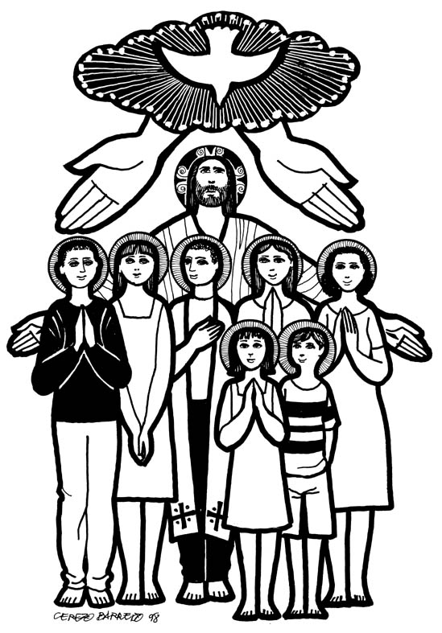

**Journeying with our Catechumens and Candidates**

Since last October, seven of our RCIA (Rite of Christian Initiation for Adult) members have met regularly to learn the teachings and practices of our Catholic Faith. Three of them are in our English RCIA Group and four of them are in our Mandarin Group. With the guidance of Rose Lau, Joyce Hsieh, and a few Chinese priests and sisters, who are studying at the Catholic Theological Union, all seven of them are ready to celebrate the Rite of Election this Sunday. This is a major step in their journey toward the Initiation Rites, namely Baptism, Confirmation, and First Communion, at Easter Vigil.

Why is the Election so important? It is because “the acceptance made by the Church is founded on the election by God, in whose name the Church acts (RCIA 119).” Election begins with God and is made concrete by the Church. God takes initiative to call these people to join God’s Church. Catechists and sponsors help them to respond to God’s call. The Church formerly accepts them by inviting them to enroll their names in the Book of the Elect after listening to the testimony of their readiness by their godparents and sponsors. Names are important. Signing one’s names symbolizes one’s willingness to give one’s life to God. This part is called *Sending Out Rite* and is usually done in one’s individual parish. Then the names and books are presented at the *Rite of Election*, which is usually presided over by the local bishops. After receiving their names, the bishop makes the following proclamation: *“I now declare you to be members of the elect, to be initiated into the sacred mysteries at the next Easter Vigil.”*

Our parish will celebrate the *Sending Out Rite* for our Catechumens and candidates this Sunday at the 9:30am mass. Then they, along with their sponsors and catechists will attend the *Rite of Election* at the Holy Name Cathedral at 2:30pm in the afternoon. Cardinal George will publicly accept them as the Elect. Having attended a few times at the Rite, I have always been inspired by the number of Catechumens and candidates and the spirit of the celebration. Every year, there are five services for Election offered at Holy Name for catechumens from all over the Archdiocese. All are packed. It’s good to see so many people being prepared for the Sacrament of Initiation at Easter Vigil.

As the RCIA members continue their journey, we, their faith community, are not speculators. We are called to pray for them, and to journey with them. “After the election, the entire community should surround the elect with prayer, so that the entire Church will accompany and lead them to encounter Christ (RCIA 121).” By our own baptisms, we are entrusted with the responsibility of supporting them. As they continue to deepen their knowledge and faith in Christ, we are called to strengthen our own faith.

Please keep Maureen McDonald, Mina Tse, Billy Biao, Eda Wang, Yupo J. Lin, Megumi Hayashi, and Shell Han in your prayers during this Lent. And may we find time and space to “*Deepen Our Faith in Christ*” this week and in the Year of Faith.

***~Peace, Fr. Francis***

***Year of Sunday Mass***

***Hospitality Schedule for March 3, 2013***

**GREETERS: Teresa Moy, John Moy, Tim Tie**

**RECEPTION VOLUNTEERS: Elisa, Rita & Renee**

**♪♫ Choir Corner ♫♪**

**February 24, 2013 – Second Sunday of Lent—Guitar Mass**

**PROCESSIONAL: # 574 - LEAD ME, GUIDE ME**

**OFFERTORY: #881 – REMEMBER YOUR LOVE**

**COMMUNION: #832 – LET US BREAK BREAD TOGETHER**

**RECESSIONAL: #590 – WE WALK BY FAITH**

**HELP NEEDED IN CHURCH TODAY!**

Can you spare some time today at 12:30pm?We need your helping hands to take down the Lunar New Year decorations so that we can prepare the Altar for Lent. Lunch will be provided. Please see Jade. Thank you!

**Catholic Relief Service Rice Bowl**

***Today*** *we begin our efforts at supporting the poor and needy throughout the world through our yearly Lenten collection for Operation Rice Bowl. There are many people in countries everywhere who are starving, are without adequate health care or quality education. Your generous offering is the sign of our care for those in need.* ***Please take a rice bowl and be as generous as you can for the poor of the world! It is a perfect and simple way to practice almsgiving during Lent!***

**RCIA Signing of Names**

*in the Book of the Elect during the 9:30AM Mass today.*

**RCIA Rite of Election**

*at Holy Name Cathedral today at 2:30pm.*

**Stations of the Cross**Fridays at 7:00pm preceded by supper at 6:00pm. On March 1st, benediction will immediately follow the Stations*. Please join in on this wonderful & prayerful tradition!*

**St. James Food Pantry** *St. James is in need of your helping hands on Saturday, March 9th starting at 8:30 A.M.. We need 10 volunteers to help with the distribution of food to many people from our community. Be a witness to St. Therese’s spirit of love and care for our friends and neighbors in need. They are counting on us! Please sign up at the church entrance table.*

**Catechists Certification Class “Liturgy Part I”** *will take place on Saturday, March 2nd from 9:00am to 3:00pm in the Community Room. All are welcome to attend. Please sign up at the church entrance table if you are planning to attend.*

**Ministry of Care**

*What is “Ministry of Care?” Ministers of Care are those people who visit the sick and homebound. They pray with them and bring them the Holy Eucharist when they cannot come to Church by sharing the Eucharist with them and by visiting them in their time of need. The Minsters of Care touch people deeply. Are you interested in this ministry? Please contact Father Li if you are interested*.

**ST. THERESE SCHOOL NEEDS OUR VOTES!!!**

**Please help our school for a chance to win $60,000 from the Follett Grant. Please vote each day and encourage others to vote as well. It’s easy to do! How to vote:**

1. Go to [www.follettchallenge.com](http://www.follettchallenge.com/)  
2. In the search type, "St. Therese School". You should see "St. Therese School: Little School Big Dreams" video. CLICK on this.  
3. On the right, you need to enter your email address. Click to submit.  
4. Then you need to confirm your vote through an email sent to your email address. (Check if the email went to your spam folder!)  
**VOTE ONCE A DAY through MARCH 18th.**

**Please ask family & friends to vote for St. Therese as well! Thanks for your support!**

**Computer Teachers**

*We need people who can teach basic computer skills in our parish. Requirements are:* ***a****) knows Microsoft Office, Google Docs;* ***b****) knows how to surf the internet, use and create Email* ***c****) can operate a printer,* ***d****) can commit to 1.5 to 3 hours a week* ***e****) knowledge of Cantonese or Mandarin preferred. If interested please contact Edy at eguwan@sttheresechinatown.org or call the church office at 312-842-6777.*

**Tax Letter***—if you would like to receive a tax letter for your 2012 donations to St. Therese, please contact the office at 312-842-6777.*

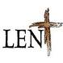

**2013 Updated**

**“Deepen Our Faith in Christ”**

**Stations of the Cross**

Fridays at 7:00P.M. in Church preceded by dinner in the Community Room at 6:00 P.M.

**Sharing on The Eucharist**

Fridays at 7:45P.M. following the Stations of the Cross in the Community Room,

except the 1st Friday in March, when **BENEDICTION** will take place instead of the sharing.

**Second Sunday of Lent –Feb. 24th** Distribution of the Rice Bowls

**Service**

We will help out at St. James Food Pantry on Saturday March 9th, and Sisterhouse (date TBA). Volunteers are needed.

**RCIA**

*Sending out Rite for Election will take place at the 9:30am Mass on the Second

Sunday of Lent-Feb. 24th.

*The Rite of Election will be on Feb. 24th at 2:30pm at Holy Name Cathedral.

*Scrutiny Rites will be celebrated on the 3rd, 4th and 5th Sundays of Lent.

**CCD**

*Reconciliation will take place on Sunday, March 10th after the 9:30A.M. Mass.

*CCD students Lenten project on Sunday March 17th

*Catechists will take their third class on ***Liturgy*** toward certification on Saturdays March 2nd and 9th from 9:00A.M. to 3:00P.M. in the Community Room.

**All are welcome**.

**First Reconciliation**

For CCD and School students will take place on March 16th at 10:00am.

**Parish Retreat and Communal Reconciliation**

Date TBA

**March Mandarin Mass**

Will be on March24th followed by an afternoon of reflection and prayer.

**REPENT, AND BELIEVE IN THE GOOD NEWS!**

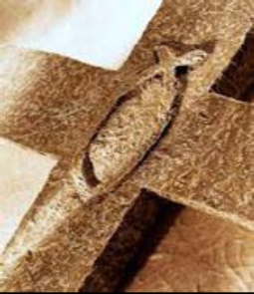

**Lenten Regulations**

**(Beginning February 13, 2013– Ash Wednesday, to the Paschal Triduum)**

**Abstinence** from meat is to be observed by all Catholics 14 years old and older on Ash Wednesday and on all the Fridays of Lent.

**Fasting** is to be observed on Ash Wednesday by all Catholics who are 18 years of age but not yet 59. Those who are bound by this may take only one full meal. Two smaller meals are permitted if necessary to maintain strength according to one’s needs, but eating solid foods between meals is not permitted. The special Paschal fast, as well as abstinence, are prescribed for Good Friday and encouraged for Holy Saturday.

***“Lent is ordered to preparing for the celebration of Easter, since the Lenten liturgy prepares for celebration of the Paschal Mystery both catechumens, by the various stages of Christian Initiation, and the faithful, who recall their own Baptism and do penance.”***

(Universal Norms on the Liturgical Year, #27)

By the threefold discipline of fasting, almsgiving and prayer the church keeps Lent from Ash Wednesday until the evening of Holy Thursday. All of the faithful and the catechumens should undertake the serious practice of these three traditions. Failure to observe penitential days totally or a substantial number of such days must be considered serious.

“(On) weekdays of Lent, we strongly recommend participation in daily Mass and self-imposed observances of fasting. In light of grave human needs which weigh on the Christian conscience in all seasons, we urge particularly during Lent, generosity to local, national and world programs of sharing of all things needed to translate our duty to penance into a means of implementing the right of the poor to their part of our abundance.”

(U.S. Bishops statement on penitential observances, 1966.)

**Weekly Offering:**

Collection for February 17, 2013

Sunday Envelopes $2,504

Sunday Loose $ 1,403 July 1-To-Present (Actual): $68,809

Total Collection $3,907 July1-To -Present (Budget): $68,000

Weekly Budget: $2,000 % of Budget Attained: 101%

Please consider giving one hour of your weekly salary as your contribution.

***May God bless your generosity! Thank YOU!***

***Good News! / dear Padre***

***Ads***

**Please remember in your prayers those who are**

**ill, hospitalized, and homebound...**

Sarah Phillips Marie Balestri Carmella Scanlon

Natasha Chang Lucille Iasillo Carmen (Rails) Balestri

Dominic Barbaro Winnie So Vincent Thome

Barbara McElroy Barb Davis Rose Perez

Ramona Zavala Ken Barber Nicholas Tobar

Michael Howley Lauren Mandel Ruth Barone

Bernie Presto YoYo Damico Dolly Roti

Lina Andriacchi Baby Jessa Piotrowski Sister Noel Devine

Su Zhen Liao Fr. Walter Johnson, MM Michele Young

Sister Elizabeth Lee John Galvin Wu Wai Hing

Shirley A. Bills Barbara Maung Lan Ying Yee

John Palenik Roseann Gurgone Carolyn Fields

Frank Nardi David Leung Alice Young

John Piegari Bai Xue Ching Siu Yau

Leonard Louie *Richard Tobar Sister Agnes Christina*

Pam Ecklund Betsy Young Joseph Leung

Jane Lee Mary Balestri

If you wish to add a name or remove your name from this list, please call the parish office.

**—”Let us build a tent…”**

Every once in a while we have unusual experiences, It might be a party we wish would never end. It might be seeing a friend, going to a special place. It can even be prayer experiences we carry in our hearts which we wish would never end. Many of these experiences are not planned. They just happen. That event is never again experienced the same way. Even if we go back to the same place the experience is not the same. Try as we might we cannot re-create it.

When Jesus took Peter, James and John up the mountain to pray, they probably did not expect anything unusual to happen. They had prayed with Jesus before. In scripture, going up a mountain often led to an unexpected encounter with God. Jesus’ appearance changed. They had a vision of men talking with Him. Falling asleep, reawakening , they see Jesus glorified. Being awe struck and overwhelmed, Peter says , “Lord it is good for us to be here. Let us build a tent...” Let us stay in this experience forever. Let us live here. A cloud overshadows them and fear fills them. As they are in the cloud they hear the Father’s voice, “This is my chosen Son: listen to Him.“ In seconds the experience ends and they see only Jesus. They do not discuss the experience. They carry it with them as they go toward Jerusalem. Perhaps it will be a source of strength as they experience Jesus’ Passion and Death.

What experiences in your life do you remember and treasure? How have they brought encouragement and energy, hope and new life to you? Who are the people whose presence brings joy, those whose coming you await? Do you take time to reflect on these experiences and draw strength from them? Can you begin to look at your daily experiences as sources of strength which God sends each day to bring you life and joy? Do you stop and reflect? Can you be grateful for even the difficult times? Are you too busy? The good passes you by without remembrance or gratitude. The event ends, the person dies and we have not “***Listened to Him***”, we have not taken the time to see God in our everyday lives. **Begin Now!**

**~Sr. Caritas**

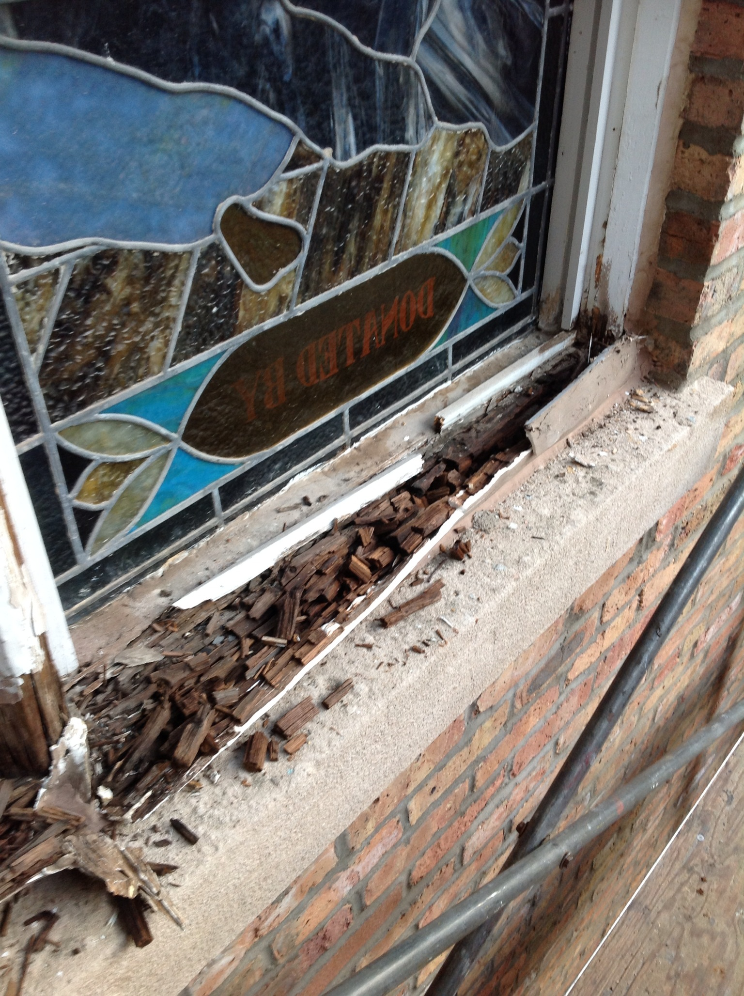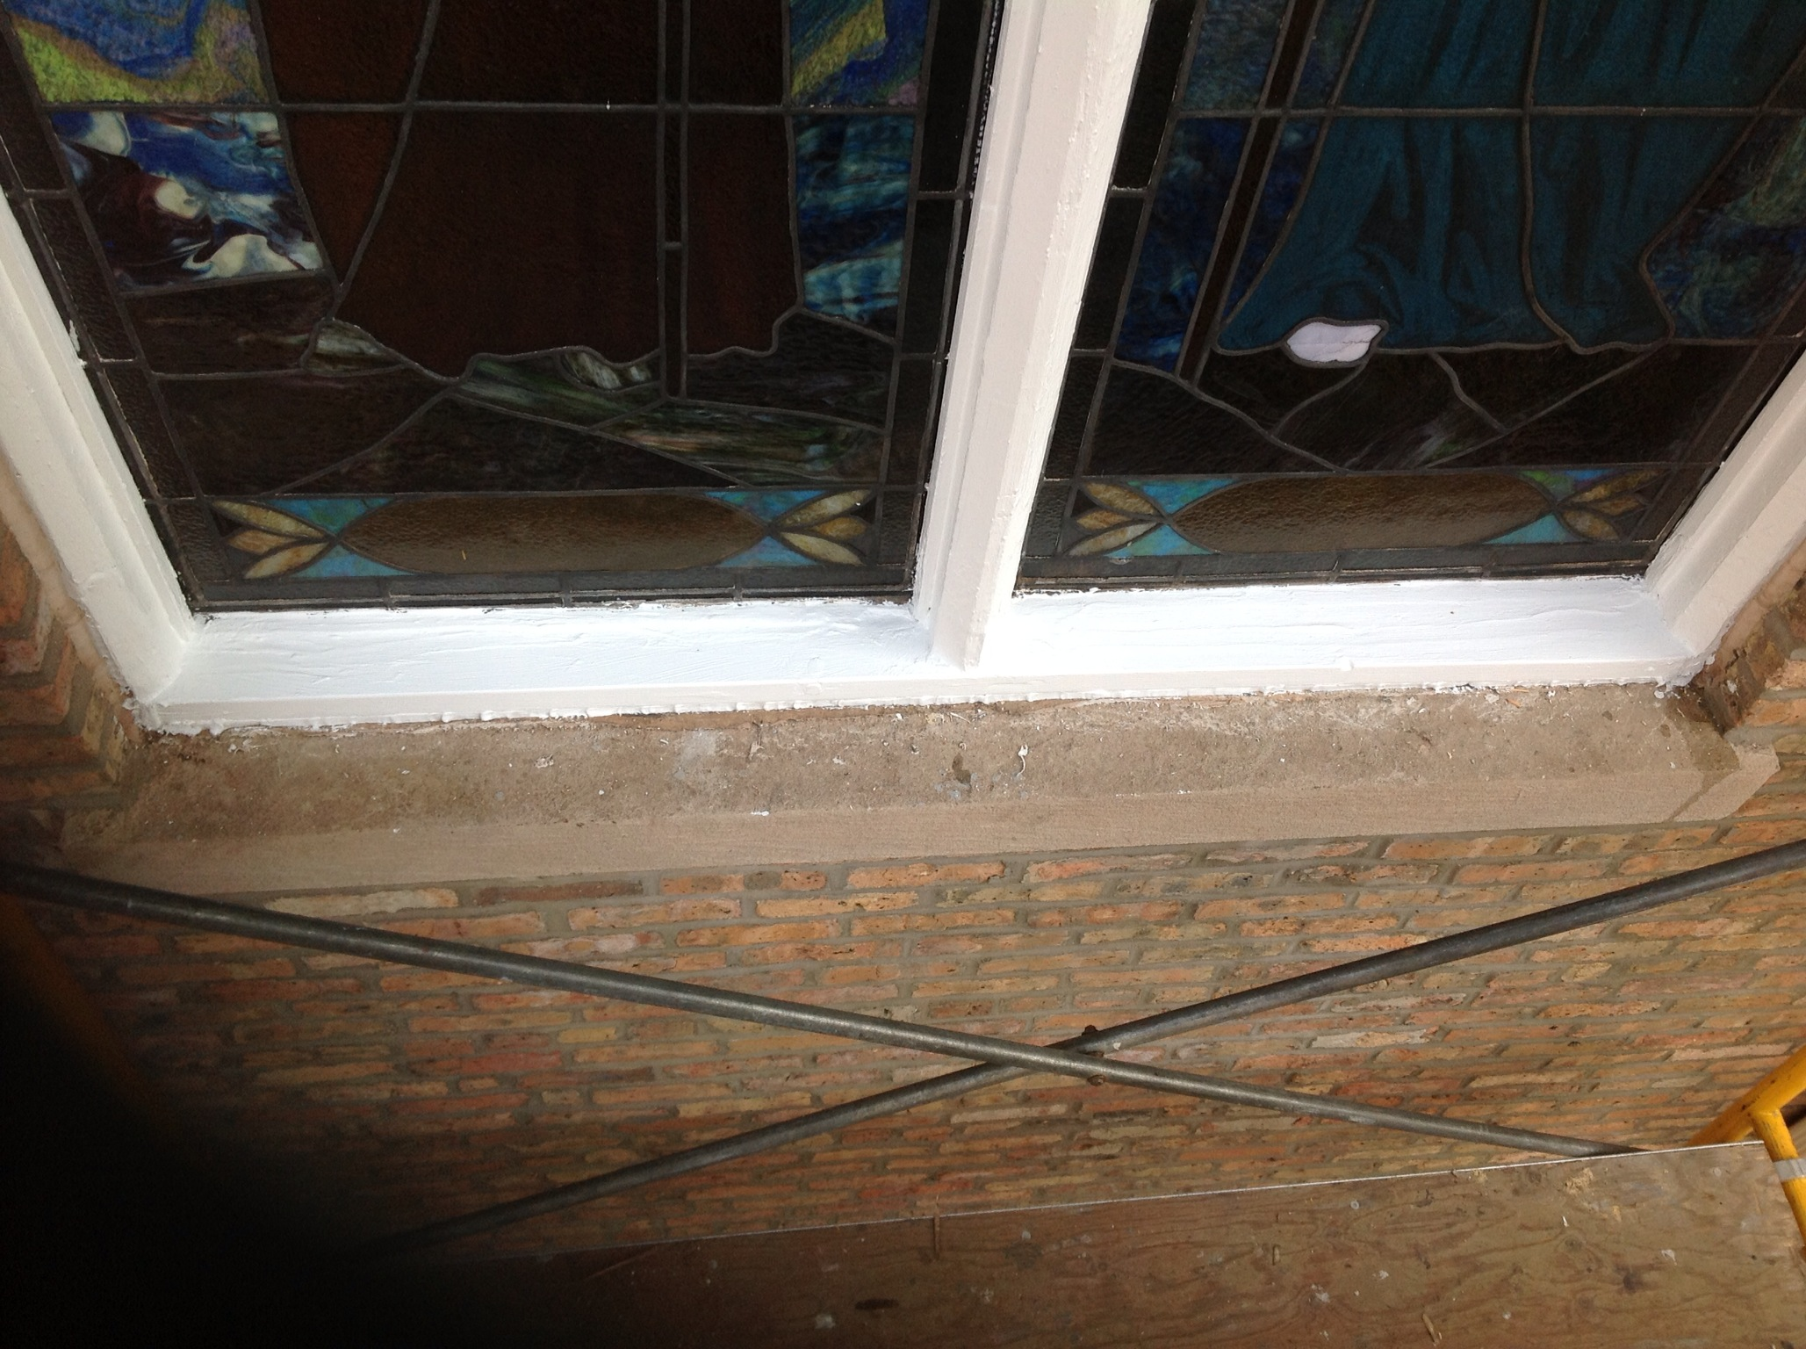

Before) (After)

Church Stained Glass Window Repair Appeal

Due to old age, our church window frames and parts of the damaged stained glass are in great need of care and repairs.  These stained glass windows add much beauty to our church and are part of the precious history of this parish, as donated by parishioners of decades ago.

To prevent further deterioration, we have engaged a firm to repair all 20 of these stained glass windows to bring them back to good form. The average repair cost is around $1,900 per window.   **\*\*\*UPDATE:**

**The entire exterior work for our church window repair and broken stained glasses have completed. Unfortunately, this is not the end of the project. As with fixing up any old windows, there is a higher chance of surprise.**  **It’s now been confirmed that we need to replace a few of the moon-shaped top window frames on the inside. With the additional work on the inside window frames, our estimated total cost of this project is now $55,000. We hope to complete the next phase of this work as soon as possible.**

**We need your support for this project.  If you would like to make any donations toward the window project, please mark your contributions with “*Window Repairs*.”** *T****hank you to all who have already made a donation:***

***Paul &Cindy Lau: $2000* Francine Caruso: $100**

***James &Akina Moy: $1000* Bonnie Tse: $100**

***Dan &Pam Spano: $130* Kevin Wu (Sweet Station): $100**

***Shu Man & Florence Yu: $300* Frank S. Scuito: $100**

***Chris & Darlene Lowe: $500* Peter Blais: $50**

***N. N.: $200* Teresa Au: $50**

***N. N.: $100* Phyllis & Rose Marie Centofanti: $100**

***Sacred Heart Ladies Club: $1000* Wendy Fluder: $100**

***The May Family: $2105* Frank & Sophie Nardi: $500**

***Betsy Young & Woodie Lee: $50* Dominic Barbaro: $200**

***Wanda Stearns: $50* Richard & Rita Young: $200**

***Lucille Salerno: $100* Edy & Lisa Gunawan: $100**

***Santa Maria Incoronata : $ 1000* Annie Lowe: $100**

***Albert & Bernie Wong: $200* Menacita Chan: $100**

***Rose Cho: $2000* Gemma Wong: $200**

***Dominic Lai: $380* Jennifer Chan & Jorge Morales: $50**

***Robert Lee: $10* Tony Lin & Sharon Wong: $355**

***Larry A. Pusateri : $500* Wendy Sin: $500**

***Eugene & Geraldine Kwan: $100* The Tse Family : $53**

***Gene & Teresa Lee: $200* Renee & George Fong: $53**

***Gary & Linda Leong: $200* The Urso Family: $500**

***Wesley & Sharon Wong: $100* Gertrude Chan: $50**

***Sandra Moy: $100* Leonard & Elaine Louie: $1900**

***Sharon Yu: $1000* Joseph DiFazio: $100**

***Ray Lin (The Lin Family): $500* Lucille Salerno: $500**

**Mr. & Mrs. William Moy: $50 Joseph & Bernadette Zito: $100**

**Andrew & Eva Feng: $1900 Michael & Sevila Schiml: $150**

**Fr. Francis Li: $100 Mr. & Mrs. Francis Degnan: $75**

**Mr. & Mrs. Vincent Briglio: $100**

**Mr. & Mrs. John Lusak: $1000**

**Augustine & Donna Gonzalez: $200**

**BULLETIN TOTAL AS OF 02/24/13: $23,661**

**A plaque of remembrance will be placed in the church in gratitude to all the donors at the end of the project.**