Mass Intentions

Feb. 3, 2013 - Fourth Sunday in Ordinary Time

8:00A.M. + Benny Chan by Children and Grandson

9:30A.M. + Benny Chan by Darlene and Nicole

MON. Feb. 4th Weekday

8:00A.M. + Peter F. Caruso by Family

TUE. Feb. 5th Saint Agatha, Virgin and Martyr

8:00A.M. Blessings on Frank and Sophie Nardi by Maria Vinci

WED. Feb. 6th Saint Paul Miki and Companions, Martyrs

8:00A.M. Blessings on Robert and Sara Phillips by Maria Vinci

THU. Feb. 7th Weekday

8:00A.M. Blessings on Anna Marie Caponigri by Godson Jim Vinci, Sr.

FRI. Feb. 8th Saint Jerome Emiliani, Saint Josephine Bakhita, Virgin

8:00A.M. + David Jarzyna -Birthday Remembrance by Wife Cookie
+ John Nudo, Sr. by Son, Tony
+ Catherine Gurgone by Family
+ Deceased Friends and Relatives of Dominic Barbaro

SAT. Feb. 9th Weekday

8:00A.M. + Don Yee Chan and Family by Monica Lam

5:00P.M. Friends and Parishioners of St. Therese
+ Josephine Parrilli by Rose Ann Gurgone
+ Josephine Parrilli by by SMI Club

From the Desk of Fr. Francis
Greetings of Christ’s Peace and Joy! Hope you all had a blessed week.
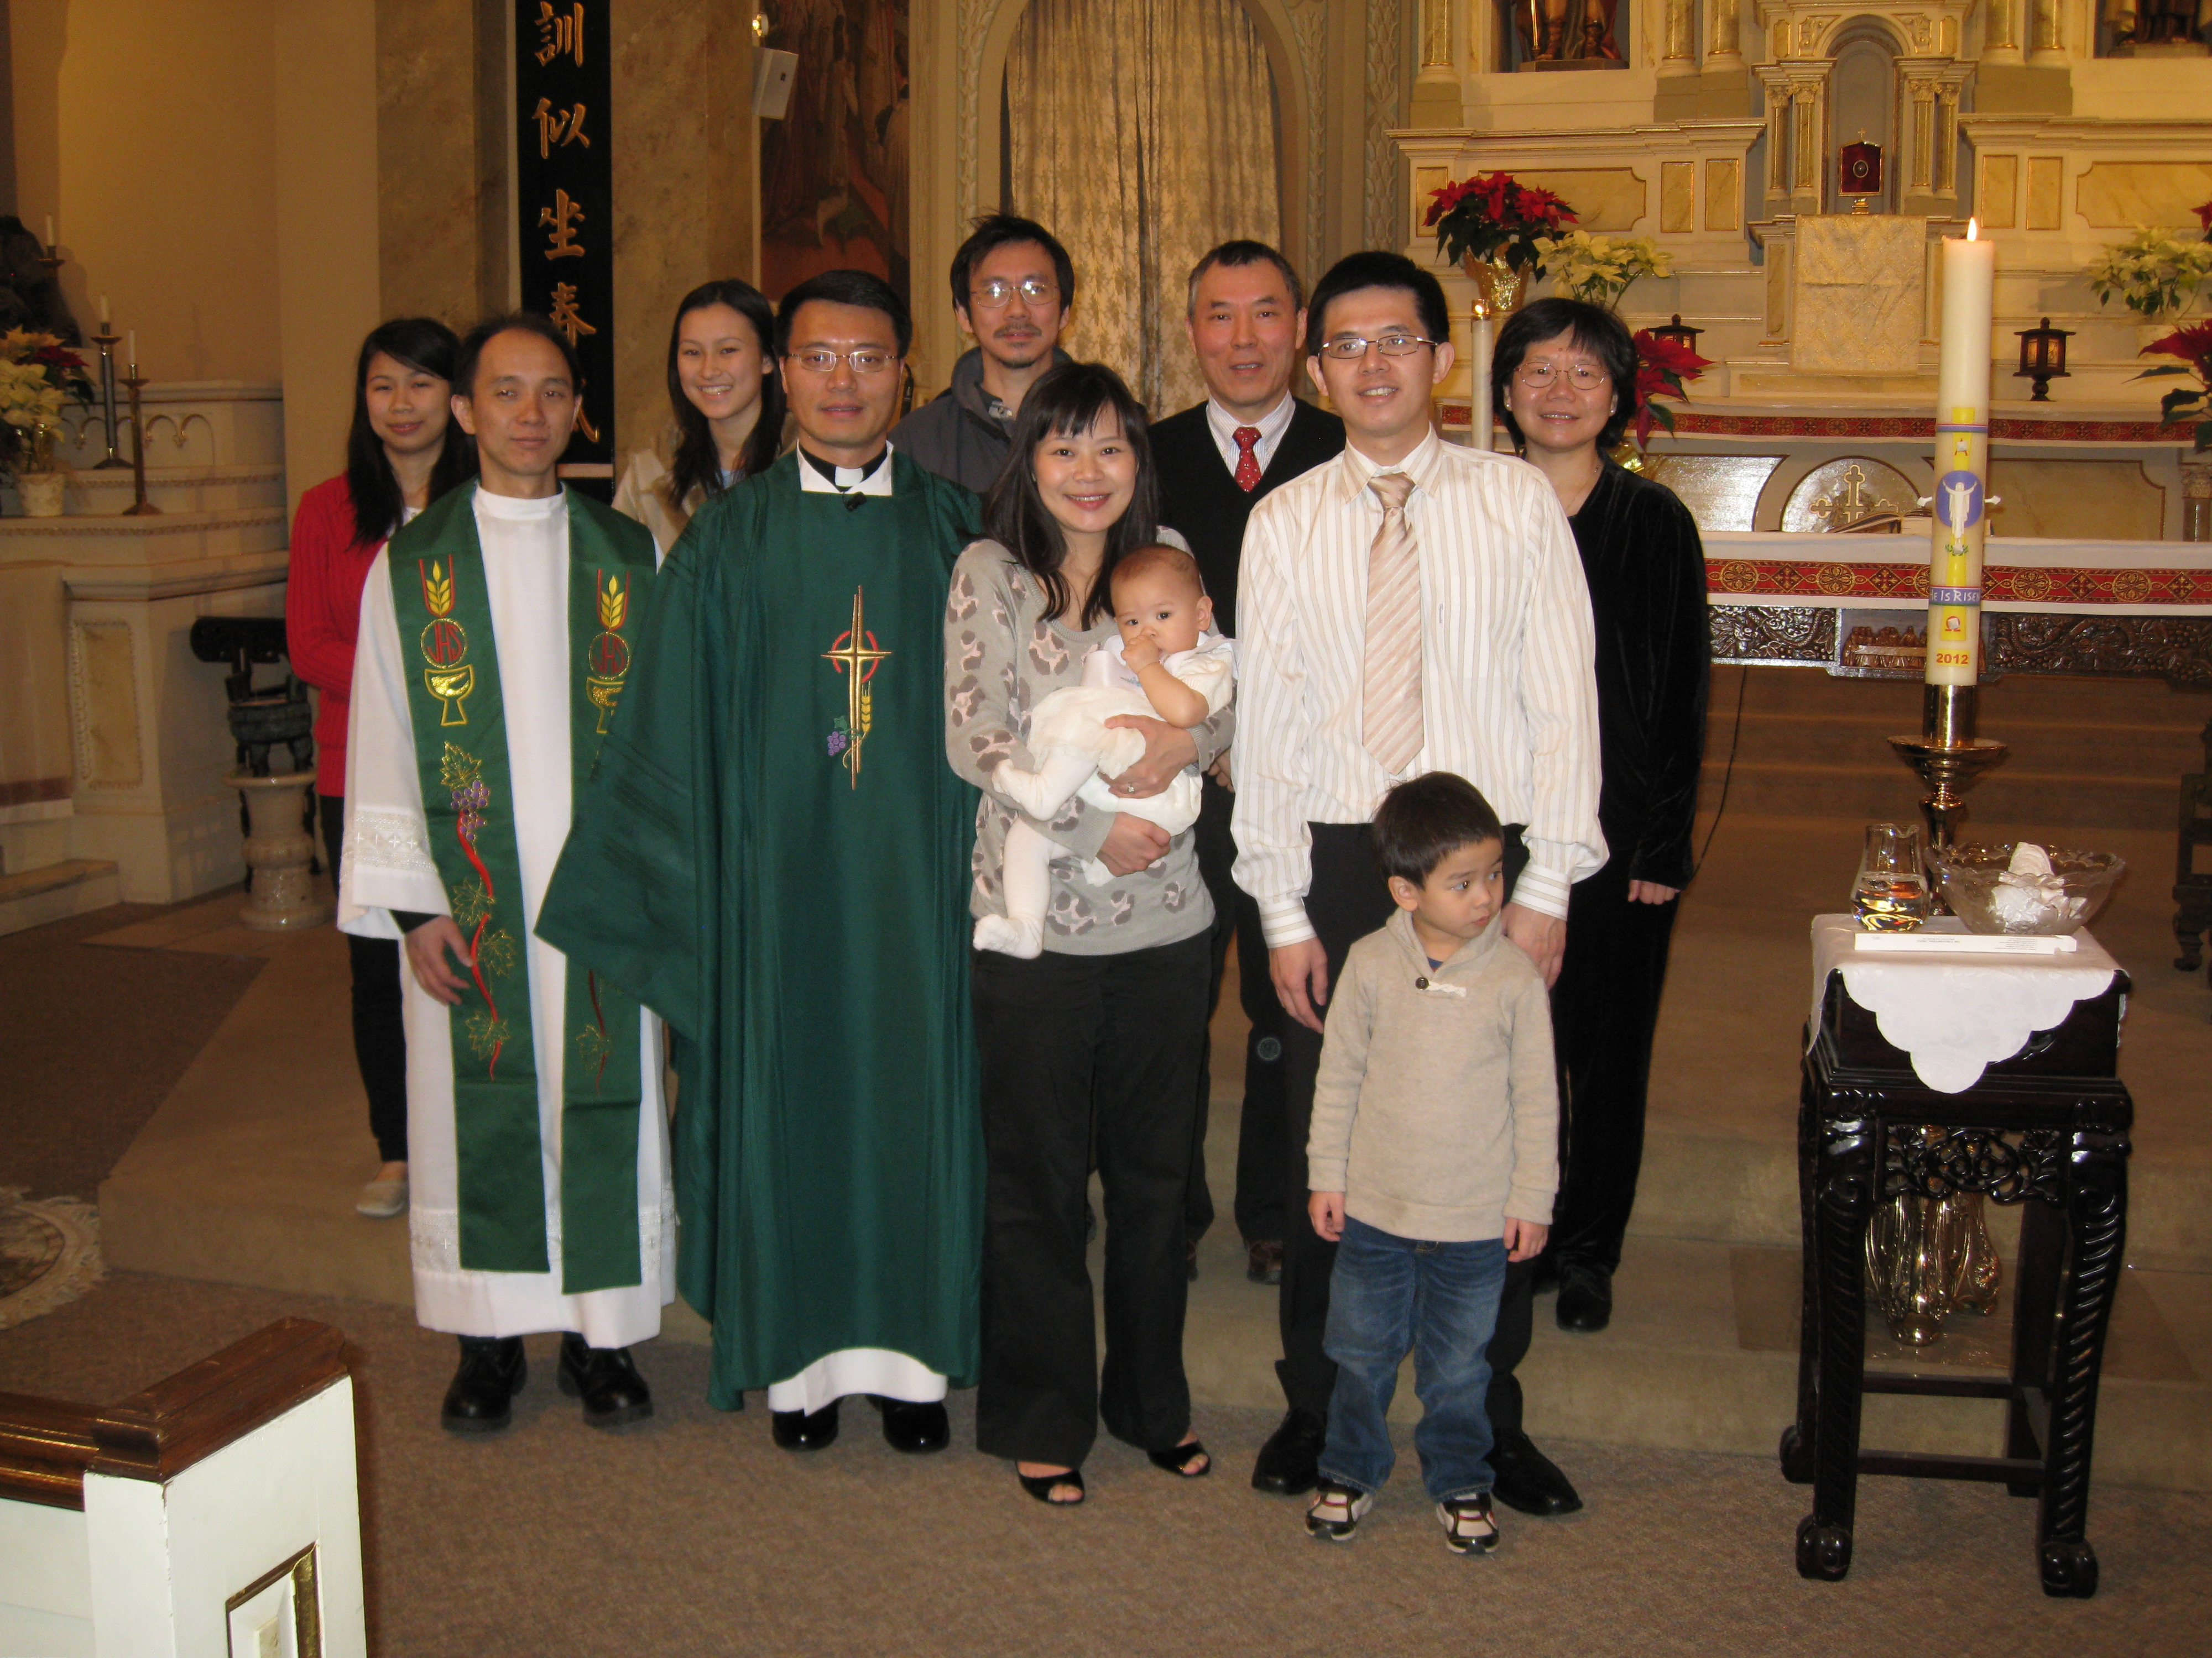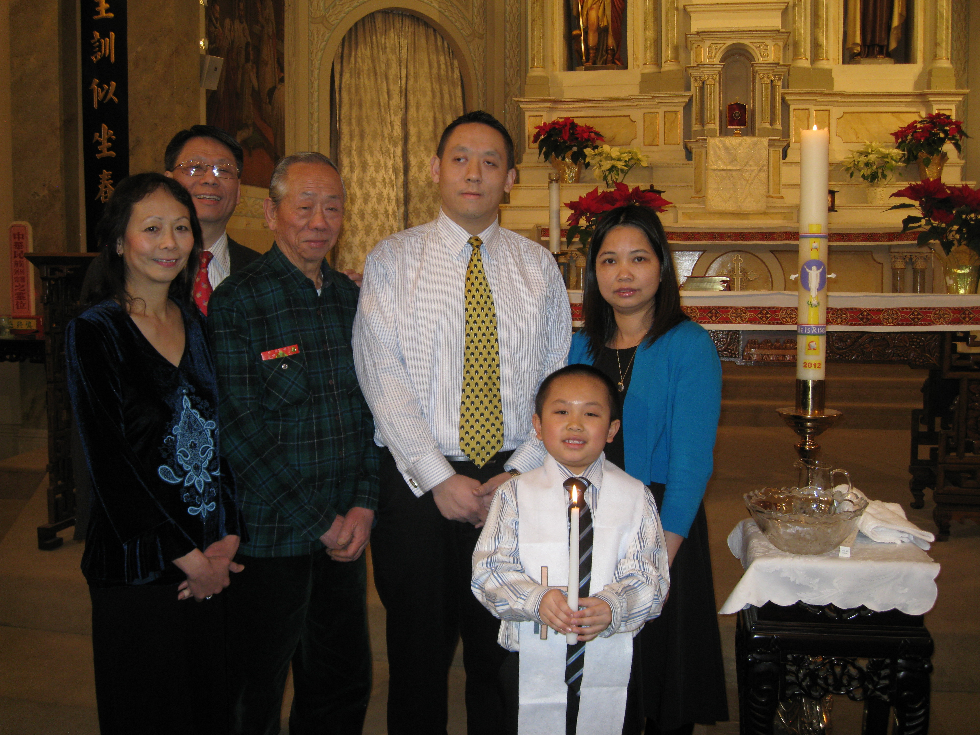

(Nathan with Family) (Annabelle with Family & Friends)

Congratulations
Congratulations to Nathan Lau, 2nd grader at St. Therese School, son of John Lau and Ivy Huang. Nathan was baptized in our Church on Sat. Jan. 26th. Congratulations to Annabelle Hsu, daughter of Shih-Hsun Hsu and Hsiao-Wei Chang. Annabelle was baptized in our Church last Sunday. We welcome them and assure them of our prayers.
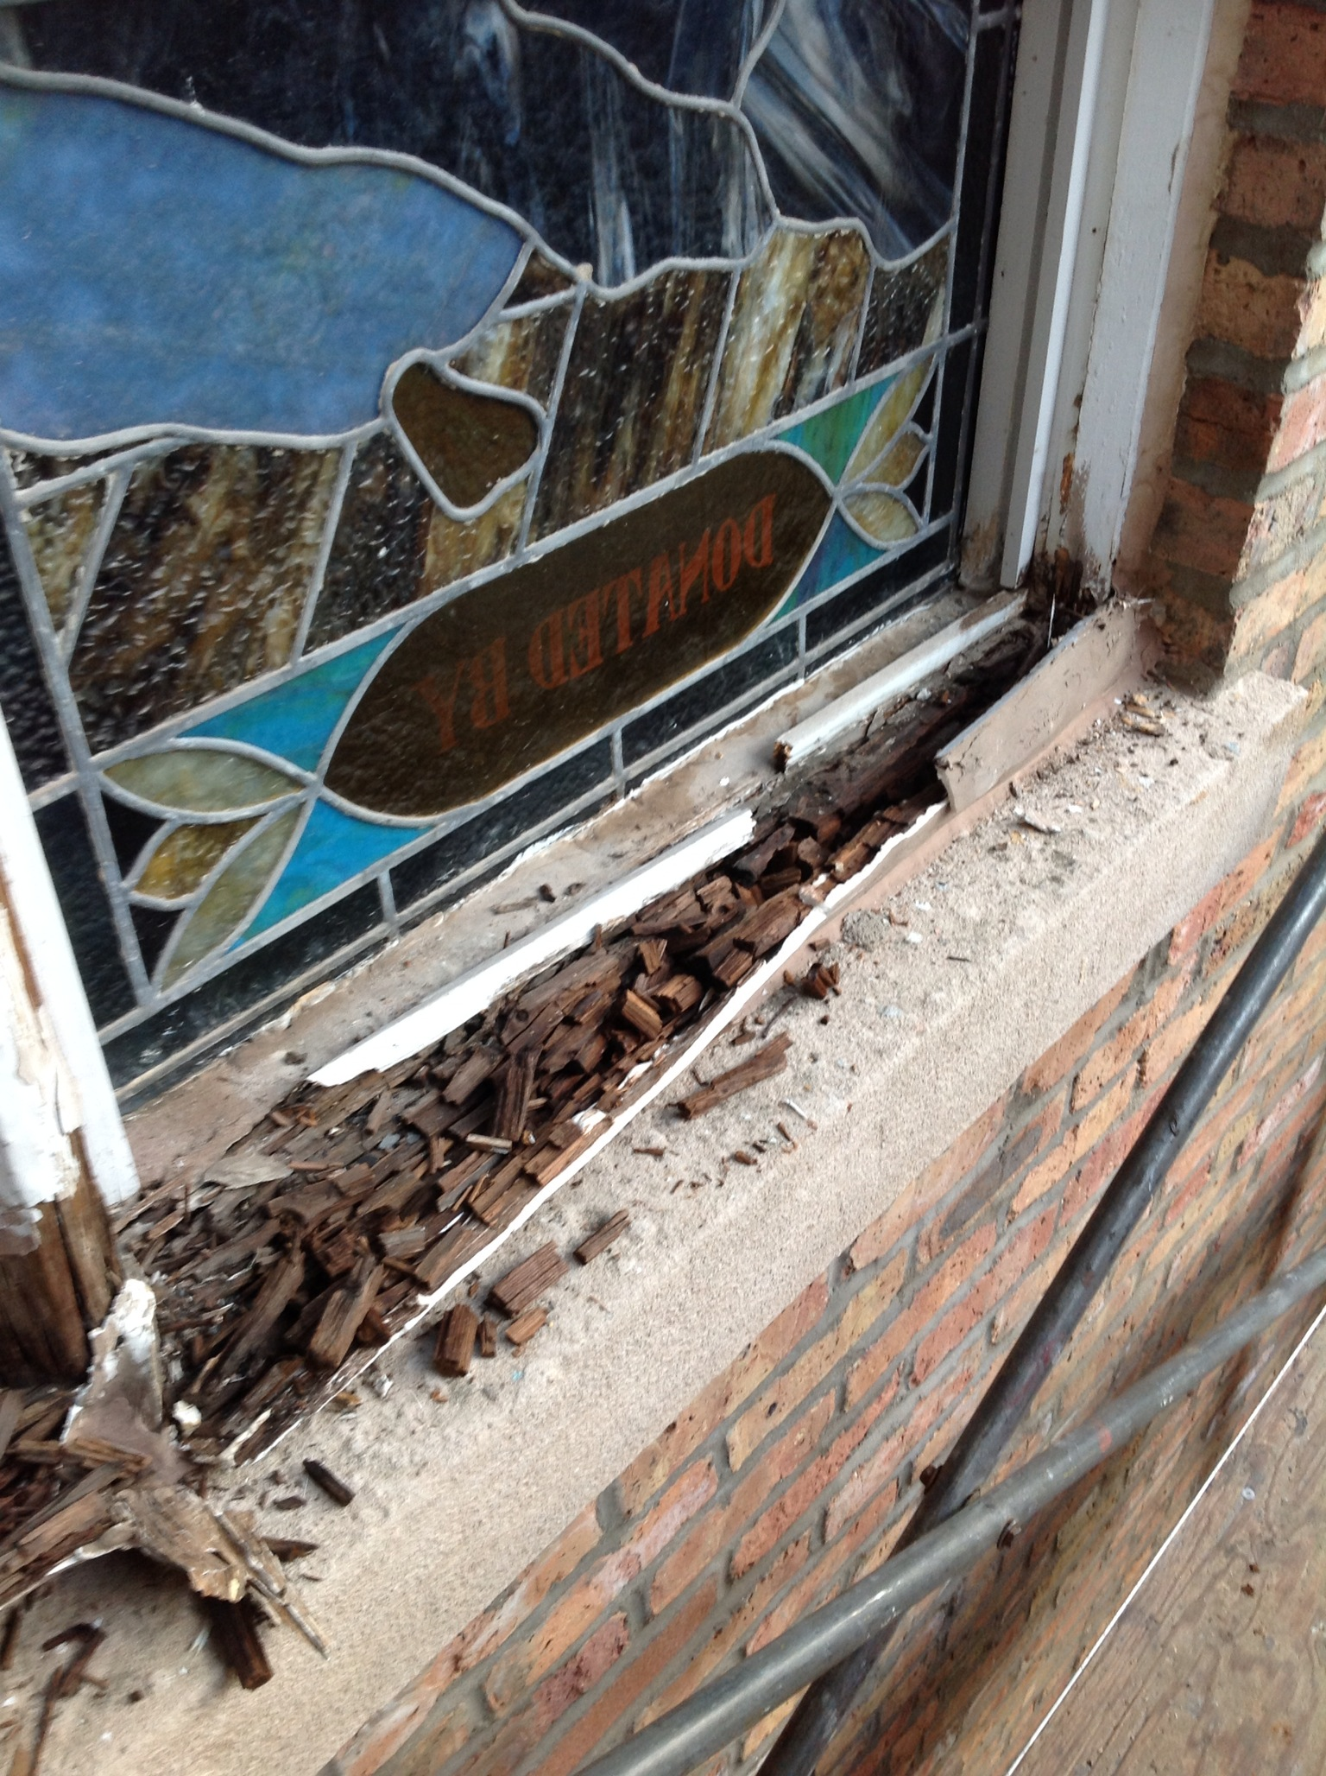

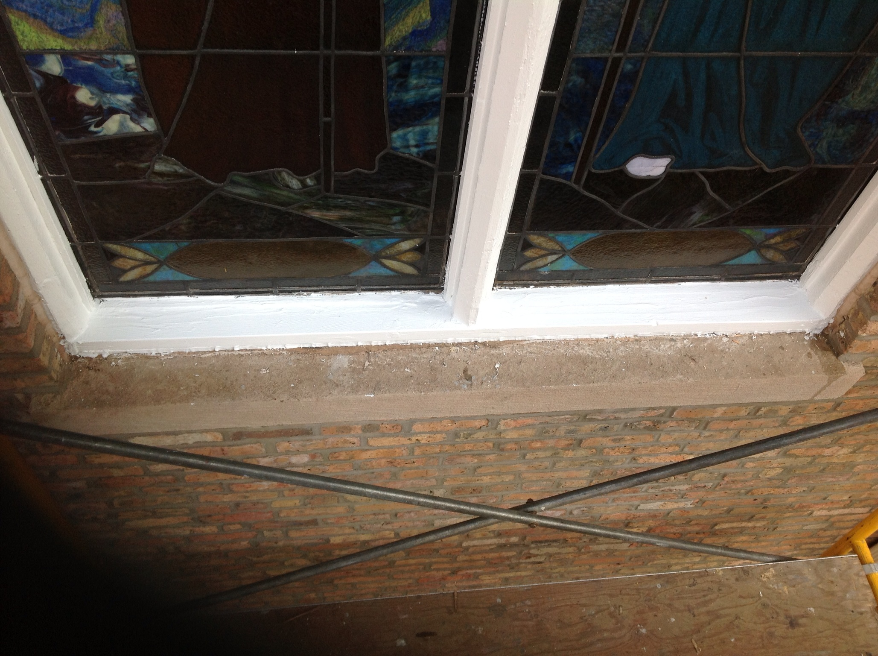

(Before) (After)

Update on Church Window Repair
The entire exterior work for our church window repair and broken stained glasses have completed. The rotten sills were replaced; window frames were fixed and painted; and protective glasses were replaced; and new screens were installed for all the moon shaped windows. With new technology, the newly installed protective glasses not only protect the stained glasses, but the wood frames as well. It prevents possible damages caused by dust, sunlight, and rainwater. Many of you have remarked to me on how beautiful our Church windows look from outside. We are pleased with the job that our chosen contractor has done for us. Unfortunately, this is not the end of this project. As with fixing up any old windows, there is a higher chance of a surprise. I was told that there are a few moon shaped top window frames that need to be replaced. This calls for a second phase of the project. This will increase our cost. We are waiting for the proposal. We hope to have it done as soon as possible. I will keep you posted. Thanks to all who have contributed to this project. Those who are thinking to make a donation to this cause, you may still do so. Your generosity helps us to preserve our treasured stained glasses for the next generation of the faithful disciples of Jesus Christ at St. Therese.

Blessing of Throats
Blessing is a traditional ritual we carry on in our daily lives. We bless ourselves with the holy water. We bless others with well wishes. We have our houses, cars, holy medals blessed. Blessing is rooted in the ministry of Jesus Christ and his apostles. As we celebrate the Feast of St. Blasé, we have our throats blessed this weekend after all the masses.

A priest or a lay minister touches the throat of each person with the crossed candles and says the prayer of blessing. “Through the intercession of Saint Blase, bishop and martyr, may God deliver you from every disease of the throat and from every other illness: In the name of the Father, and of the Son, + and of the Holy Spirit.” Each person responds: “Amen”.

As we celebrate the Fourth Sunday in Ordinary Time, may we find time and space to “Deepen Our Faith in Christ” this week and in the Year of Faith! Peace, Fr. Francis

Hospitality Schedule for February 10, 2012
GREETERS: Carl DiFranco, Janet Fectau, Samantha Ng
RECEPTION VOLUNTEERS: Nancy, Lushia

♪♫ Choir Corner ♫♪
February 3, 2012– Cantonese Mass
PROCESSIONAL: p. 25, # 73 – Before God
OFFERTORY: p. 36, # 89 – My Hands I Give to You
COMMUNION: p. 38, # 91 – When I Receive the Body & Blood of Christ
RECESSIONAL: p. 50, # 107 – Sun for All Hearts
2013 Annual Catholic Appeal
St. Therese’s 2013 Target is: $8723.

Year of Sunday Mass

2013 Annual Catholic Appeal

2013 Annual Catholic Appeal
St. Therese’s 2013 Target is: $8723.
This is Commitment Weekend: Feb. 2 and 3. The theme of this year’s Annual Catholic Appeal is taken from St. Paul’s first letter to the Corinthians, LOVE NEVER FAILS.

Super Duper Bowl Sunday! Attend the XLVII super bowl party at St. Therese on Sunday, Feb. 3rd from 4:00pm to 9:00pm. Enjoy the game with friends and good food! Thanks and good luck to those who bought a square for a chance to win!

2013 Lunar New Year Celebration will take place on Sunday Feb. 17th at the 9:30am mass followed by a luncheon. Bishop Alberto Rojas will be with us this year. Please save the date and invite your families and friends to join us for this annual special festivity.

St. James Food Pantry—We are again in need of 8 to 10 adult helpers for the St. James Food pantry for a few hours in the morning of Saturday, February 9th. Sign up sheet is on the church entrance table.

Tax Letter—if you would like to receive a tax letter for your 2012 donation to St. Therese, please contact the office at 312-842-6777

Church Stained Glass Window Repair Appeal
Due to old age, our church window frames and parts of the damaged stained glass are
in great need of care and repairs. These stained glass windows add much beauty to our church and are part of the precious history of this parish, as all were donated by parishioners of decades ago.
To prevent further deterioration, we have engaged a firm to repair all 20 of these stained glass windows to bring them back to good form. The average repair cost is around $1,900 per window.
We need your support for this project. If you would like to make any donations toward the window project, please mark your contributions with “Window Repairs.” Thank you to all who have already made a donation:

Paul and Cindy Lau: $1000
James and Akina Moy: $1000
Dan and Pam Spano: $100
Shu Man and Florence Yu: $300
Chris and Darlene Lowe: $500
N. N.: $200
N. N.: $100
Sacred Heart Ladies Club: $1000
The May Family: $2000
Betsy Young & Woodie Lee: $50
Wanda Stearns: $50
Lucille Salerno: $100
Santa Maria Incoronata : $ 1000
Albert & Bernie Wong: $200
Rose Cho: $2000
Dominic Lai: $380
Robert Lee: $10
Larry A. Pusateri : $500
Eugene & Geraldine Kwan: $100
Gene & Teresa Lee: $200
Gary & Linda Leong: $200
Wesley & Sharon Wong: $100
Sandra Moy: $100
Sharon Yu: $1000
Ray Lin (The Lin Family): $500
Mr. & Mrs. William Moy: $50
Andrew & Eva Feng: $1900
Fr. Francis Li: $100
Francine Caruso: $100
Bonnie Tse: $100
Kevin Wu (Sweet Stations): $100
Frank S. Scuito: $100
Peter Blais: $50
Teresa Au: $50
Phyllis & Rose Marie Centofanti: $100
Wendy Fluder: $100
Frank & Sophie Nardi: $500
Dominic Barbaro: $200
Rita Young: $200
Edy & Lisa Gunawan: $100
Annie Lowe: $100

BULLETIN TOTAL AS OF 01/30/13: $16,540

A plaque of remembrance will be placed in the church in gratitude to all the donors at the end of the project.

Questions & Reflections on Sunday Mass

When is it considered to be late for Mass? Or to leave too early?

Sunday Mass is not something we do just to cross a task off our to-do list for God. Rather, it is fuel for our lives; we become enriched with God’s Word in the Scripture, and God’s presence in the Eucharist. Each part is vital to nourishing the community of faith. The Liturgy of the Word challenges us and teaches us, preparing us to receive the Eucharist with inspired hearts. In order to model Christ, we must first come to know Christ. On the reverse, we cannot model Christ, no matter how well we may know His teachings, without His help. Through the Liturgy of the Eucharist, we are consecrated as a community into the living Body of Christ sent forth to serve the world. Every hymn sung and prayer recited for the day is based on a specific theme of the liturgy to enhance this message.

As such, it is important to view Mass as one experience of community prayer and inspiration, from the opening hymn through to the closing hymn. In fact, it is ideal to come to Mass early to have a few moments to center ourselves, calm our busy minds, and spend time in individual prayer to prepare ourselves for listening to the message of the liturgy.

That being said, we are human, and things happen. We have emergency calls, we can’t find our keys, the traffic is worse than we expected. In those moments, it is certainly better to enter Mass five minutes late than not to attend at all. There is no specific doctrine of the Church on when it is too late to come to Mass or too early to leave; it is left up to the discretion of the Pastor. For some, there is no specific limit. Leaving early once for an emergency is understandable; leaving habitually after Communion because you’ve received “the important part” diminishes the Mass experience. The important thing to remember is to attempt to attend the Mass in its entirety to receive the full experience of prayer.



Protecting God’s Children for Adults
Do you help out in our parish in a capacity involving children or young people? Would you like to chaperon or help out with one of our upcoming Youth Ministry events, or get involved with our CCD program?
If so, the Archdiocese asks that you be in compliance with their child abuse prevention program, known as Virtus, or Protecting God’s Children for Adults. If you are currently not but would like to become ‘Virtus Certified’, St. Therese is hosting two sessions: Wednesday, Feb. 6th from 6:00-9:00pm OR Saturday, Feb. 9th from 9am-12noon

Both sessions will take place at the St. Therese School basement. To register, go to: www.virtus.org and sign up, or else contact Steven Cottam at: scottam@sttheresechicago.org

Weekly Offering:

Collection for January 27, 2013

Sunday Envelopes $1,317
Sunday Loose $ 272 July 1-To-Present (Actual): $60,638
Total Collection $ 1,589 July1-To -Present (Budget): $62,000

Weekly Budget: $2,000 % of Budget Attained: 97%
Please consider giving one hour of your weekly salary as your contribution.
May God bless your generosity! Thank YOU!
Mandarin Mass of January 27, 2013: $527.00 Thank YOU!

Good News! / dear Padre

Please remember in your prayers those who are
ill, hospitalized, and homebound...
Sarah Phillips Marie Balestri Carmella Scanlon
Natasha Chang Lucille Iasillo Carmen (Rails) Balestri
Dominic Barbaro Winnie So Vincent Thome
Barbara McElroy Barb Davis Rose Perez
Ramona Zavala Ken Barber Nicholas Tobar
Michael Howley Lauren Mandel Ruth Barone
Bernie Presto YoYo Damico Dolly Roti
Lina Andriacchi Baby Jessa Piotrowski Sister Noel Devine
Su Zhen Liao Fr. Walter Johnson, MM Michele Young
Sister Elizabeth Lee John Galvin Wu Wai Hing
Shirley A. Bills Barbara Maung Lan Ying Yee
John Palenik Roseann Gurgone Carolyn Fields
Frank Nardi David Leung Alice Young
John Piegari Bai Xue Ching Siu Yau
Leonard Louie Richard Tobar Sister Agnes Christina
Pam Ecklund Betsy Young Joseph Leung
Jane Lee Mary Balestri

If you wish to add a name or remove your name from this list, please call the parish office.

“What Do You Seek? “

Many times in our lives we are looking for something. We look for answers to questions. We look for information about jobs, entertainment or ways to do things better. Some of our time is spent looking for another place to live or a way to end pain or illness. We search for many different things each day of our lives

If we reflect seriously on our spiritual lives many of us will find deep inside of us, a hunger and thirst for God, His presence in us, and the experience of God’s love for us. God places many situations and experiences in our lives but we do not always see events as God’s active love. Sometimes we look at situations as God’s punishment. Most of the time that is not a correct judgment.

Sometimes we are asking God,” What should I do to please you.” St Paul writes about Spiritual gifts. He describes various actions but tells us they all mean nothing if we do not love. How do you know if you love? His writing tells us that love has the qualities of patience, kindness, freedom from jealousy or boasting. Love is not self- seeking, or easily angered, rude, nor is love happy over evil. Love is happy about the truth. Love ”bears all things, believes all things,, hopes all things, endures all things and never fails.” Place your life of love against these characteristics and virtues and see how much you need to grow. This virtue of love is “The Gift” to seek. Real loves lasts forever.
~Sr. Caritas
Ads

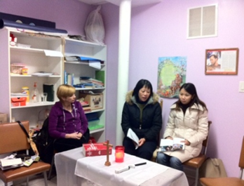

Update on Landings
The Landings program started on January 18th, 2013 at St. Therese Chinese Catholic Church. This program welcomes returning Catholics to the Church by giving them a gentle place to land.
Meetings are held on Thursday evenings from 6:30 to 8:30pm in the St. Francis Assisi room in the church. Please let any inactive Catholic know who is thinking about reconnecting with their faith that WE ARE STILL OPEN to taking new participants! Please call the parish office before Feb 7th at 312-842-6777.

“Love Never Fails!” 1 Cor 13:8

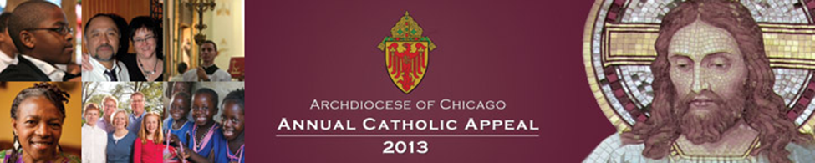

Please remember that the Annual Catholic Appeal campaign is much different than a one-time special collection. It is a pledge campaign where you can make a gift payable in installments.

As you review the work enabled by your contribution to the Annual Catholic Appeal, please reflect on God’s gifts to you. He has given you all that you have. Your gifts to our parish, to the Archdiocese and to the work of the Church throughout the world are given in gratitude for the continuing gifts that God gives you.

Sometimes it is difficult to envision how one pledge can help an organization the size of our Archdiocese, how it can make a real difference. But each pledge does make a difference because all parishes participate in the campaign and the gifts of many enable our Archdiocese to deliver needed ministries and services.

Our combined gifts not only signify our gratitude to God, they fund a significant portion of the work of our Archdiocese. After our parish goal of $8723 is reached in cash, 100% of the additional funds come back to our parish to help to fund our needs.

If you received your pledge form in the mail, please complete it and mail it back or bring it to Mass next weekend. For those of you that did not receive a mailing or have not had time to respond to it, we will conduct our in-pew pledge process at all Masses this weekend.

Thank you for your prayerful consideration and generous response.

