**Mass Intentions**

***May 13, 2012 - Sixth Sunday of Easter***

**8:00A.M.** Special Blessings for Tommy & Haidee Longmire by Nancy Longmire

Special Blessings for Pat Eaves by Lucille Salerno

+ Lena Roti by Cookie

+ Jeanette Moy by Family

+ Nancy Caruso by Family

+ Jennie Bertucci, Antoinette Briglio & Catherine Spina by

Briglio Family

**9:30A.M.** In Honor of the Blessed Mother for Michele

+ Rita Lee by Family

+ Ginger Cheung by Mary Jean Chan

+ Sue Wong Jow by Mary Jean Chan

+ Annie Lee Yong by Ming, Mae & Oy

+ Alice Moy, Mabel Chan & Pearl Ko by Darlene & Nicole

+ Eric Yun by Tie’s Family

***MON. May 14th Saint Matthias, Apostle***

**8:00A.M.** + Yuke Sang Chan-Cheng by Shui Foon Chan

***TUE. May 15th Saint Isidore, the worker***

**8:00A.M.** + Boon Man Lee by Rose Lee & Children

+ Yuke Sang Chan-Cheng by Rose Lee

***WED. May 16th Easter Weekday***

**8:00 A.M. +** Eric Yun by Gertrude Chan

+ Poor Souls in Purgatory

***THU. May 17th The Ascension of the Lord***

**8:00 A.M.**  + Eric Yun by Chris & Darlene Lowe & Family

***FRI. May 18th Saint John I, Pope and Martyr***

**8:00 A.M.** + Robert Feldmeier by Jay & Wendy McMahon

+ Deceased Friends & Relatives of Dominic Barbaro

***SAT. May 19th Easter Weekday***

**8:00 A.M.** Vocations to Priesthood and Religious Life

**5:00 P.M.** St. Therese Friends and Parishioners

**From the Desk of Fr. Francis**

**Greetings of Christ’s Peace and Joy! Hope you all had a blessed week.**

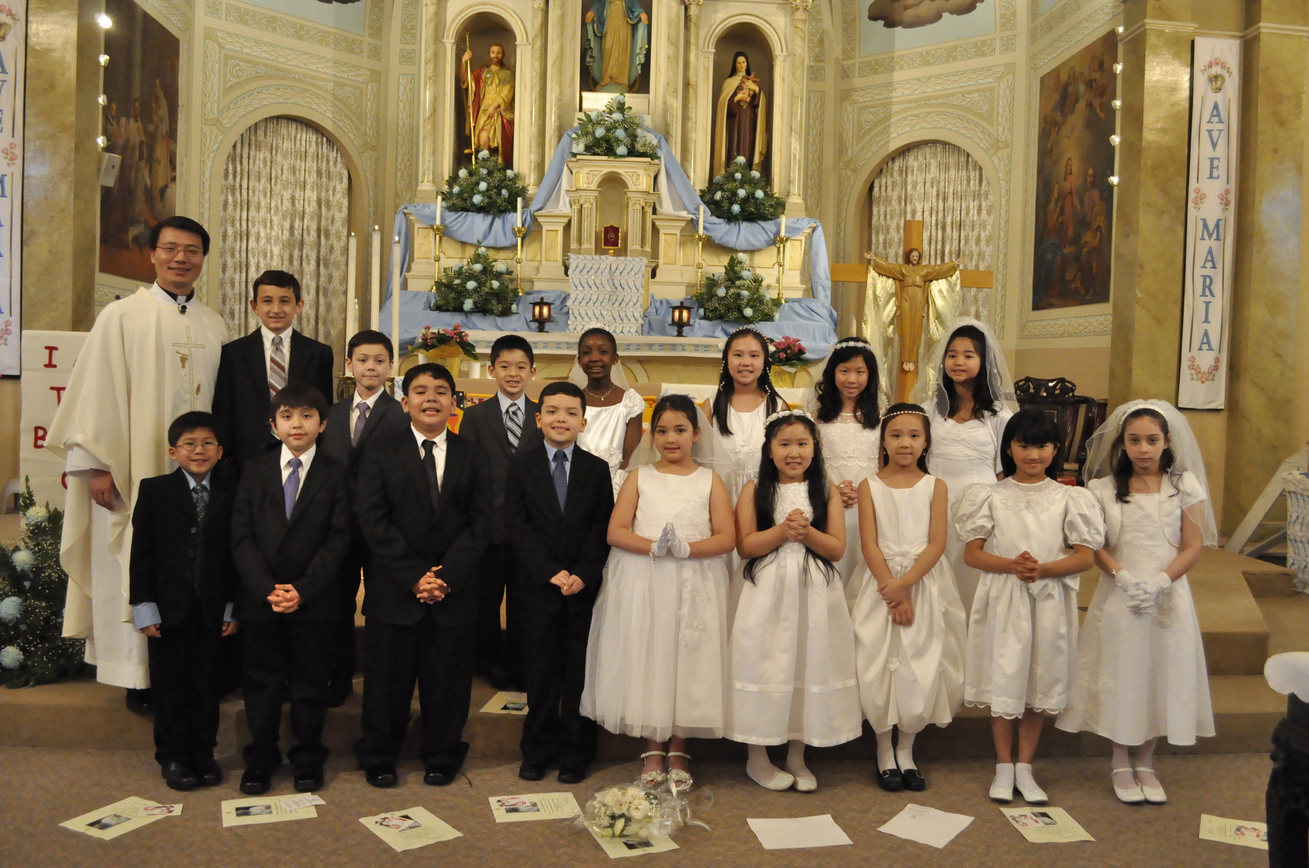

**Congratulations**

**and Thank You!**

Sixteen of our School and CCD children received their First Communion last Sunday. This is the second largest group our parish had in the recent years. ***Congratulations to our First Communicants!*** Thanks to their parents for being their “first and best teachers.” Thanks also to their teachers and catechists who prepared them so well for the Sacrament of Holy Eucharist.

(Photo—Courtesy of Geraldine Kwan. Thanks!)

**What are our CCD Children saying about their Mothers?**

Mothers are special, our CCD children agree. The following are a few reasons why they believe their mothers are so special in their lives:

***\*She gave birth to me!***

***\*She is kind and caring and helps me with all my problems.***

***\*She means everything to me because without her I would not have everything I have now. I have toys I want, electronics I want and all the cloths I want.***

***\*She buys me a lot of stuff and always gives me presents on special occasions.***

***\*She is always there for me in a time of need. For example, when I was sick with a cold, she makes me soup and gives me medicine to help me get better.***

***\*She disciplines me so that I can be a good person and make right decisions in the future.***

Thank you for sharing! What they said above certainly reminds me of the precious memories I have about my mother. I hope they help you to be mindful of the gift of your mothers. For all the mothers out there, I hope these honest and heartfelt words make you feel proud and joyful.

As we honor and celebrate all mothers on this Mother’s Day, we thank our mothers for their unconditional love, for both the ordinary and extraordinary things they do for us. As a token of our appreciation, our CCD children and a few of their fathers will cook and serve a simple lunch after the 9:30am Mass. Please join us in honor of our mothers!

***Happy Mother’s Day!***

***Peace ~Fr. Francis***

***St. Therese College Scholarships– 2012***

***Some good news for High School Seniors! Through the generosity of an anonymous donor- who is very grateful for all the help he received from the St. Therese Chinese Mission years ago and who wants now to give back to help others, our parish is proudly able to offer college scholarships again this year.***

•  **Applicants *must* be of Chinese descent AND has volunteered or will**

**commit to volunteering at St. Therese Church (summer of 2012).**

•  **Each scholarship grant is $1,000 to be paid out in August 2012.**

•  **Application deadline is JUNE 10, 2012. Applications, complete with required documents must be submitted no later than this date to: St. Therese Church, to the attention of “*The Scholarship Committee*.”**

•  **Applications & related requirements can be found on the application forms**

**located on the table at the entrance of the church.**

**————————————————————————————————————————-**

***Hospitality Schedule for May 20, 2012***

**GREETERS: Darlene Chan-Lowe, Jennifer Sin, Sharon Yu**

**RECEPTION VOLUNTEERS (*Family Meal*): Anne, Kien, Raymond**

**——————————————————————————————–—**

**♪♫ Choir Corner ♫♪**

**May 13, 2012 -- Sixth Sunday of Easter—(*Mother’s Day*)**

**PROCESSIONAL: #435 - SING TO THE MOUNTAINS**

**OFFERTORY: #699—WE HAVE BEEN TOLD**

**COMMUNION: # 785 – AVE MARIA**

***Meditation Hymn*: IMMACULATE MARY (*Catechists & CCD Students*)**

**RECESSIONAL: # 622 – LOVE DIVINE, ALL LOVES EXCELLING**

***(Choir Rehearsal on Thursday, May 17th from 7-9pm.)***

***News and Events***

**Annual Second Collection today for Catholic Charities– Mother’s Day Collection.**

**Monday, May 14th at 7pm**

Liturgy Committee Meeting takes place.

**Wednesday, May 16 at 7pm**

Parish Council Meeting takes place.

**The Ascension of the Lord** Mass will be celebrated on next Sunday, May 20th.

**NATO SUMMIT— Sunday, May 20th**

**Due to the Summit and numerous street closures, please allow yourselves more time to get to Mass next week.**

**10th Anniversary of the Dedication of**

**Our Lady of China Mosaic Pilgrimage**

**When: Thurs, 8/2/12 – Sun, 8/5/12**

**Where: Washington DC area**

**Cost: $380 per person**

**Include meals, hotel, transportation & tour in Washington DC, Basilica of the National Shrine of Immaculate Conception, Basilica of the National Shrine of St. Elizabeth Ann Seton, National Shrine Grotto of Our Lady of Lourdes.**

**For more information contact Parish rectory 312-842-6777 or see George Lee.**



**“Pilgrimage of Trust In Chicago”**

**From May 25-28, 2012, “young people will come to pray, meet others, reflect on the Gospel, search for ways of being in solidarity with others, and to live the experience of Church as a community of hope.” So come experience the power of Taize!**

***St. Therese Young Adult Ministry* (YAM) will attend the 8:00 pm Taize evening prayer at DePaul University on Friday, May 25, 2012.**

**Feel free to join YAM! All will gather at church at 6:45 pm to go together. *Please sign up at the church entrance table.***

**Retreat**

Mid-life Singles (mid-30s to 50s): register today for a life-changing weekend retreat at the Cardinal Stritch Retreat House, Mundelein, on June 29-July 1, 2012. Cost is just $175 for meals and a single room. Take a chance and get involved... you won't regret it! Call (312) 532-8286, e-mail [reflect.illinois@gmail.com](mailto:reflect.illinois@gmail.com), or visit [www.ReflectRetreat.com](http://www.reflectretreat.com/) for details.

**Please pray for the following as they prepare for Holy Confirmation on May 27th::**

**Sophia Bisch**



**Carl DiFranco**

**David Del Raso**

**Ryan Flaherty**

**Athena Gonzalez**



**Joseph Lowe**

**Phillip Lowe**

**Tristan Novak**

**Monica Wong**

**Catechists Needed!**

The CCD Program is looking for Catechists for the 2012-2013 school year. If you are interested or know of anyone who would like to be a Catechist, please contact Christine Delfin, Darlene Chan-Lowe or any of our Catechists. Thanks!

**Prayers**

Please pray for the repose of the soul of Eric Yun, the brother of our parishioner Lushia Tie. Mr. Yun passed away a couple of weeks ago in Korea.

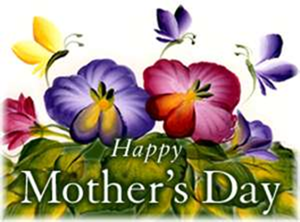

***Mothers: Source of Love and Hope***

Today we celebrate the Sixth Sunday of Easter and Mother’s Day. Liturgically speaking, we are reminded of “an intimate meal (the Last Supper) and a deepening relationship and involvement of the disciples [as] Jesus issues two commands: to remain in his love and to love one another” (*Celebrating the Eucharist,* 82). As we continue to be nourished by the Body and Blood of our Risen Lord, let us always desire to grow in faith and love. Let us also strive to enter into deeper communion with Him by living the Gospel, by loving God with our whole hearts and minds, and by loving one another. Sometimes it’s hard to grasp the concept of love, especially in a society that’s become disconnected with violence and moral indifference. Even more difficult is to love your “enemies” – those who offend you, those who hurt you. But isn’t that what Jesus asks of us? Yes, it’s easier said than done. Inevitably, there will be times when we wrestle with our faith because of secularism, peer pressure, or personal biases. Still, we must move forward by acknowledging our sins, working to overcome them, and keeping true to the source of love which is God. So how do we achieve this task? How do we become ardent followers of Christ? Can we look to our mothers as a model of love and hope?

In today’s Gospel reading, Jesus tells his disciples to “love one another as I love you.” Of course, Jesus is the ultimate example of love. He is the Good Shepherd; He lays down His life for His “friends”, for us! As Jesus reminds us, we can attain this kind of love by remaining in Him, by keeping His commandments just as Jesus keeps His Father’s commandments. With this in mind, let’s now pause to think of our own mothers – to appreciate the life they have given us. Along with fathers, our mothers raise us, nurture us, and teach us. Like Christ, they are willing to lay down their life for us; they are willing to make sacrifices for us. Their selflessness and unconditional love is a testament to the love of God. Serving as a source of affection, our mothers show us how to love, and by experiencing its effects, we, too, intrinsically understand the significance of remaining in God’s love and loving one another. On this day, let us pray for all mothers: that, with the intercession of our Heavenly Mother, mothers around the world will continue to be a beacon of hope as well as a virtuous model of God’s love. May they be blessed and rewarded for all that they do!

**- Christian Shiu**

***“Whoever is without love does not know God, for God is love.”*** - I John 4:8

**Weekly Offering:**

Collection for May 6, 2012

Sunday Envelopes $1,853

Sunday Loose $ 670 July 1-To-Present (Actual): $88,383

Total Collection $2,523 July1-To -Present (Budget): $85,800

Weekly Budget: $1,950 % of Budget Attained: 103%

Please consider giving one hour of your weekly salary as your contribution.

***May God bless your generosity! Thank You!***

***SMI May Crowning Mass of May 6, 2012: $1,274.00 Thank You!***

***Archdiocese Letter***

# *God loves you and me! We are called to remain deeply in this love God gives us.*

# 

# Could there be any sweeter words in the English language than “I love you”? OK, perhaps “Would you like some free chocolate?” are a very close second (or for salt-loving types like my husband, “Hot buttered popcorn coming right up!”) But whether the words are between grandchild and grandparent, people falling in love, or friends after an argument, they are tender and powerful and can be life-changing.

# 

# How often, though, do we let ourselves hear God saying these words to us? We think of “I love you” as being exchanged most regularly between humans or from us to God. But do we remember, in an ongoing way, how much God loves us? We hear this clearly from John in our second reading and from Jesus in the Gospel. We’re told pointedly that any love we show comes first from the love God has for us.

# 

# Before we ever knew God, God loved us. Before we ever did anything meaningful, before we ever spoke a word, before we ever emerged from our mother’s womb, God loved us. God loved us simply because we existed and because we belonged to God. It can be a bit overwhelming to think about– perhaps that’s why we don’t always let ourselves remember this love.

# 

# But in today’s readings, Jesus firmly challenges us to “Remain in my love.” Remaining in God’s love means not ignoring the deep love God has for us. It means choosing actions each day that reflect that love rather than straying from it. It means trusting that even in our moments of feeling most unlovable, God truly loves and treasures us.

# 

# Hear those words from God today—I love you– and let their sweetness transform you.

# 

# - Janel Esker

# ———————————————————————————————————————————

# *Whatever happened to incense?*

# 

# *I recently attended a Mass in which incense was used. I’m very allergic to it and had to leave. It made me realize how long it’s been since I was at a Mass with incense. Why is it so seldom used these days?*

# *- Ellen*

# Dear Ellen,

# 

# The General Instruction of the Roman Missal says incense at Mass is optional(235). In the Latin rite, incensation is usually determined by the solemnity of the occasion; in Eastern rites, its use is more prevalent.

# 

# In Scripture, an angel “holding a gold censer…was given a great quantity of incense to offer, along with the prayers of all the holy ones, on the gold altar that was before the throne. The smoke of the incense along with the prayers of the holy ones went up before God from the hand of the angel” (Rev 8:3-4). We also worship God at Mass by incensing the assembly, the Book of the Gospels, the altar and gifts, and the deceased at a funeral.

# 

# Liturgy incorporates symbol and ritual to enter the transcendent mystery. Incense symbolizes sanctification and purification. Senses are heightened when our prayers are mingled with perfumed frankincense to symbolically rise with the ascending smoke to heaven (see Psalm 141:2). But our prayers and petitions are offered through Christ even when they’re not wreathed in smoke like that of the heavenly hosts.

# 

# People who are allergic to incense should consider using the cry room or sitting in the back of church to minimize its effects.

# - Byron Miller, CSsR

**Please remember in your prayers those who are**

**ill, hospitalized, and homebound...**

Sarah Phillips Marie Balestri Carmella Scanlon

Natasha Chang Lucille Iasillo Carmen (Rails) Balestri

Baby Dominic Vittori Dominic Barbaro Winnie So

Barbara McElroy Barb Davis Rose Perez

Ramona Zavala Ken Barber Nicholas Tobar

Michael Howley Lauren Mandel Ruth Barone

Bernie Presto YoYo Damico Dolly Roti

Lina Andriacchi Baby Jessa Piotrowski Sister Noel Devine

Su Zhen Liao Fr. Walter Johnson, MM Michele Young

Sister Elizabeth Lee John Galvin Wu Wai Hing

Fr. Anthony Chen Barbara Maung Lan Ying Yee

Shirley A. Bills Roseann Gurgone Elaine Sin

John Palenik David Leung

If you wish to add a name or remove your name from this list, please call the parish office.

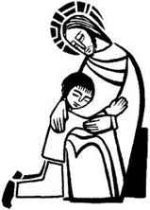

**“I have Called You Friends...”**

The wonder and mystery of Jesus’ love for us is spoken of in today’s readings. Jesus chooses us and calls us “friend.”

What does it mean to be a friend? It means, first of all, to have met the person in some way. Friends spend time together. Friends share experiences, ideas, events, joys, and sorrows. Friends are “for you” and are mutually there for each other. A true friend is faithful and cares for you despite your weaknesses and faults. A real friend cares for you without conditions and for your sake, not theirs. Jesus is this kind of friend.

Jesus tells us that to be His friend we are challenged “to love one another as I love you.” He goes on to say great love is shown by laying down one’s life for a friend. This can take many forms. Doing the unexpected kind thing or acting in a kind way in spite of anger or hurt is another way. It can take the form of forgiveness and support. It can be continuing care in illness and struggle. It can mean believing in someone and helping them live to their full potential even when they cannot believe in that view of themselves. It can be celebrating joy as well as successes.

Jesus calls us to this kind of love and friendship. He promises us joy if we keep this commandment. Can this be why St. Therese is such a joy-filled place? We are chosen by Jesus as His friends to keep this joy growing and alive.

**- Sr. Caritas**