**Mass Intentions**

***May 6, 2012 - Fifth Sunday of Easter***

**8:00A.M.** + Ben & Mabel Chan by Patty Lee

**9:30A.M.** Speedy Recovery for David Leung by father Henry Leung

+ So-Mui Yau Moy by Rose Lee

+ Yuke Sang Chan-Cheng by John & Sheila Lin & Family

+ Eric Yun by Tie’s Family

+ John Ying Law & Deceased Family by Jimmy & Loretta Yu

+ Wah Hee Moy by Long Fong Yau

**11:30A.M. *SMI May Crowning***

***MON. May 7th Easter Weekday***

**8:00A.M.** + Yuke Sang Chan-Cheng by Lucy Moy

+ So-Mui Yau Moy by Monica Lam

+ Ping Woon Yue & Deceased Family by Jimmy & Loretta Yu

***TUE. May 8th Easter Weekday***

**8:00A.M.** Thanksgiving by James & Maria Wang

+ Yuke Sang Chan-Cheng by Lucy Moy

+ So-Mui Yau Moy by Mary Chan

***WED. May 9th Easter Weekday***

**8:00 A.M.** Birthday Blessings & Health for Sophie Nardi by Lucille Salerno

**+** Yuke Sang Chan-Cheng by Judy Moy

***THU. May 10th Saint Damien Joseph de Veuster of Moloka’I, Priest***

**8:00 A.M.**  + Yuke Sang Chan-Cheng by Monica Lam

+ So-Mui Yau Moy by Eva Hui

***FRI. May 11th Easter Weekday***

**8:00 A.M.** + Yuke Sang Chan-Cheng by John & Sheila Lin & Family

+ Yee Kiong Yau by Long Fong Yau

+ Birthday Remembrance for Hazel Nardi by Frank & Sophie

***SAT. May 12th Saints Nereus and Achilleus, Martyrs; Saint Pancras, Martyr***

**8:00 A.M.** Special Blessings for Haidee E. Guigayoma & Tommy J.

Longmire by Family

+ Yuke Sang Chan-Cheng by Monica Lam

**5:00 P.M.** Blessings for Sarah Phillips by Family

+ Georgeann Ferro by SMI Club

+ Josephine Tarantino by SMI Club

+ Michael Phillips by Phillips Family

+ Michael Phillips by Formusa Family

+ Barbara Alberts by SMI Club

**From the Desk of Fr. Francis**

**Greetings of Christ’s Peace and Joy! Hope you all had a blessed week.**

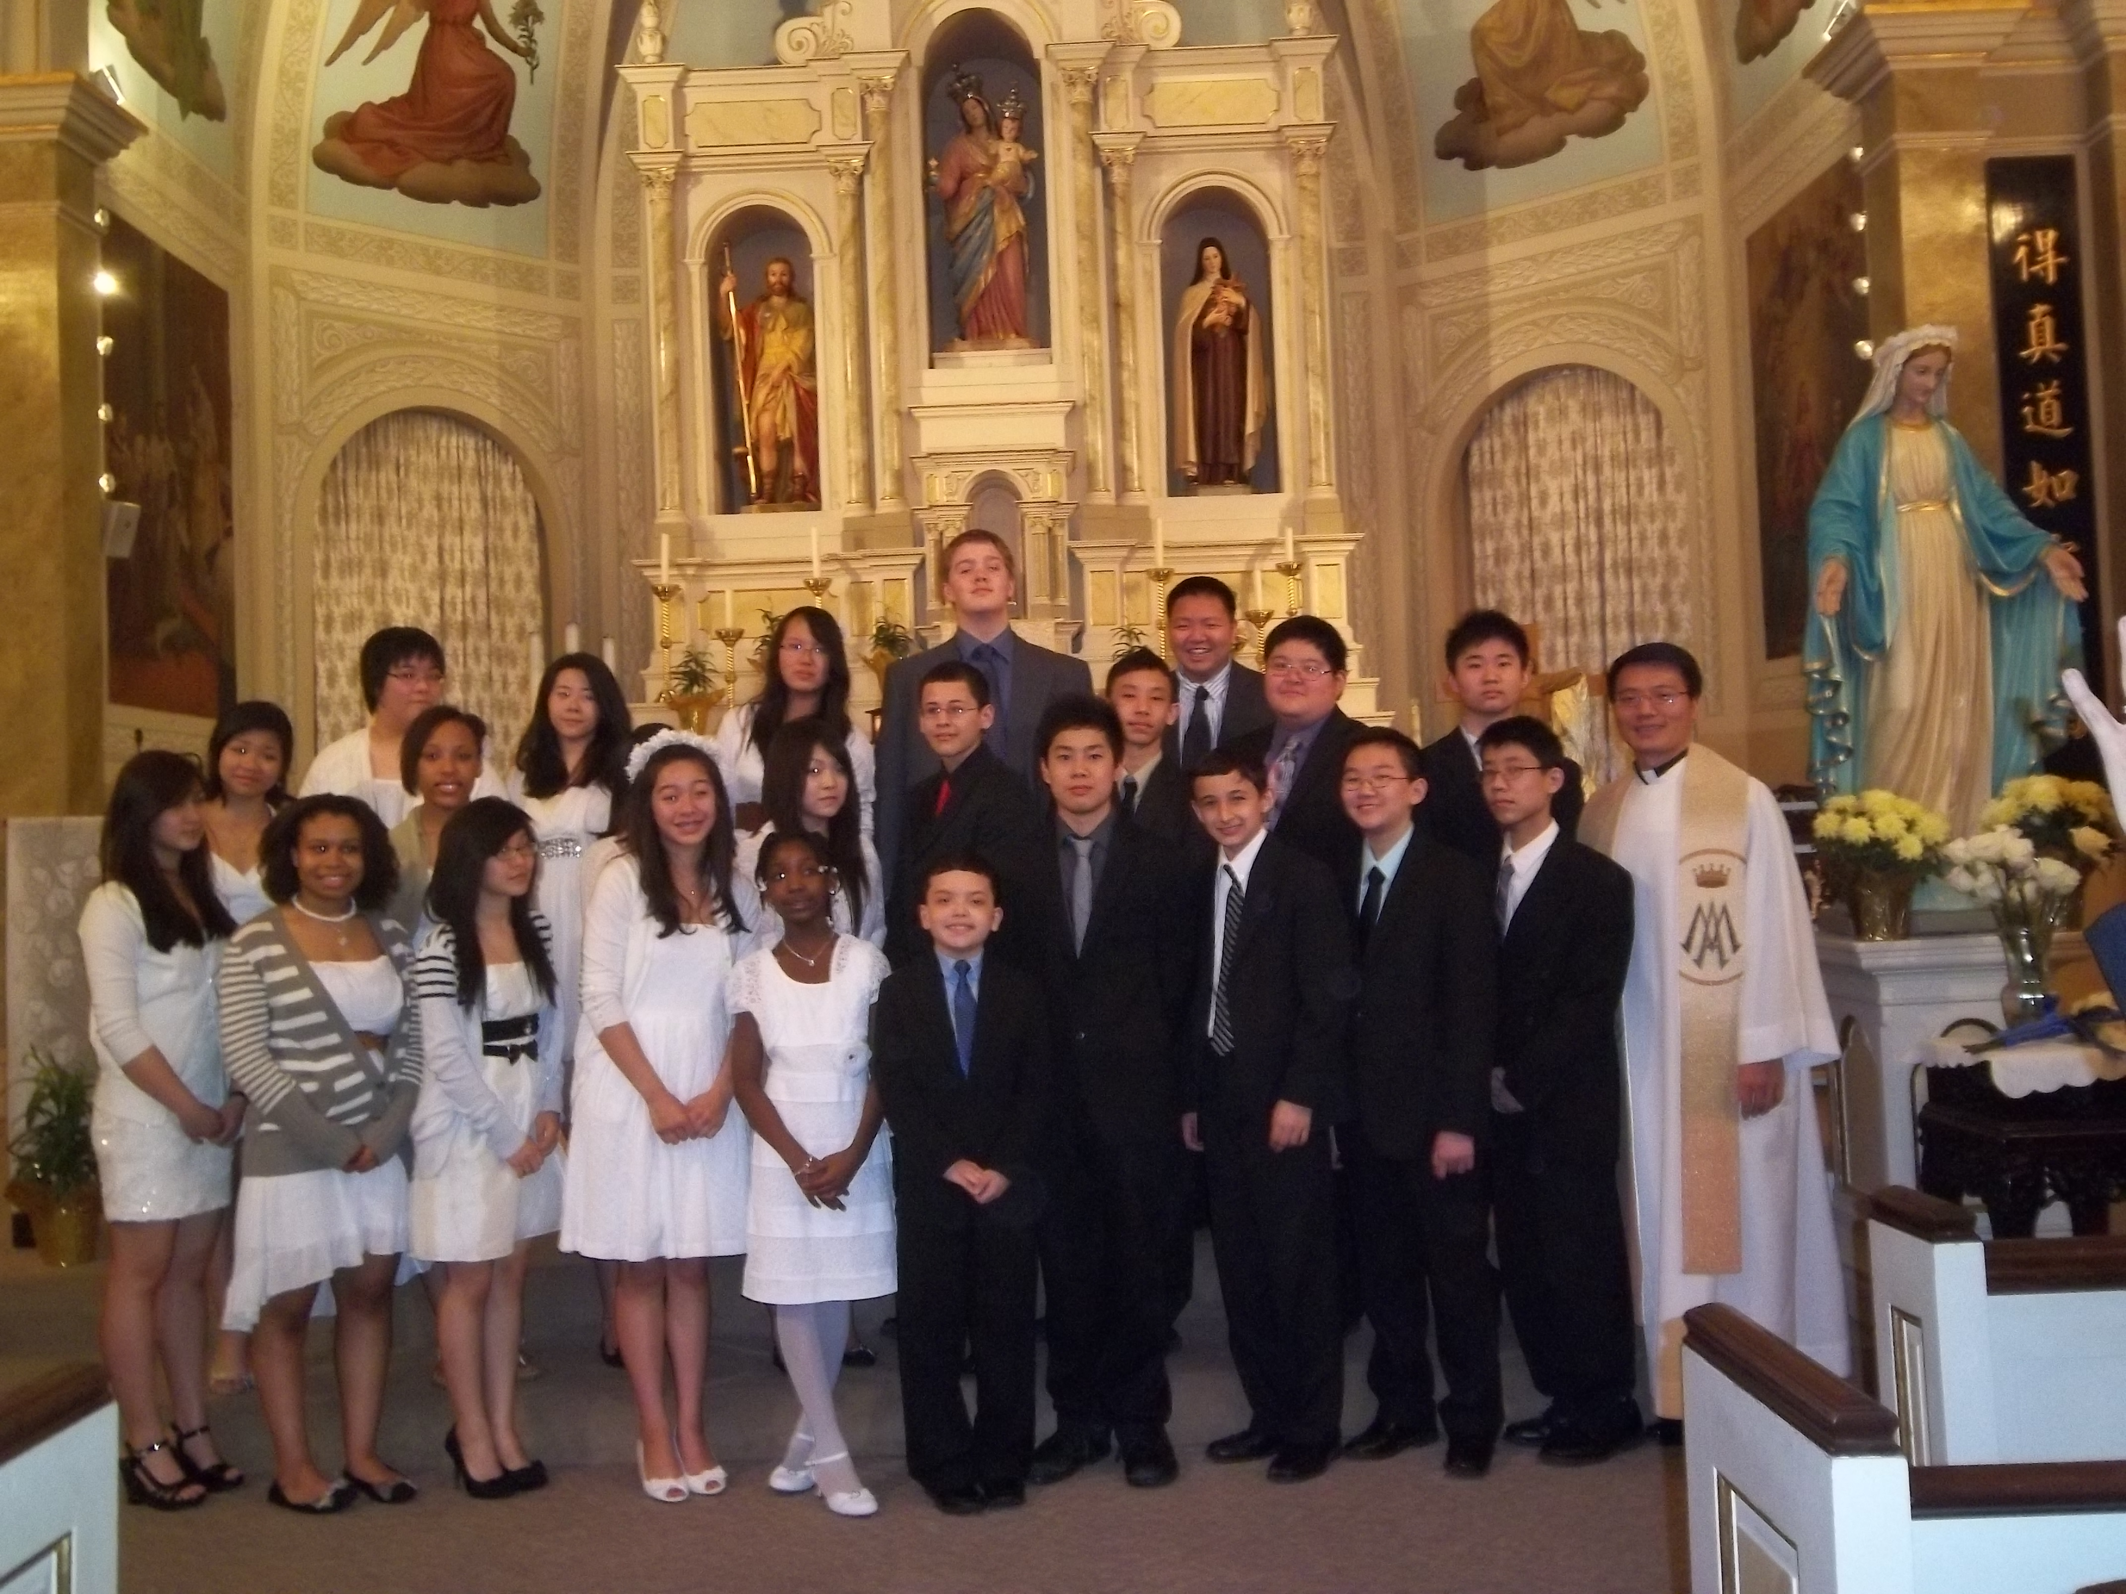

**Thank You and Welcome!**

Thanks to the 8th graders of St. Therese School and all who helped for providing our school community with a beautiful “May Crowning” ceremony in honor of our heavenly mother-Mary this past Tuesday.

We congratulate our First Communicants and welcome their families and friends to join in with us for a spirited celebration! We also welcome all visitors for the annual SMI May Crowning Mass.

***“Holy Eating”***

Eating is deeply ingrained in all cultures. It is a culture itself. Every culture has its own characteristic ethnic food and every person has one’s personal favorite dish. Certainly, eating is no stranger to St. Therese. Why are meals important for St. Therese? How are we part of a meal? A meal after mass or on special occasions can create such wonderful opportunity for human encounters. Henri Nouwen describes this beautifully by stating: “**We all need to eat and drink to stay alive. But having a meal is more than eating and drinking. It is celebrating the gifts of life we share. A meal together is one of the most intimate and sacred human events. Around the table we become vulnerable, filling one another’s plates and cups and encouraging one another to eat and drink. Much more happens at a meal than satisfying hunger and quenching thirst. Around the table we become family, friends, community, yes, a body. That is why it is important to ‘set’ the table. Flowers, candles, colorful napkins all help us to say to one another, ‘This is a very special time for us, let’s enjoy it**.’”

Indeed, this is a very special time for us and for our ***first communicants*** as they receive “***the Body of Christ***” for the very first time today. We come around the table of the Lord. Through our sharing and participation, we become “family, friends, community, yes, a body.” No longer are we separated, we are “the body of Christ.” Isn’t this a great message for us to be reminded of and for our children to learn?

Beginning this July, the Strategic Pastoral Plan of the Archdiocese will move from focusing on Teens and Young Adults to the *Year of Sunday Mass*. The purpose of the Year of Sunday Mass, explained by Monsignor Canary, our vicar general, is “**to reclaim the vital significance of our weekly worship and, therefore, to reclaim the motivation to participate. Ultimately, this has to do with the very life of faith that we share, our existence in God**.”

Eating is important to us. “Holy eating,” a term I refer to Communion, is indispensable for our spiritual well-being. How are you taking part around the table of “holy eating”?

***Peace ~Fr. Francis***



**Congratulations and God Bless the following children from our school and CCD program who received their First Holy Communion today:**

**Armelle Balogun Gregory Kwan**

**Isabella Cabello Jodi Moy**

**Ethan Camacho Kaci Moy**

**Michael Costa Morgan Naylor**

**Solomon Duhon Tristan Novak**

**Maria Feng Alexis Ruelo**

**Kathryn Fong Leann Torrez**

**Ethan Gonzalez Andres Villalobos**



**Easter 2012 Donations—Update: Total as of May 2, 2012: $16,809**

Sammy Moy & Debbe Oi $200

$200.00+ $16,609 (total reported in 4/29 Bulletin) **=** **$16,809**

***Thank You* for your generosity!**

**♪♫ Choir Corner ♫♪**

**May 6, 2012 -- Fifth Sunday of Easter (First Communion)**

**PROCESSIONAL: #435 - SING TO THE MOUNTAINS**

**OFFERTORY: #852– AT THAT FIRST EUCHARIST**

**COMMUNION: #851– I RECEIVED THE LIVING GOD**

***Meditation Hymn*: THIS LITTLE LIGHT OF MINE (*First Communicants*)**

**RECESSIONAL: #443- ALLELUIA, ALLELUIA, GIVE THANKS**

***(Choir Rehearsal on Thursday, May 10th from 7-9pm.)***

***News and Events***

**Annual Second Collection for Catholic Charities** will take place next Sunday, May 13th

**Saturday, May 12th from 8:30am -2:30pm-**Confirmation Retreat

**Sunday, May 13th**—Mother’s Day Pancake Breakfast hosted by CCD kids & Dads

**Monday, May 14th at 7pm**—Liturgy Committee Meeting takes place

**Wednesday, May 16 at 7pm-** Parish Council Meeting takes place

**Monday, May 7- Called to Religious Life—**

**Are you a** Single Young Adult Catholic wondering how your life can respond to God’s call to be transformative love in our world?   You are invited to an evening of input, prayer & discussion on being ***Called to Religious Life***, **Monday, May 7th, 7:30-9:00 p.m. at the Cenacle Retreat Center,** **513 W. Fullerton Ave., Chicago.**  E-mail [cava@archchicago.org](mailto:cava@archchicago.org) or call Sr. Elyse at 312-534-5240.

**Chicago Fire Soccer Game—Free Tickets**

A BIG Thank You to Sr. Caritas for getting the parish “free” tickets to see the **Chicago Fire on Wednesday, May 9th at 7:30 pm** at Toyota Park. Anyone who would like tickets or are interested in attending the game can see Steve Cottam, or email: cottam.s@gmail.comTickets- first come first serve basis!

**The Women’s Center** During the month of May, we honor our heavenly mother and our earthly mothers. At the Women’s Center, since last Mother’s Day, we enabled over 1,000 mothers to bring their babies into the world. ***If you wish to volunteer your time and talents, help is needed to sell flowers after Masses for our annual flower sale on Mother’s Day weekend, May 12 & 13.*** Help is aslo needed in our Chicago Family Resource Room. We are also looking for Women’s Clubs, Respect Life Groups, Scouts, Confirmation projects, students looking for service hours, etc. to host Baby Showers for us. To help us in any of these projects, email [***jkeenan@womens-center.org***](mailto:jkeenan@womens-center.org) or call Jackie at 773-794-8807. **We desperately need 5 fixed side baby cribs,** 7 infant car seats/ carriers, 3 toddler beds, small chests of drawers, 4 pack n plays, 6 strollers, and 3 bassinets. For our address, or if a pick-up is needed, please call 773-794-1313.

**10th Anniversary of the Dedication of**

**Our Lady of China Mosaic Pilgrimage**

**When: Thurs, 8/2 – Sun, 8/5**

**Where: Washington DC area**

**Cost: $380 per person**

**Include meals, hotel, transportation & tour in Washington DC, Basilica of the National Shrine of Immaculate Conception, Basilica of the National Shrine of St. Elizabeth Ann Seton, National Shrine Grotto of Our Lady of Lourdes.**

**For more information contact Parish rectory 312-842-6777 or see George Lee.**



**“Pilgrimage of Trust In Chicago”**

**From May 25-28, 2012, “young people will come to pray, meet others, reflect on the Gospel, search for ways of being in solidarity with others, and to live the experience of Church as a community of hope.” So come experience the power of Taize!**

***St. Therese Young Adult Ministry* (YAM) will attend the 8:00 pm Taize evening prayer at DePaul University on Friday, May 25, 2012. Feel free to join YAM! All will gather at church at 6:45 pm to go together. Please sign up at the church entrance table.**

***Worldwide Marriage Encounter***In the second reading today John encourages us to love one another not in speech only but in deed and truth.  Do you show your spouse that you truly love them, not just say it?  Love your spouse in *deed* by giving the gift of yourself; make the time to attend the next Marriage Encounter weekend.  Show your love for one another by deepening your communication, rekindling your romance and renewing your sacrament.  The next Worldwide Marriage Encounter weekends for the Chicago/Northwest Indiana area in 2012 are June 8-10, Sept.7-9, or Nov. 2-4. For information, call Jim & Kris at 800-442-3554 or contact [www.wwmechicago-gary.org](http://www.wwmechicago-gary.org/).

**Cause for Hope: *Family***

**Issue**:

As we recall from past (“Cause for Hope”) issues, the breakdown of the family unit is becoming more prevalent; this is confirmed by a society that seems to encompass more violence, immorality, and secularism. Yet despite negative external influences, we believe that the family is responsible for instilling in children a strong moral compass – though sometimes, this doesn’t happen. So what causes the family to lose its effectiveness? To understand this, we’ll look at key points from a study conducted by *Tearfund*, “a Christian international aid and development agency working globally to end poverty and injustice” (Tearfund.org). Through careful methodology, they find that it is, indeed, a shift in cultural values and personal morals that has attributed to the deterioration of the family nucleus. For instance, “the new individualism (and its expressions in divorce), out-of-wedlock births, single parenting and careerism” (including economic imbalances) are all factors. But that’s not all. As societal institutions such as government, banks, and schools become more progressive, particularly in terms of the “economic, political, and social functions once undertaken by the family,” familial ties eventually succumb to an auxiliary role and lose its significance (Tearfund.org). If current trends continue, will the family be able to thrive? For the sake of future generations, the answer, hopefully, is “yes”!

**Response**:

Typically, the majority agrees that public awareness is essential in any effort to effectuate change. If parents are well-informed and realize that the installation of good morals and values must start at the home, then there is hope for the future. We cannot turn back the clock and resolve past wrongs, but we can move forward and start anew. The key here is to understand and appreciate the concept of a family, especially the well-being of children – who, after all, are our future! To conclude, let’s think of the family in this way: the family is like a vine that holds the branches together. Without a strong vine, the branches will wither and fall off. Similarly, without a strong family, children can become more prone to the negative influences of [certain] peers, media, and the secular culture. In today’s Gospel, Jesus tells us, “*I am the vine, you are the branches. Whoever remains in me and I in him will bear much fruit*.” In other words, we are all connected to Christ, and only through Him can we become His faithful disciples and prosper. Likewise, children need the support and love of their parents and their families. The family is the vine, the children are the branches, and through love and guidance, both must remain in each other if they are to bear fruit. So with this in mind, let us bring our needs and intentions to our Loving Savior. Let us pray for our own family and for families around the world: that -- guided by the way, the truth, and the light of Christ – we may all come together as brothers and sisters to one day share in the joys of eternal life.

**- Christian Shiu**

**Weekly Offering:**

Collection for April 29, 2012

Sunday Envelopes $1,844

Sunday Loose $ 195 July 1-To-Present (Actual): $85,860

Total Collection $2,039 July1-To -Present (Budget): $83,850

Weekly Budget: $1,950 % of Budget Attained: 102%

Please consider giving one hour of your weekly salary as your contribution.

***May God bless your generosity! Thank You!***

***Archdiocese Of Chicago***

# *Jesus is the vine. We are the branches connected to Him as one vine!*

# 

# Now that summer is around the corner, I look forward to breaking out my favorite outdoor friend: our electric hedge trimmer. My husband does a good amount of the yard work, but I might as well have carved my initials in the trimmer– I love it. We have lots of bushes in our yard that need regular trimming, and I delight in shearing excess branches and pruning foliage to invite new growth and life. And I have to admit that the “power tool” aspect of the trimmer is especially addictive.

# 

# Today’s readings have a lot to say about pruning and shearing, but it’s important to remember who holds the power tool. In the first reading, the early Christian community is suspicious of Saul’s sudden conversion from Christian-persecutor to active disciple. They have a right to be uncertain, of course, but they learn that God pruned Saul and transformed him and that they must welcome him into their community.

# 

# We’re familiar with the image of Jesus as the vine and us as the branches, but sometimes we forget that in this image we’re connected to Jesus the vine and to all the other branches through him.

# 

# We may not like all the other branches, or we may think they’re in need of serious pruning or shearing. Yet our initials aren’t carved in the trimmer. God’s is. We’re not in charge of pruning others (and ourselves)- God is.

# 

# Our job is to stay connected to the vine and to one another, to welcome even those we might find suspicious or distasteful or foreign to us. The community of branches belongs to Jesus– and to its members.

# - Janel Esker

# 

# 

# ———————————————————————————————————————————

# *How do we know if an apparition is real?*

# 

# *My aunt told me last week that the Blessed Mother has been appearing to her for several years. I said it was just her imagination, and she countered, “If she could appear to Saint Bernadette, why can’t she appear to me?” How should I answer that?*

# *- Dillon*

# Dear Dillon,

# 

# Ask your aunt what these revelations are about. Is the Blessed Mother telling her to go to Mass every week, to be good to the poor, to say her prayers? If she is, I wouldn’t be too concerned.

# 

# If, however, your aunt says the Blessed Mother is telling her to sell her house or quit her job, or if she feels compelled to share these revelations with others, I would be more concerned.

# 

# The *Catechism of the Catholic Church* is very clear on apparitions: “Throughout the ages, some (private revelations) have been recognized by the authority of the Church...Guided by the magisterium…, the *sensus fidelium* knows how to discern and welcome in these revelations whatever constitutes an authentic call of Christ or his saints to the Church” (67).

# 

# Your aunt’s encounters with Mary might be her imagination, or they might be something more. Your aunt should ask her pastor to recommend a spiritual director, someone she can talk this over with and who can help her discern what will bring her closer to Jesus.

# - Patrick Keyes, CSsR

**Please remember in your prayers those who are**

**ill, hospitalized, and homebound...**

Sarah Phillips Marie Balestri Carmella Scanlon

Natasha Chang Lucille Iasillo Carmen (Rails) Balestri

Baby Dominic Vittori Dominic Barbaro Winnie So

Barbara McElroy Barb Davis Rose Perez

Ramona Zavala Ken Barber Nicholas Tobar

Michael Howley Lauren Mandel Ruth Barone

Bernie Presto YoYo Damico Dolly Roti

Lina Andriacchi Baby Jessa Piotrowski Sister Noel Devine

Su Zhen Liao Fr. Walter Johnson, MM Michele Young

Sister Elizabeth Lee John Galvin Wu Wai Hing

Fr. Anthony Chen Barbara Maung Lan Ying Yee

Shirley A. Bills Roseann Gurgone Elaine Sin

John Palenik David Leung

If you wish to add a name or remove your name from this list, please call the parish office.

**“I Am the Vine, You are the Branches”**

Vines grow in many places and in great variety. Some vines produce food like cucumbers, pumpkin or melons. Some are blossoming vines like morning glories, honeysuckle or periwinkle. Poison Ivy can also be a vine. The people Jesus was speaking to probably knew grape vines. Good grape vines produce fruit (i.e., grapes) which would be used in the making of wine. Vines have growth extensions or branches which serve various purposes. They flower or produce fruit as well as furthering growth.

Jesus identifies Himself as ‘*The Vine*” telling us we are the branches. Nourishment, life and growth come to the branches by staying connected to the Vine, Jesus. By being part of the vine we are identified with the vine. We belong to Jesus. Usually vines need the branches for growth. Jesus’ Body, the Church, grows through the outreach and growth of the branches.

Jesus tells us that without staying attached to the vine we will not live. The profound truth is “Without me you can do nothing.” He reminds us through this image, that without Him we cannot accomplish good things, growth in grace, and virtue, or bring help to others. Jesus, The Vine, is our source of grace and life. So intimate is our relationship to Jesus that “in Him we live and move and have our being.” (St. Paul) “***I*** *am the vine*, ***YOU*** *are the branches*.”

**- Sr. Caritas**